

**Application for Alumni Funding (£100-£1000)**

**Project name:**

**Name of society, club, student group or department applying for funds:**

**Related website &/or social media page:**

**Principal Applicant/Project Lead** *One named individual must take responsibility for leading the application. Correspondence will be principally conducted by use of College email only*

Title:

First Name:

Family Name:

Student Number:

College email address:

Phone number:

Position held within society, club, student group or department:

**Total amount of money applied for (GB pounds):**

**Number of students involved in project:**

**Names of students involved in project:**

**Please provide full details about the project, including dates and items for which you require funding:**

**Please note which of the College’s strategic objectives your project supports,** [**most notably those under Theme 3 – Our Student Experience**](https://www.royalholloway.ac.uk/iquad/documents/pdf/principal/theroyalhollowaystrategicplan2013%E2%80%932020.pdf)

E.g. 3.1, 3.3a

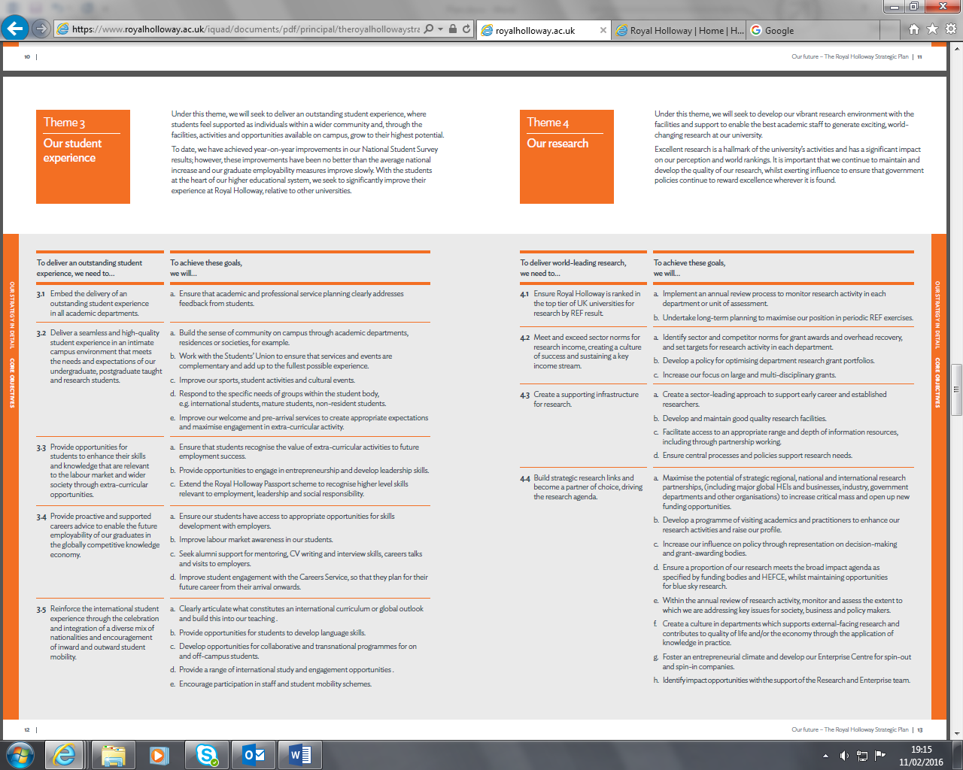

**Budget**

Please illustrate all expenditure (and any income) relating to the project clearly identifying where funds are to be raised by other sources or by the amount being applied for by the fund. Please also clearly show what is guaranteed/confirmed and what is provisional/estimated.

**Supportive statement**

**Name:**

**Role:**

**Date:**

**Statement to confirm this application has been discussed in detail and the funds applied for are genuine and required**

**Notes:**

Once completed, this form must please be emailed by the supportive department to [alumnifund@royalholloway.ac.uk](mailto:alumnifund@royalholloway.ac.uk) from a College or Students’ Union registered email

By submitting the application you are acknowledging your understanding of the application criteria and declaring that to the best of your knowledge the information you have supplied is correct. Please ensure you have met all the application criteria (see appendix 1) and will be willing and able to commit to the terms and conditions of receiving the funds (appendix 2 provides a brief overview). Successful applicants will receive will need to complete and return a Memorandum of Understanding Form within five days of receipt. It can then take 2-4 for you to receive the funds so please consider this in your financial planning