
Royal Holloway Equality, Diversity and Inclusion (EDI) Annual Report August 2024-July 2025)
Contents
1. Introduction 2
Our community and ambitions 2
Report summary 3
Achievements in 2024/25 3
Looking ahead 4
Moving on from 2023–24 5
Progress against our EDI KPIs 6
2. Our EDI framework 2023-2028 6
3. EDI governance and structures 7
4. Diversifying our community 9
Our students 9
Our colleagues 9
5. Inclusive culture, infrastructure and environment 10
Dignity at Work 10
Equality Impact Assessments (EIA) 10
Our Staff Diversity Networks 11
Learning and awareness 11
Listening and support 13
Race equity 13
Accessible and inclusive campus 15
EDI events and celebrations 16
Mental health and wellbeing 18
A peri/menopause-friendly University. 19
7. Fair and inclusive recruitment. 20
Next steps 21
8. Development and progression. 21
Academic promotion and career development 21
9. Priorities for 2025/26. 23
Appendix 1 EDI Guiding Principles. 25
Appendix 2 Workforce report (with pay gap reporting). 27
Introduction. 27
Representation by protected characteristics. 28
Factors which influence representation. 38
Pay gaps. 47
Appendix 3 - Review of KPIs (Colleagues) 56

Terminology: We acknowledge all terms used around race/ethnicity have limitations. Following community/network consultations, Royal Holloway uses the term Black and global majority (BGM), though understanding the sensitivities and complexities involved and trying wherever possible to contextualise and disaggregate data/information.
We use the abbreviation EDI for Equality, Diversity and Inclusion, throughout.
Benchmarking: HESA data for 2024-25, accessed via Heidi Plus Gold, has been used for benchmarking. We have conducted our benchmarking by aggregating data from ten institutions comparable to ours in size, geography, and academic focus. This group, informally known as the S10 University Network, includes Brunel, City, East Anglia, Essex, Goldsmiths, Kent, Reading, Sussex, and Surrey. Where characteristics are not included in HESA returns (such as sexual orientation, gender reassignment) we have used the Advance HE statistical report 2024 for benchmarking.

Introduction.

Our community and ambitions.
At Royal Holloway, our ambition to cultivate a diverse and inclusive community where everyone belongs, is supported to succeed, and empowered to thrive, is stronger than ever. In a context of increasing economic, legal and political uncertainty, alongside growing social polarisation and geopolitical instability, this has never been more challenging, nor more necessary. Universities specifically face heightened scrutiny, and are navigating rapidly shifting expectations, legal requirements and regulatory responsibilities, and we continue to respond to these with urgency, intention, and care. Our commitment extends beyond compliance, as we aim to weave equitable practice and a culture of belonging into the fabric of the University and maximise the impact of our collective efforts.
This ambition – and the aspirations embedded in our EDI Framework 2023-28 – is central to RH2030s, our new University strategy introduced in autumn 2024. Equity and Inclusion sit unequivocally at the heart of this strategy, underpinning our values, our operations, and our vision for the future. Action on EDI is fundamental to our vision to be a University of Social Purpose. Our values of Respectful, Open, Innovative and Daring guide this work, supporting meaningful change that benefits students, colleagues and the wider community.
Over the past year, we have continued to work closely with our senior leaders, who demonstrate a sustained commitment to stepping into key spaces and engage directly in discussions, sharing their own lived experiences and listening with intention to those of others to progress meaningful change. Senior Leader Champions for different strands of equality have maintained an active presence across all our Equity Groups and staff networks, as well as in a number of rapidly convened working groups established in response to the emerging needs of students and colleagues feeling the impact of world events and shifting geopolitical and legislative contexts. This includes the Antisemitism and Islamophobia Working Group as well as spaces to understand changes to legislation, including in relation to Freedom of Speech and the Equality Act 2010. These spaces play a vital role in initiating and coordinating action across the University against a complex and evolving backdrop.

Report summary.
This report provides an overview of the key projects and initiatives delivered during 2024/25, and outlines our progress against agreed targets and KPIs. While we have made meaningful strides, we recognise that there is still significant work ahead. As we look back on this year’s achievements and the ongoing challenges affecting our community, our commitment remains clear: to build a University in which respect, equity and inclusion are embedded in everyday practice and experienced by all. The following sections set out our progress, highlight areas of continued focus, and outline the priorities that will guide our work moving forward.
We don’t always get it right, and continue to learn through community engagement and consultation, deepening our understanding of the nuances of communication and lived experience, as we balance our legal obligations relating to protected characteristics with our commitment to community wellbeing. This commitment is reflected in plans to launch new spaces for listening and dialogue, introduce courses that support awareness raising and pluralist, inclusive perspectives, and strengthen our approach to understanding and acting on community feedback.
At the heart of all our efforts remains our vision to be a University of Social Purpose, resolutely pursuing education, research, and student experience as catalysts for social change. Our goal is to contribute to a more inclusive society and a better future for generations to come.
Looking ahead, we will continue strengthening access, participation and belonging for students from all backgrounds, with a particular focus on reducing awarding gaps, enhancing inclusive careers support, and removing barriers to postgraduate study. Together, these priorities reflect our commitment to nurturing a University culture grounded in equity, inclusion and belonging, where every student and colleague feels supported to succeed.

Achievements in 2024/25.
A key highlight of 2024–25 was our achievement of University of Sanctuary Recognition in June 2025, reflecting our commitment to supporting refugees and people in the asylum system through widening access to higher education and fostering a culture of welcome.
We also secured a Silver Race Equality Charter award following our submission in December 2024. Together with our Athena Swan Silver Award and Disability Confident Leader status, these recognitions demonstrate the depth and breadth of sustained work across our community. More importantly, they reinforce our ambition and commitment to translating our values into meaningful action that drives the change we want to see.
Further progress includes:
- We have refreshed and strengthened the operation of our Equity Groups through formal inductions and activities to cultivate a strong sense of purpose and confidence in the work we are doing.
- We have continued to address bullying and harassment, including holding a Town Hall event open to all colleagues; revising our Dignity at Work Policy; and preparing to launch a new reporting process for colleagues.
- We have strengthened our Equality Impact Assessment (EIA) processes, with revised user-friendly forms and guidance. Our Policy Review Committee, a sub-committee of our Executive Board, now require evidence of EDI consideration for policies submitted.
- We continue to improve policies and process for all our communities where challenges are identified via our staff networks.
- We have worked tirelessly to improve mandatory EDI training completion and the last six months we have seen an overall 15% increase in completion rates across the University.
- We are expanding resources and initiatives to support disability inclusion, including new disability and accessibility training, reasonable adjustment training for managers, and collaborating with AccessAble to support access to our estate.
- We have completed a full review of our Academic Promotion criteria and processes to provide more clarity, flexibility and fairness.

University of Sanctuary.

In June 2025, Royal Holloway was formally recognised as a University of Sanctuary—an achievement that reflects our long‑standing commitment to creating a welcoming, safe and empowering environment for people seeking refuge and protection. This recognition aligns closely with the ambitions of our RH2030s Strategy, which positions Royal Holloway as a University of Social Purpose and strengthens our focus on building a culture of safety, solidarity and opportunity for all those seeking sanctuary.

Our work in this area spans across education, community engagement and research. We provide tailored support for displaced students and academics, extend meaningful partnerships with local refugee organisations, and encourage student involvement in volunteering and community initiatives. Our academic contribution is also central to this mission, with teaching and research exploring the experiences of refugees and people affected by forced migration, and the structural barriers they face in accessing higher education.

This commitment is grounded in Royal Holloway’s long tradition of standing with those in need. As global displacement continues to rise due to conflict, persecution, climate instability and human rights violations, we remain focused on combining research excellence with practical support. This includes sustained investment in Sanctuary Scholarships, which open pathways to study for individuals who might otherwise be unable to access higher education.

By offering both a place of safety and the opportunity to rebuild and thrive, we continue to uphold the values that define Royal Holloway: a University that seeks to drive positive change and extend sanctuary, opportunity and dignity—one individual at a time.

Looking ahead.
In the year ahead, we will build on our ongoing commitment to ensuring that students from all backgrounds are able to access, participate in, and thrive within higher education. Our work will continue to prioritise reducing awarding gaps and strengthening students’ sense of belonging across the University community. Ensuring that all students can benefit from inclusive, equitable careers support remains central to this commitment, helping them to develop skills, explore future pathways, and connect with opportunities that support their long‑term goals.
We will also maintain a strong focus on addressing barriers to access and inclusion within postgraduate study. Creating an environment where postgraduate students can flourish—academically, personally, and professionally—will be a key area of development.
Taken together, these priorities reflect our broader aim of cultivating a University culture grounded in inclusion, equity, and belonging. Our goal is to ensure that every member of our community—students and colleagues alike—feels supported, valued, and able to succeed.

Moving on from 2023–24.
Building on the foundational work undertaken in 2022/23 to strengthen our EDI direction and capability — including the development of our EDI Framework and Guiding Principles, improvements to recruitment and promotions processes, and the introduction of core learning for managers — 2023/24 marked a shift towards delivery through the coordinated themes of our four Strategy Working Groups: selection and onboarding, inclusive culture and environment, inclusive physical and digital infrastructure, and development and progression.
In 2024/25, we built on this structured approach by continuing to embed and implement our EDI priorities across the University. At the same time, the heightened external uncertainty and scrutiny facing the higher education sector required us to strengthen our institutional responsiveness, ensuring that our work remained agile, coordinated and aligned with emerging needs. This year has seen tangible progress through strengthened leadership, visibility and accountability and greater engagement in Equity Groups and rapid-response working groups, alongside significant work on culture, policy and inclusive practice.
While our colleague community is diversifying, progress and recruitment into senior roles remains slow. We continue to explore new ways of addressing this, expanding career development opportunities, including tailored support for Early Career Researchers and the creation of safe spaces for reflection and professional growth. A key development this year has been the launch of our Breaking Barriers scheme, led by Professor Ruth Livesey, Pro-Vice Chancellor (Research and Innovation), which aims to dismantle systemic barriers to career progression for Black and global majority academics.
We have also accelerated activity to address underrepresentation and progression barriers through continued improvements in EIA practice, accessibility and inclusive infrastructure. Importantly, 2024/25 brought external recognition of our sustained efforts, including University of Sanctuary status and a Silver Race Equality Charter award, reinforcing ongoing progress towards more embedded inclusion and belonging.
Through 2025/26, we will continue to evolve our approaches with a focus on building robust inclusion systems that strengthen institutional resilience, reduce anxiety, and support our community through ambiguity and change.
Our upcoming Listening Circles project will be an important part of this journey. Through centring on those most affected, listening for insight, and focusing on lasting impact, these spaces will help us stay connected, accountable and responsive as we continue to work towards a more equitable future together.

Progress against our EDI KPIs.
Across the past four years, we have seen steady progress in several of our EDI KPIs (Appendix 3). Disability representation has increased across both academic and Professional Services roles, with particularly strong gains at senior Professional Services grades. The proportion of Black and global majority academic staff has continued to rise year on year, bringing us closer to our long term targets for a more representative academic community. Progress has been slower and more variable in senior academic and Professional Services roles, especially in relation to ethnic diversity and gender balance within the professoriate. These patterns reinforce the importance of continuing to strengthen our recruitment, progression and talent development activities to support more equitable pathways into senior roles.
In 2025-26 we will launch the next iteration of our People, Culture and Inclusion Survey, which will provide quantitative and qualitative insights into organisational culture, culture change and colleagues’ sense of belonging. It will also allow us to compare progress against the previous survey, which was reported on in the 2023/24 EDI Annual Report, and track shifts over time. As the 2025 survey cycle did not align with the timeframe of this year’s EDI Report, the findings are not included here, but will form a core part of action and analysis in the next reporting period.

Our EDI framework 2023-2028.

Our framework sets out Royal Holloway’s commitment to creating an environment where everyone is treated equitably and feels a genuine sense of belonging.
This framework sits firmly within the ambition of our RH2030s strategy and our journey as a University of Social Purpose. Our framework is aligned with our People, Culture and Inclusion enabler and reflects our core values – including ‘Respectful’ – which guide how we support and engage with one another across the University. Respect at Royal Holloway means recognising ourselves as a community, fostering a culture of collegiality, building mutual trust, and listening to understand – especially when we disagree. These principles shape our approach to fairness and inclusion, ensuring that our policies and practices are underpinned by integrity and compassion.
This framework is grounded in our legal responsibilities and shaped by the lived experiences of our students and colleagues. It supports open dialogue, diverse perspectives, and respectful engagement, all of which are essential to our ambitions around academic excellence and commitment to social purpose. It articulates our priorities and outlines how we will monitor progress and measure impact. Its three aims are:

- Achieve diversity in our staff and student body.
- Establish an equitable and fair environment.
- Ensure everyone is included and feels a sense of belonging.

These aims are accompanied by the following objectives:

- Achieve proportionate representation of marginalised groups throughout Professional Services and the academy, and among decision-makers across the University.
- Increase the diversity of our students across all levels of study.
- Ensure all staff and students are supported to succeed and all barriers are identified and removed.
- Ensure all physical and digital spaces are accessible, eliminating barriers to participation.
- Empower all members of our community to understand, value, and respect difference and be active bystanders.
- Equip our community to understand and uphold freedom of speech, academic freedom, and equality law, ensuring respectful dialogue and inclusion within the bounds of the law.

The framework is supported by a set of shared principles (Appendix 1) that reflect what matters most to our University community. These principles emerged from extensive conversations with colleagues and students throughout 2021 and 2022, and shape our approach to equity, inclusion, and belonging.
Rather than prescribing behaviour or language, these principles help guide how we work together, how we make decisions, and how we build a culture of trust, collegiality, and respect. They are reflected in our policies, structures, and everyday interactions, and they support our efforts to create an environment where everyone feels empowered and included.
In line with our values, we aspire to meet and go beyond our legal compliance requirements in our support of a diverse community of students and colleagues. A key underlying theme and focus of our work continues to be for equity and inclusion to become ‘what we do’ in our everyday practices, and we are working hard to equip and support colleagues and students to contribute to this.

EDI governance and structures.

Our Vice-Chancellor and Principal Professor Julie Sanders, alongside our University Council, has overall responsibility for equality, diversity and inclusion. The EDI Committee, chaired by Professor Tracy Bhamra, Provost and Pro-Vice-Chancellor (Global), continues to drive the development and implementation of the Equality Framework 2023-2028. This group comprises colleagues from across the University including from Professional Services, diversity Network leads, Equity Group chairs and Vice-Deans for EDI (0.6 FTE). During 2025-26 with changes to our academic structures (including the move from six Schools to three Faculties), we will establish the role of Associate Dean for Culture and Inclusion at Faculty level to work alongside EDI roles in our new Departments.
Our EDI team in Human Resources, comprising three posts, supports all EDI initiatives and works closely with the Vice-Deans for EDI, who lead on School-based approaches and contribute to EDI leadership at University level. We have four University Equity Leads (0.1 FTE), each leading one of our Equality Groups (Race, Gender, LGBT+, Disability).
Our Strategy Working Groups include representation from Professional and Technical Services colleagues who support local EDI work in these areas. Our Student Inclusion Communities (e.g. Black and global majority students, disabled students, LGBT+ students) in the SU, led by Community Officers, feed into our structure.

Our EDI Governance Structure
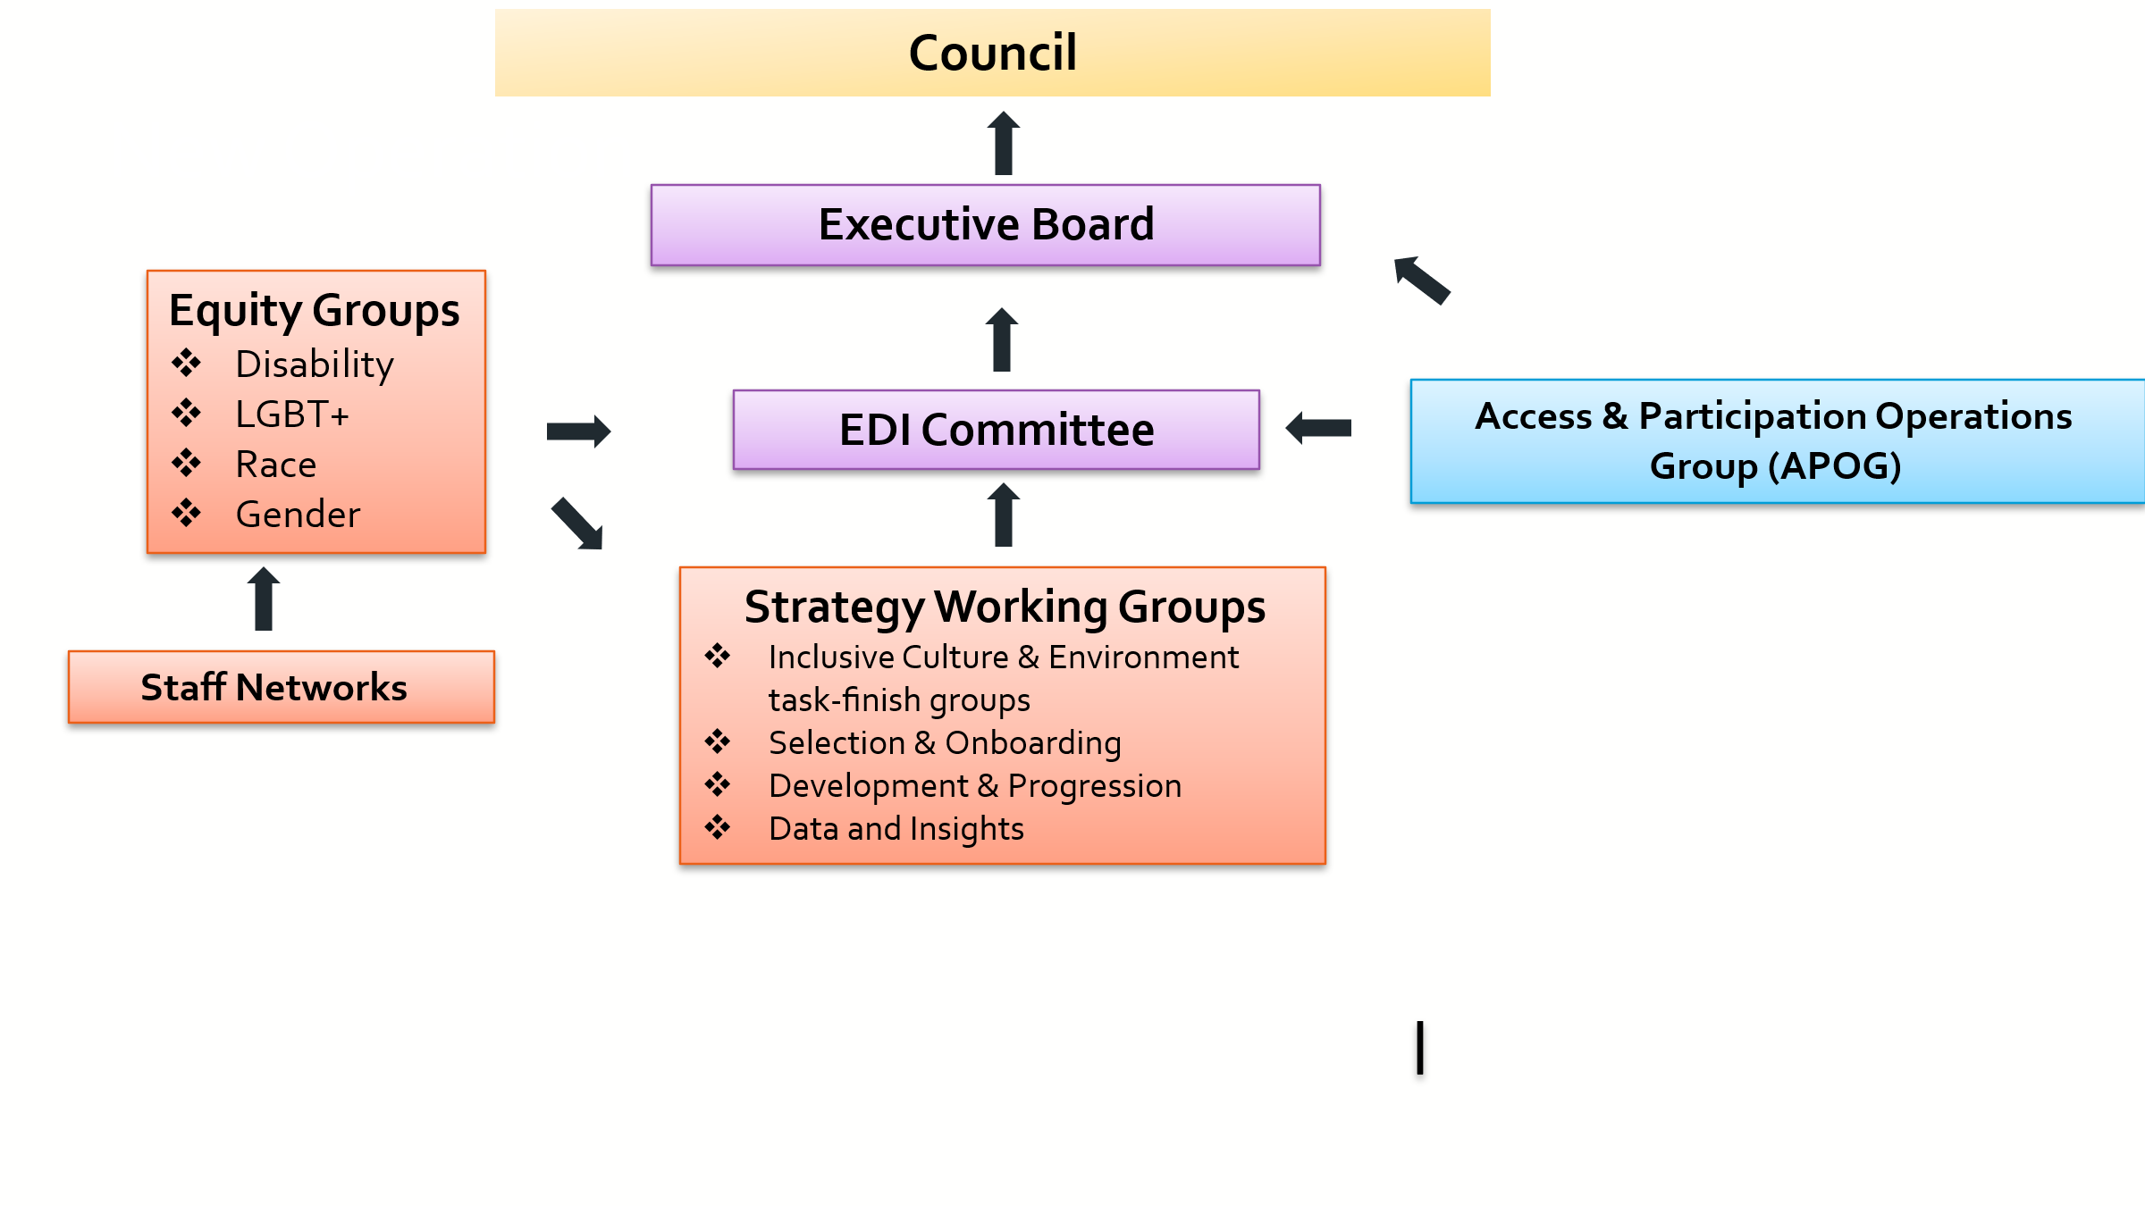
Our EDI structure is designed to:
- Embed network representation across the University to ensure diverse perspectives and lived experiences inform our work.
- Facilitate focus on intersecting issues through Strategy Working Groups, and task-finish groups, to accelerate transition from theory to action. These groups focus on culture and inclusion, recruitment, development and progression, and data.
- Strengthen collaboration between colleagues and students by creating shared spaces for dialogue, reflection and joint problem solving.

Throughout 2024/25 we refreshed and strengthened the operation of our Equity Groups through formal inductions and activities to bring members of these groups together to feel a strong sense of purpose, community, and confidence in the work we are doing. These sessions also led to the creation of team charters to formalise roles, expectations, and team norms. The charter is designed to provide strong foundations for continued progress on action plans.

Professional Services (PS) departments are at different stages on their journey towards ensuring inclusion by design both through, and also within, their areas. The University is gradually extending EDI Champions across the University, with a new role in Estates, and representation from Estates on the EDI Committee and the Disability Equity Group.

Diversifying our community.

Our students.
Our student cohort has changed rapidly in size and diversity over the past few years. In 2024/25 we had 12,900 students, compared to 11,500 in 2020/21, and 85% of our current students are undergraduates. Our student population has become more ethnically diverse. In 2024/25, 52% were from BGM backgrounds, and 32% were Asian.

Our colleagues.
Workforce data shows a gradual diversification of our colleague community. This includes increasing proportions of women, individuals from Black and global majority backgrounds, an increase in proportion of colleagues declaring a disability, and colleagues from LGBT+ communities.
- Representation of Black and global majority colleagues continues to steadily increase and is 22.7% in 2024/5 compared to 17.4% in 2021, though slightly lower than the 2024/25 S10 benchmark of 24%.
- The proportion of colleagues declaring a disability rose to 5.4% in 2023/24 and is now 6.2%. This figure remains below the S10 average of 9%. At the same time, however, we have seen a sharp decline in turnover for disabled colleagues from 32.2% in 2023 to 11.4% in 2024 and 10.4% in 2025.
- In 2024/25, 54.0% of colleagues are female: a slight increase since 2023/24 (53.2%). This is lower than the 2024/25 S10 average which is 57%.
- The proportion of LGBT+ colleagues, which had decreased in 2022/23, has increased from 6.4% in 2022/23 to 8.0% in 2024/25. The proportion of colleagues who preferred not to record their sexual orientation has continued to decrease year on year and is now 22.7% (down from 30.9% in 2020/21).
- These last two years we have been able to report on trans status due to an improvement in reporting mechanisms. In 2024/25, 13 colleagues (0.7%, comparable with the sector 0.8% as reported in Advance HE statistical report 2024), up from 0.5% last year (10). 27.4% did not disclose this information, which is lower than last year’s 33.8%.

Inclusive culture, infrastructure and environment.

Dignity at Work.
A key focus this year has been strengthening our workplace culture, as highlighted in last year’s report and reinforced by findings from the June 2024 Pulse Survey relating to bullying and harassment. This work builds on the co‑creation of our four University Values, developed through a university‑wide engagement process, including ‘Respectful’. Following this, we delivered open sessions and department‑based workshops to explore what the Values mean in practice and how they should guide everyday interactions.
In December 2024 we hosted a well‑attended Town Hall on bullying and harassment, providing colleagues with insight into what was learned through the 2024 Pulse Survey and outlining our approach to prevention, reporting, support and response. Alongside this, significant work has gone into revising our Dignity at Work Policy to align with the Worker Protection Act – which introduces a proactive duty on employers to take reasonable steps to prevent sexual misconduct – and to strengthen alignment with our broader work on bullying and harassment. The revised policy also includes a clearer statement of the culture we aspire to, framed explicitly by our University Values.
To deepen understanding of colleague experiences and strengthen early intervention support, we piloted a Dignity Listener scheme in the School of Life Sciences and the Environment in July 2024. Trained colleagues offered confidential, informal conversations about concerns including bullying, harassment and discrimination, helping individuals navigate policies, understand reporting routes, and access wellbeing or other forms of support. Feedback from the pilot will inform a decision relating to a broader rollout.
We have continued to promote mandatory training on bullying and harassment and introduced mandatory training on preventing sexual misconduct. Training for line managers has also been implemented to support early intervention where concerns arise. Alongside this, we launched a new online reporting process, RH Dignity Voice, to make reporting clearer, more accessible and more transparent for colleagues.
In May 2025, colleagues across the University were invited to provide feedback on the revised Dignity at Work policy and new reporting forms through the Inclusive Culture and Environment Strategy Working Group. This engagement directly informed the Equality Impact Assessment for both the policy and the reporting mechanism.
As we move forward, we will continue to focus on building trust in our reporting systems so that colleagues feel confident in the effectiveness and fairness of the processes designed to uphold dignity and respect. Strengthening both preventative measures and follow‑through actions remains essential as we strive for a culture where all colleagues feel safe, supported and respected. To support this next phase, we will be establishing a dedicated working group to guide continued development and implementation of our dignity and respect framework.

Equality Impact Assessments (EIA).
We have developed a comprehensive EIA policy and process, supported by synchronous training designed for all colleagues directly involved in amending existing policies or developing new ones that impact colleagues and/or students. This policy and training equip colleagues to assess the impact of proposed changes systematically, ensuring that we identify and address existing or potential inequities as part of our commitment to fostering equity and inclusion.
It is notable that EIA completion rates across Royal Holloway are increasing, with a new Executive Board sub-committee reviewing all policies and requesting evidence of EDI consideration.

Our Staff Diversity Networks.
Our Networks are run by colleagues for colleagues, supported by the central EDI team. Networks provide peer support, and constitute platforms for raising awareness and for different voices to be heard . They are also represented in our EDI governance structure, where they influence the development of policies and processes.
We now have six Staff Networks:
- Black and Global Majority.
- Disability and Mental Health.
- Neurodiversity.
- LGBT+.
- Parents and Carers.
- Peri/Menopause.
- Royal Holloway Women’s Network (RoWaN).

Our Staff Networks also play an important role in highlighting the challenges they experience, giving us a direct and meaningful line of communication. Their feedback has led to a number of positive policy changes. For example, input from the Parents and Carers Network prompted revisions to our guidance on sabbatical arrangements following a return from family leave, providing greater clarity and consistency. We also introduced an accompanying guidance document for the Shared Parental Leave policy, outlining the different ways leave and pay can be arranged. These improvements were shaped directly by colleagues who told us the previous policy was difficult to navigate.

Learning and awareness.
We continue our work to strengthen our knowledge and capacity to create safe, respectful and inclusive spaces across the University, through promoting existing mandatory EDI courses, and through other forms of learning.
Throughout October Black History Month 2024, to address low engagement with EDI training and low awareness of EDI activities, the EDI team visited teams across the University (‘Race equity Toolkit “On Tour”’) promoting resources for anti-racism learning and practice, including micro-learning (e.g. ‘Where are you REALLY from? Microaggressions at work’ and ‘Becoming anti-racist’). We received extensive positive feedback on these sessions and will continue to deliver locally‑embedded engagement activities that raise awareness of EDI priorities and promote practical learning across teams.

We have continued to improve mandatory training completion, including allyship and microaggressions, bullying and harassment and unconscious bias, and expanded our wider training offer, including the introduction of Disability Awareness training. We have also strengthened the impact of the Inclusive Leadership for Managers programme by promoting the initiatives that participants design and implement as part of the course, helping to embed more inclusive practices within teams.
We continue to offer LGBT+ Allyship training, focused on sexuality and gender identity, and have worked to develop comprehensive training for managers to accompany the launch of our new Reasonable Adjustment Policy. The EDI team also visits individual departments as requested for tailored training.
We continue to offer Conversation About Race sessions, and plan to carry out a full review of this initiative to a provide a more intentional structure to better enable meaningful learning and change, ensure psychological safety and maximise the impact of participation.

Spotlight: Inclusive Behaviours training: an antiracism focus.

This year we introduced a new Inclusive Behaviours training programme designed to strengthen colleagues’ confidence, language and cultural awareness when engaging in conversations about race, bias and inclusion. This is one of our Access and Participation Plan interventions and is offered to areas with the highest awarding gaps.

The training supports colleagues in developing a deeper understanding of how structural inequalities shape student experiences and equips them with practical tools to recognise and respond to microaggressions, navigate sensitive interactions, and foster classroom environments where Black and global majority students feel valued, respected and heard. By building cultural humility and solidarity practices, the programme aims to enhance inclusive teaching and contribute to closing Royal Holloway’s awarding gaps.

Delivered through a main workshop and a reflective follow‑up session, and facilitated by external specialists Strawberry Words, the programme encourages participants to reflect on their own practice and develop an individual action plan for change. Learnings inform work on broader educational enhancement priorities, including contributions to Advance HE Fellowship applications, academic promotions, and future TEF submissions. Early participant feedback has been highly positive, highlighting increased awareness of racism in university settings, greater understanding of microaggressions, and tangible changes in teaching practice that support more equitable learning environments.

Following the UK Supreme Court ruling on the definition of sex in the Equality Act, the Vice Chancellor and Principal convened a working group to help the University navigate an evolving legal landscape and ensure colleagues feeling vulnerable at this time are supported. This work will continue to be a priority, and will help inform future approaches to communication, policy and safe spaces for dialogue, so everyone in our community feels heard, supported and safe.

Listening and support.
Recognising the need for supportive, conversation‑based spaces, particularly in a dynamic context, we are introducing Listening Circles: identity-based groups facilitated by an external, experienced, trauma informed practitioner. These circles are designed to acknowledge the impact of current legislative and societal shifts, create space for colleagues to explore what they are carrying, foster connection, and ensure people feel heard, validated and supported. They will also help us understand what more colleagues, teams and the wider University can do to build robust, inclusive systems.
Through these conversations, we aim to translate colleagues’ experiences into deeper institutional understanding, shaping new approaches to inclusion, respect and awareness. Listening Circles will play a key role in helping us engage with lived experience empathetically and responsibly, ensuring our values are reflected in practice and contribute to sustained, meaningful change. Identity-based cohorts will include trans and non-binary colleagues, Jewish colleagues, Muslim colleagues and a wider Black and global majority-focused circle.

Race equity.
The Race Equality Charter (REC), led by Advance HE, provides a structured, evidence‑informed framework that helps institutions identify racial inequalities and commit to long‑term improvement. We have used the REC as a key driver for our race equity work and, in November 2024, achieved a Silver Award.
We recognise, however, that holding this Award is not the goal in itself. Real progress depends on the depth of our commitment to sustained, meaningful action that goes far beyond the accreditation process.
In October 2024, we shared an early version of our Anti‑Racism Action Plan 2024–29 at a four‑day exhibition, inviting colleagues and students to help shape its development. The Action Plan remains a living document, refined as new insights emerge and as our work evolves.

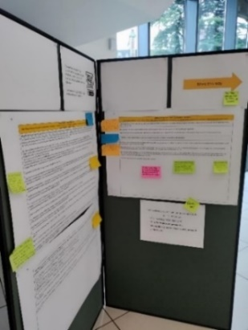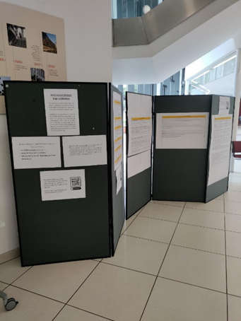
Interactive Exhibition of Anti-Racism Action Plan 2024-29 working draft with our community invited to provide input into its development.
Our aim continues to be the adoption of a whole University approach to race equity. Over the past year, activity across departments and teams has continued to build on the foundations established through our REC submission, deepening reflection on policies, practices and culture, and strengthening collaboration between academic and Professional Services at different stages of their race equity journeys.

This work has sustained important conversations, improved the quality and visibility of our data, and encouraged more intentional integration of race equity into planning and decision making. The Race Equality Implementation Group, chaired by Chris Howorth and championed by Professor Tracy Bhamra (Provost and ProVice Chancellor, Global) remains central to this effort, bringing together insight and activity from across the institution, aligning priorities, and ensuring ongoing leadership and oversight.

Our Anti-Racism Action Plan 2024-29, championed by our Senior Leadership Team, and co-created with our wider community of colleagues and students, comprises five Strategic Priority Areas, aligned with our EDI Framework 2023-28, Athena Swan Action Plan 2023-2028, APP 2024-2029, RH2030s strategy, and vision to become a University of Social Purpose.

A. Enabling progress with race equality and accountability: Anti-racist practice, grounded in an intersectional approach, is embedded in decisions and action-planning across the University with robust progress and impact monitoring in place.
B. Culture, behaviours and belonging: Create a more inclusive anti-racist ‘call it out’ culture through awareness raising and impactful training for all including managers and leaders.
C. Equity in education: All our students, regardless of background and intersecting identities, have equity of opportunity to access and to succeed at University, and progress to the personal, social and economic benefits of higher education.
D. Fair recruitment process: Increase representation of colleagues from BGM backgrounds by removing barriers within our recruitment practices to advance diversity and inclusion.
E. Development and Progression: Create an environment that enables colleagues to succeed through development and progression, ensuring that this contributes to achieving fair representation at all levels and considers intersections of race with other interconnected identities.
F. Underpinning vision – University of Social Purpose: Use education, research, and student experience as a vehicle for social change, striving towards a better and more inclusive society and world for future generations.

Antisemitism and Islamophobia Working Group.
In May 2025 the University launched the Antisemitism and Islamophobia Working Group to coordinate and advance initiatives that foster positive relations on campus in the current geopolitical context, providing the necessary space for informed, balanced and expert-led deliberation.
The group was intentionally designed to bring colleagues together to guide decisions grounded in community understanding and care. The group includes subject experts, lived experience voices, the SU, Chaplaincy, EDI, Student Journey and Senior Leadership Team colleagues, ensuring that a range of perspectives informs every stage of the process. Its remit includes advising on complex issues including incidents and reporting, shaping institutional guidance, and offering guidance on the development of educational resources and training.

In 2025, Black Cultural Archives and Royal Holloway launched the second phase of the Digital Timelines project, part of the University’s five-year partnership that aims to democratise the teaching and learning of inclusive, shared histories for all. This second phase, 'Medicine, Race and Activism', explores the contribution of Caribbean and West African medical professionals to 19th- and 20th-century Britain. At the heart of this collaborative project lies a commitment to fostering a more inclusive understanding of British history, particularly in educational settings.

Image: Lisa Anderson, Director of BCA with Royal Holloway's Giuliana Pieri launching the new partnership in 2023.

Accessible and inclusive campus.
We are continuing to strengthen our support for access and disability inclusion across the University, promoting greater awareness of everyone’s role in making everyday practices accessible and inclusive. We continue to update and promote our Accessibility and Inclusion Hub, which provides colleagues with a central point of reference for all things concerning accessibility and inclusion and encourages them to think about how they could implement it in their work, individually and as a team.
Alongside face-to-face accessibility training, which focuses on hosting inclusive meetings, writing accessible documents and designing accessible webpages, we launched new face-to-face Reasonable Adjustment sessions for managers to help them support colleagues through good practice.
Royal Holloway joined the Hidden Disabilities Sunflower scheme, which enables students and staff with non-visible conditions to discreetly indicate that they may need additional support, understanding or extra time. Sunflower badges can be a helpful invitation to colleagues to offer appropriate assistance, and contribute to creating a more aware, inclusive and respectful campus environment.
We plan to renew our contract with AccessAble to continue mapping out access and inclusion features on our Egham and London campuses to support access for disabled and neurodivergent colleagues and students.

EDI events and celebrations.
Throughout 2024/25 we marked a broad range of diversity dates and heritage months across the University. Highlights included our Disability History Month event with writer and artist Khairani Barokka, who delivered a candid and powerful talk on sustaining long‑term labour in the arts through a disability justice lens. For LGBT+ History Month, the School of Law and The School of Social Sciences hosted a talk centred around trans lived experience, offering colleagues and students an opportunity for open and reflective dialogue. The LGBT+ Staff Network and EDI team also invited Professor Rusi Jaspal who talked about ’Quality of Life among lesbian, gay and bi people’ to mark LGBT+ History month.

Our Parents and Carers Network hosted a dedicated session on Navigating the Care Maze as part of Parent Mental Health Day, offering colleagues practical guidance and peer support. We also delivered a Bollywood dance workshop to mark Diwali, organised collaboratively across academic schools. Together, these events strengthened visibility, understanding and celebration of our diverse University community.
We continue to visually mark diversity months through providing variations on our University logo with guidance for staff on how to use these in email signatures. The image below shows from left to right, logos to mark Disability History Month, Black History Month, Women’s History Month and Pride Month. The logos have also been used as social media avatars across the University’s various platforms:



Pride 2025: extract from internal communications.
“At Royal Holloway we support the recognition of Pride across the country, in line with our values and those of our diverse community of colleagues and students. Year-round, we strongly uphold our principles of dignity, equity, and respect for everyone, with a zero-tolerance policy towards all forms of discrimination and harassment. “
“Particularly in light of the recent Supreme Court ruling on the definitions of sex and woman, which we know has deeply impacted our trans students, colleagues, and allies, we would like to reiterate our full support for our trans and non-binary community, alongside lesbian, gay and bi people. Our long-standing, fundamental commitment to making Royal Holloway a safe, inclusive and supportive environment for all colleagues and students remains unchanged. “
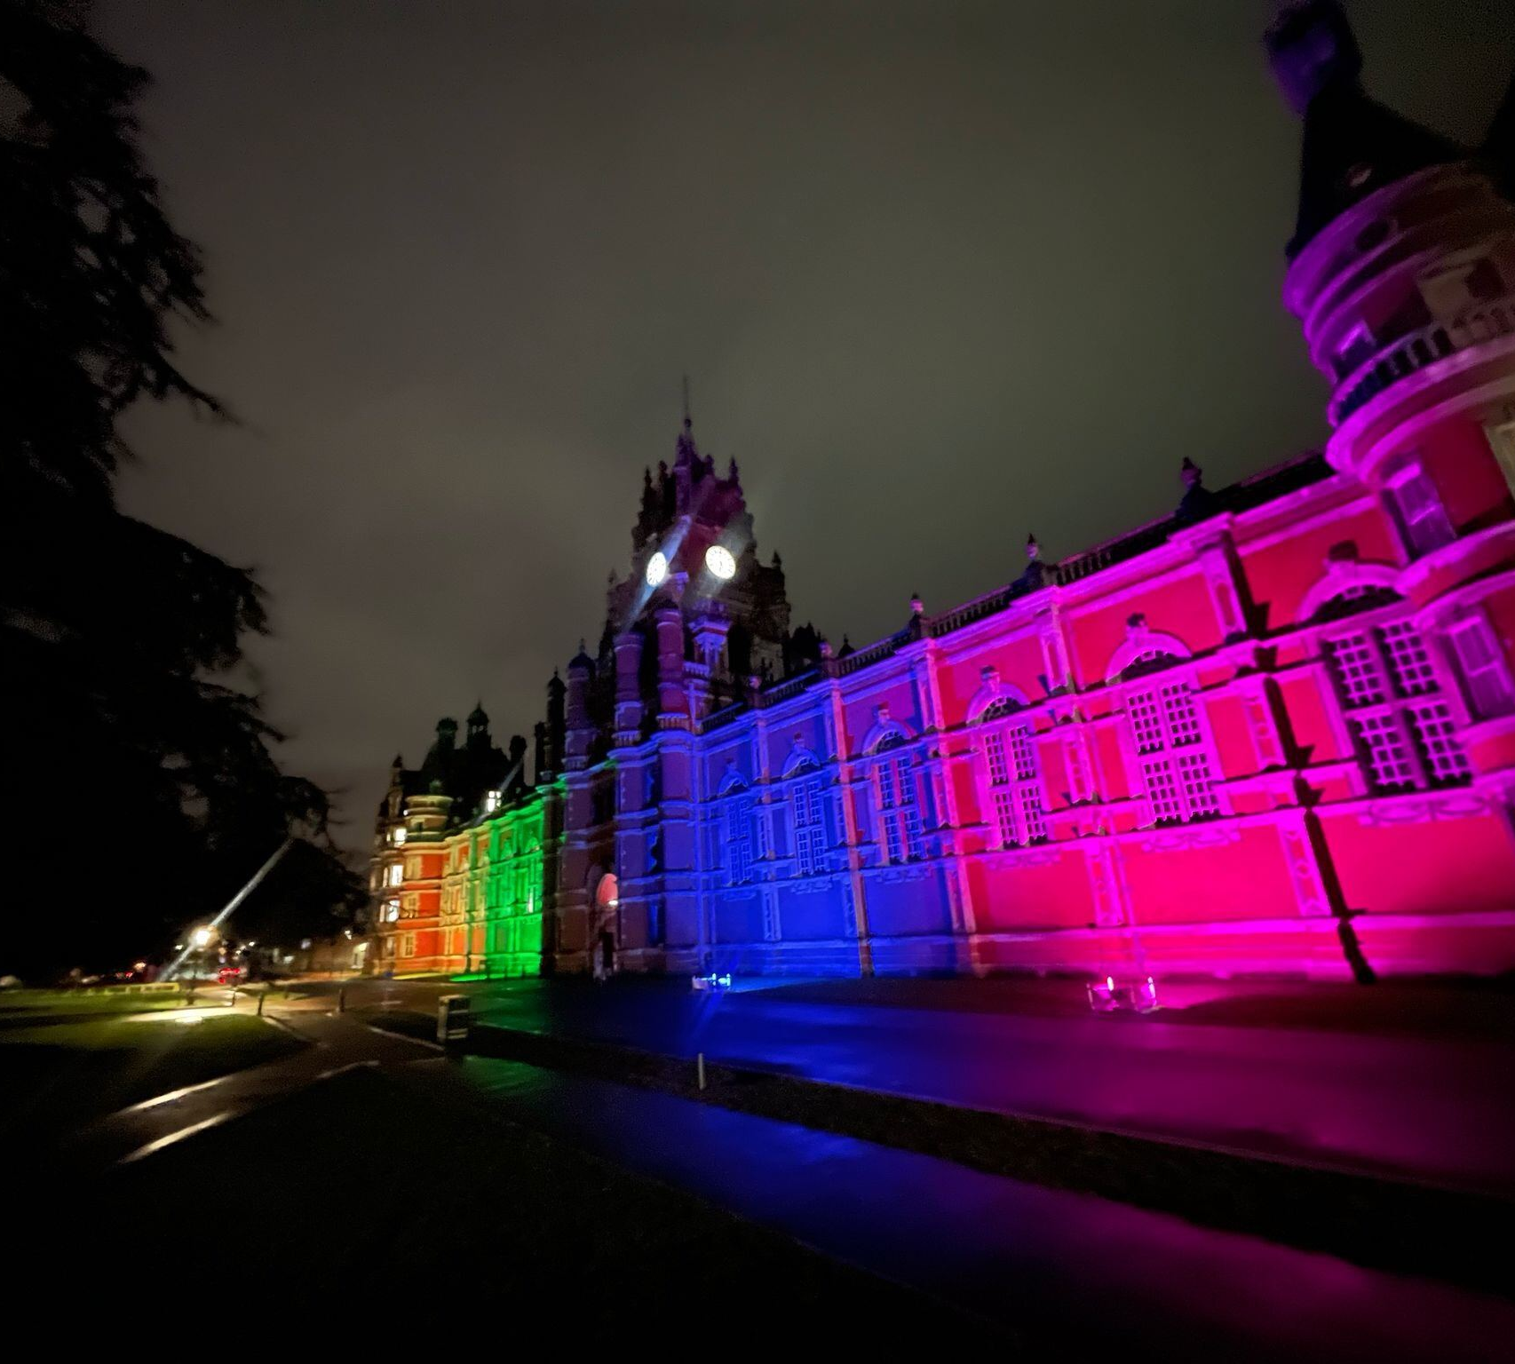
“In these times, events such as Pride hold a particular importance, and we look forward to recognising this month on our Egham campus by a colourful light-up of Founder’s building throughout June, representing colours from the Progress flag.”

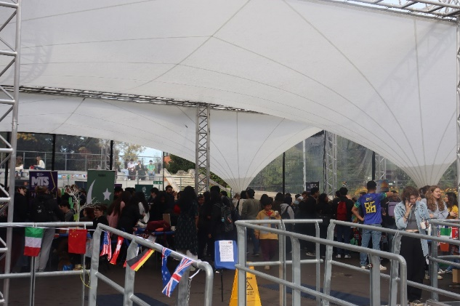
Royal Holloway Festival of Languages and Culture (October 2024)

Mental health and wellbeing.
During 2024/25, we continued to take a University wide, compassionate and proactive approach to supporting the mental health and wellbeing of colleagues and students. Central to this was our focus on strengthening colleagues’ confidence and capability to recognise, understand and respond to mental health needs through high quality training, accessible resources and supportive pathways that prioritise lived experiences.
We expanded our wellbeing training offer with dedicated courses for both line managers and student-facing colleagues. Between October 2024 and June 2025, 91 colleagues in student-facing roles attended Mental Health Awareness sessions, reflecting the strong commitment across our community to supporting students sensitively and signposting them to the right help at the right time. Over the same period, 27 managers took part in Mental Health for Line Managers training, developing their ability to notice early signs of distress, hold kind and constructive conversations, and connect colleagues to appropriate support. In total, these programmes reached 118 people.
To support wellbeing in everyday work, we also helped colleagues weave meaningful wellbeing conversations into Performance Development Reviews (PDRs). By offering prompts, guidance and practical tools, we aimed to help managers create safe, supportive spaces where individuals could reflect openly on their wellbeing alongside their professional development. Alongside this we strengthened our response to stress and workplace pressures. We equipped managers with additional guidance and tools to support empathetic and effective conversations about stress. This approach complements the wider wellbeing offer and helps ensure consistent expectations, compassionate leadership and accessible support across the University.
In 2025, we made it easier for colleagues to access help by redesigning our wellbeing intranet pages. The new site offers a coherent, central hub for information about mental health, physical health, social wellbeing, work-life balance and navigating change. The dedicated Stress Support Hub brings together practical resources on coping with stress, conversation guides, HSE standards, signs to look out for, Individual Stress Risk Assessment templates and clear referral pathways to Occupational Health and the Employee Wellbeing Programme. By creating a well signposted, easy to navigate space, we hope colleagues feel more supported when seeking help for themselves or others.
We also invested in targeted wellbeing activities that offered space for reflection, connection and learning. A series of interactive webinars on stress and burnout (April-July 2025) attracted around 100 colleagues and were highly valued for their relatable content and practical tools. Peer support capacity has been strengthened through the launch of the pilot Dignity Listeners Scheme which launched in 2024/25 and is designed to offer a listening ear and human connection for colleagues who need it; and RH Dignity Voice, an online reporting tool for colleagues, which launched in July 2025.
Throughout the year, we marked several wellbeing awareness days, including Men’s Health (Movember) and Parent & Carer Wellbeing. In May 2025, the inaugural Campus to Campus Walk offered colleagues and students the opportunity to connect, move and enjoy the benefits of time together around campus, supporting wellbeing through shared experience, conversation, physical activity, impactful speaker wellbeing talks and a sense of belonging.
Together, these initiatives reflect our sustained commitment to creating a supportive, inclusive and psychologically safe environment where people feel valued and able to thrive. As we move forward, we will continue aligning this work with the University’s strategic enablers for People, Culture and Inclusion, fostering a community that places compassion, dignity, flexibility and psychological safety at its heart.
In line with the recommendations of the 2026 Internal Audit Report on Staff Wellbeing (PwC), we remain committed to strengthening the governance, transparency and accountability of our wellbeing agenda. Over the coming year, we will embed wellbeing more deeply within existing leadership and governance structures, clarify responsibilities across the People, Culture and Inclusion Plan and ensure our priorities and progress remain visible and accessible to everyone. We will also enhance how we listen, review and report on the effectiveness of our wellbeing activities drawing on colleague feedback, survey insights and operational data to identify emerging needs and address risks. This ongoing commitment reflects our determination to build a healthy, inclusive and supportive community in which all can flourish.

A peri/menopause-friendly University.
We continue to provide support and guidance to colleagues experiencing menopause symptoms in the workplace, through our Peri/menopause Network which launched in November 2022. The University marks World Menopause Day every October. Support sessions offered throughout 2024-25 have included yoga relaxation sessions, a two-part Menopause, Cognition and Nutrition session, with ‘articles of the month’ and a range of resources and guidance, including for managers, on our hub which is updated regularly.
The University hosted a Let’s Talk About Menstruation webinar in March 2025, led by Henpicked, to improve awareness and open conversation around menstruation and menstrual health at work. The session explored what menstruation is, common symptoms, and a range of menstrual health conditions that may impact colleagues. It highlighted how these conditions can affect wellbeing and performance, and why many people feel unable to discuss their needs with managers. Participants were guided on ways to manage symptoms, seek appropriate support, and access workplace and healthcare resources. The event formed part of our commitment to fostering an inclusive, supportive environment for all colleagues.

Fair and inclusive recruitment.

Applicant profile and outcomes.
Throughout 2024/25, the University received 7,541 applications, a 4.4% decrease from 7,887 in 2024. Key patterns in the applicant profile included:

- Gender and nationality remained broadly stable (female 50.6%, male 46.7%; UK and overseas both 50%).
- Ethnicity showed the most notable change, with Black and Global Majority applicants rising to 62.7% (from 54.2%) and White applicants falling to 29.8% (from 41.7%).
- Disability declaration continued to increase (7.5%, up from 6.7%).
- LGBT+ applicants decreased (12.1%, down from 14.1%).
- ‘Prefer not to say’ responses increased for some characteristics, particularly ethnicity and sexual orientation, and should be considered when interpreting year on- -year comparisons.

Analysis of selection outcomes shows that the biggest disparities occur at the shortlisting stage, where international and BGM applicants progress at notably lower rates than other groups. Once candidates are shortlisted, offer rates are broadly consistent across most characteristics. Disabled applicants show a different pattern, progressing well at the shortlisting stage but experiencing slightly lower offer rates at final decision.

We continue working to ensure new colleagues feel equipped and empowered to contribute to a welcoming and supportive culture. We also now include the following text around ‘Values’ in our job description templates:
Advancing equity and inclusion is central to our identity as a University of Social Purpose, guided by our values of being Respectful, Innovative, Open, and Daring. We strive to build a fair and inclusive environment for all colleagues and students, where we challenge ourselves and others with integrity, and approach difference with understanding and kindness. Every member of our community is expected to treat others with dignity, work collaboratively across a wide range of backgrounds and perspectives, and contribute to a place where everyone can participate fully and feel valued.

We continually emphasise the importance of panel diversity in the selection process but see a difference in practices across the University. Panel diversity does not guarantee bias-free interviews, and we have extended training in this area to all panellists where previously only the Chair would have been offered/required to complete this. We are further improving training design to help panels create collaborative and inclusive environments that will enable them to reach fair and unbiased decisions. This includes a focus on counteracting groupthink, supporting less dominant voices, recognising disadvantage built into external systems, and considering a broader range of impact measures.

Next steps.
Our recruitment strategy working group continues to discuss data and will work to address the disparities observed at specific points in the recruitment process, including championing the use of anonymised screening, refining the clarity and consistency of shortlisting criteria, and providing targeted guidance to recruitment panels to support more inclusive and evidence-based decision making.
We will also examine the patterns affecting disabled applicants, who progress well through early stages but experience slightly lower offer rates at final decision. This work will help us understand where in the assessment process these differences arise and ensure that reasonable adjustments and supportive measures are applied appropriately and consistently.
Improving data completeness will remain an important priority, particularly in light of rising ‘prefer not to say’ responses for some characteristics We will increase transparency about how this information is used, and aim to reinforce trust in our processes, to support disclosure.
These insights will be integrated into broader workforce planning and strategic activity, allowing recruitment data to inform actions aimed at addressing underrepresentation and building a more diverse pipeline into senior roles. Continued monitoring of progression through each stage of recruitment will help us evaluate the impact of interventions and identify where further focus is required.

Development and progression.

Academic promotion and career development.
There was no academic promotion round in 2024/25. Instead, the year was dedicated to extensive discussions with colleagues and formal consultation with our recognised trade unions on proposed updates to the promotion framework. This work included reviewing and refreshing the promotion criteria. Colleagues told us they wanted a process that better reflects the variety of academic work, and this feedback has shaped a more flexible and inclusive set of expectations. The revised framework focuses on the impact and outcomes of an individual’s contribution and aims to recognise the full spectrum of academic achievement – whether demonstrated through strong, balanced performance across all areas or through exceptional impact in either education or research.

A major improvement is the move from separate pathways – teaching and research, teaching‑focused, and professional practice – to one integrated set of criteria. These criteria are organised into three core domains:
- Education and Pedagogic Scholarship.
- Research and Knowledge Exchange.
- Leadership and Citizenship.

All academic colleagues will work within this unified structure, strengthening consistency and fairness across roles, providing greater room for individuals to evidence their strengths, and offering a clearer framework to support conversations in Performance Development Reviews (PDRs). For academic colleagues, Royal Holloway is working on new career development initiatives, including the Early Career Researchers Hub and specific sessions for mid-career academics and researchers.
Breaking Barriers: Shaping Inclusive Career Development Opportunities.
As part of Royal Holloway’s Anti‑Racism Action Plan and strategic direction for Research and Innovation, the University launched a new initiative aimed at improving career progression for Black and global majority academic and research colleagues. Led by Professor Ruth Livesey, Pro Vice-Chancellor (Research and Innovation), the initiative seeks to understand the specific barriers affecting these colleagues and to co‑design meaningful professional development support that responds to their lived experiences.
A steering group of ten Black and global majority academics and researchers formed in Spring 2025 to shape the direction of the initiative by sharing insights, identifying institutional and cultural barriers, and helping develop targeted interventions. Participation was supported through a dedicated fund of up to £1,000 per member to contribute to research profile or career development activities.
This initiative complements existing professional development programmes but places an explicit focus on advancing equity, increasing participation, and ensuring that development opportunities reflect the diversity of experiences across the University. Overall, it represents a key step toward creating a more inclusive academic environment and supporting Black and global majority colleagues to thrive at every stage of their careers.
The Gender Institute hosts a range of events, including seminar series and teach-in events exploring a range of themes that intersect with gender. Through 2024-2025, the Gender Institute hosted seven ‘scholar of the month talks’, one round of lightening talks to facilitate grant networking and an international research conference.
The Gender Institute’s programme showcases intersectional, interdisciplinary research on gender, sexuality, embodiment, and power. Its events address how gender is lived, regulated, represented, and contested across diverse social, cultural, political, and technological contexts. Talks span queer identities, trans embodiment, and Black feminism solidarities, disability inclusion, anti‑gender politics, exploring intersections with law, technology, global politics, and human rights.
Together, these events position the Gender Institute as a space for critical dialogue that centres social justice, complexity, and intersectionality, drawing from global, historical, and contemporary perspectives.
The Institute’s signature Go Run Lead programme offers women and non-binary students and colleagues (all levels) training in how to participate in electoral politics and to run for office.

Africa Charter.
Royal Holloway became a signatory of the Africa Charter in October 2024, a framework designed to decolonise knowledge production, strengthen global research relevance, build sustainable research capacity in Africa and promote equitable international partnerships. Signing the Charter supports the RH2030s strategy by deepening global engagement and expanding impactful collaborations. It builds on the University’s longstanding research partnerships across Africa – spanning areas such as environmental economics, social cohesion, sustainable agriculture and conflict related sexual violence – and provides a foundation for more transformative, mutually beneficial research. The Charter aims to give African institutions greater autonomy and capacity to pursue their own research priorities while enabling global partners to contribute to a more just and collaborative research ecosystem. It is supported by a broad coalition of African and international university networks and higher education partners.
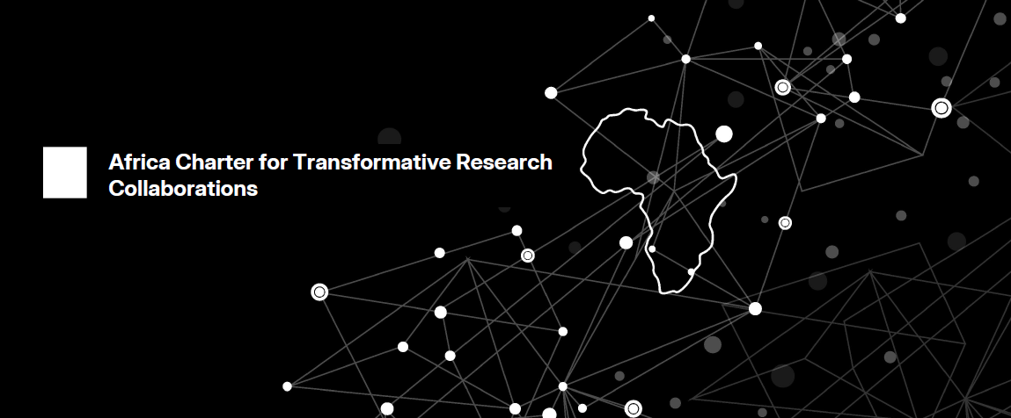

Priorities for 2025/26.
The national and global context for equality, diversity and inclusion continues to shift, with new legal requirements around freedom of speech and the wider effects of global events creating a more complex environment for universities. Against this backdrop, our priorities for 2025/26 focus on deepening community cohesion, strengthening dialogue across differences, and embedding an inclusive culture grounded in trust, respect and understanding.
Key priorities for the year ahead.
- Strengthen constructive dialogue and confidence in navigating diverse perspectives, by developing supportive environments for open discussion and enhancing colleagues’ understanding of the legal and interpersonal frameworks that guide respectful expression.
- Enhance safety, trust and accountability by strengthening preventative measures, improving follow-through on concerns raised, and deepening awareness and respect for the diverse backgrounds, identities and beliefs within our community, ensuring all colleagues and students feel supported and included.
- Reduce inequalities in recruitment and progression, focusing on disparities emerging at shortlisting and assessment stages, improving decision making consistency, and diversifying senior roles across the University.
- Advance student equity, by reducing awarding gaps, strengthening belonging, improving equitable access to careers support, and removing barriers to inclusion at postgraduate level.
Supporting this work.
These priorities will be underpinned by ongoing activity across policy development, data insight, community engagement, training, spaces listening and learning, leadership support and external collaboration. We will continue to refine our approaches based on evolving legislation, evidence and community feedback, and we will strengthen project management to ensure progress is tracked and impact assessed throughout the year.

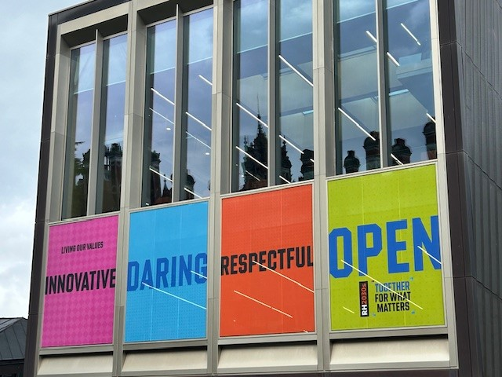
Our new RH Values exhibited on our central Emily Wilding Davison (Library) Building

Appendix 1 EDI Guiding Principles.
Principle
1. Collective responsibility for inclusive culture.
We encourage colleagues and students to take shared ownership of fostering a respectful and inclusive university environment. This includes engaging respectfully with diverse perspectives, supporting one another, and contributing to a culture of openness and belonging.

Developing an inclusive mindset is a shared journey, supported through training, reflective spaces, and everyday interactions. Traits such as open-mindedness, respectful curiosity, cultural competence, kindness, and empathy are cultivated through active listening, working in diverse teams, and developing self-awareness.

Leaders and managers play a key role in sustaining inclusive, collegiate teams. Everyone is encouraged to take responsibility for their own learning and to engage with others respectfully, even when views differ.

We maintain a zero-tolerance approach to bullying, harassment, and discrimination. All members of our community are expected to uphold standards of respectful conduct, and to challenge inappropriate behaviour when it arises - through formal channels or informal peer support.

2. Equality of Opportunity
Equality doesn’t mean treating everyone the same, but acknowledging that people have different and diverse needs, ensuring the playing field is level so that everyone has the opportunity to succeed.

We will recognise and reward EDI labour through processes including PDRs and promotions.

- Commitment to developing an inclusive mindset with the confidence to learn and act, championed by leaders and managers.
The university is committed to supporting staff and students to develop the confidence to engage with new perspectives and the commitment to make a positive impact on university culture.

Formal training opportunities alongside safe conversational spaces are available to encourage people to develop an ‘inclusive mindset’, one characterised by traits including open-mindedness, respectful curiosity, cultural competence, kindness, and empathy. These trains are developed by cultivating an ability to ask questions and listen to answers, working with a diverse team, and self-awareness.

Leaders and Managers play a key role in creating and sustaining a diverse, collegiate and supportive culture within their teams and the university at large and, will be equipped to ensure everyone feels they belong, are engaged and supported to be the best they can be.
Colleagues and students are encouraged to seek out opportunities and take responsibility for ‘self-education’ to understand and value different perspectives, recognise and challenge inappropriate behaviours and maintain a growth mindset.

- Hearing and respecting lived experiences and encouraging diverse perspectives
Truly listening to and valuing the lived experiences of our staff and students is key to enhancing understanding and empathy beyond one’s own lived experience, and identifying meaningful action to take.

Missing perspectives need to be sought out to ensure all (decision-making) spaces include diverse voices, to prevent perspectives being overlooked and to ensure that opinions and decisions are challenged with fair outcomes. This is to be achieved by including more people, rather than overburdening and tokenising existing staff.

- Be aware of multiple overlapping inequalities and integrate intersectionality into practice.
Data will be considered through an intersectional lens so that we can look at multiple characteristics where possible to better acknowledge, understand and address the different and overlapping inequalities that impact our staff and students to ensure nobody falls through the margins. It is also important to seek out and understand the stories and experiences that complement the data, to further help us develop empathy and connectedness and take action.

The concept of intersectionality describes the ways in which systems of inequality based on gender, race, ethnicity, sexual orientation, gender identity, disability, class and other forms of discrimination “intersect” to create unique dynamics and effects.

- Inclusion ‘by design’
Our university takes a mainstreaming approach to accessibility and inclusion, establishing them as central to planning, practices, processes, communication, moving towards inclusivity by design.

Appendix 2 Workforce report (with pay gap reporting).

Introduction.

This rest of this report presents data showing the diversity and representation of salaried colleagues – the group indicated in figure 1 below. The data includes all colleagues with an active contract on 31 July 2025, and therefore includes colleagues on unpaid parental leave and unpaid sickness.

Employment arrangement | Example post titles | July 2023 | July 2024 | July 2025 | HESA return
Salaried contracts | Regular, ongoing employment  Lecturer, manager, administrator, customer services | 1832 headcount (main post only)  1677 FTE  (all posts) | 1893 headcount (main post only) 1747 FTE  (all posts) | 1857 headcount (main post only) 1713 FTE  (all posts) | Yes
Figure 1 – salaried colleagues

This report does not include analysis of hourly paid colleagues, including visiting teachers, as their employment patterns require a different analytical approach. Separate, tailored analysis is needed to understand the specific needs of this group and identify appropriate solutions.
The report gives an overview by protected characteristic, with a snapshot date of 31 July 2025. For organisational location, colleagues are reported according to their primary departmental home rather than their job role, as this provides a more consistent basis for analysis.
We report on colleagues’ sex as defined in the Equality Act 2010 (female/male) as HM Revenue and Customs requires legal sex information to be known for all colleagues. My View, the University’s HR self-service system where colleagues manage and update their personal and employment information, has been updated to capture gender as well as the legal binary definition, and communications have encouraged colleagues to share this and other EDI related information, including whether their gender identity is the same as sex assigned at birth.
This year, fewer than ten colleagues recorded a non-binary gender. To protect confidentiality and avoid inadvertent identification, we are not publishing figures for gender identity. We will keep this under review and will publish more granular analysis if and when it can be done safely and meaningfully.
The term “LGBT+” is used throughout the report, although data relating to sexual orientation does not include gender identity or trans status. The term is used to demonstrate inclusivity of transgender colleagues, even though this data does not demonstrate reflection of transgender representation.

HESA data for 2024/25, accessed via Heidi Plus Gold, has been used as the primary tool for benchmarking. We have conducted our benchmarking by aggregating data from ten institutions comparable to ours in size, geography, and academic focus. This group, informally known as the S10 University Network, includes Brunel, City, East Anglia, Essex, Goldsmiths, Kent, Reading, Sussex, and Surrey. Where characteristics are not included in HESA returns (such as sexual orientation, gender reassignment) we have used the Advance HE statistical report 2024 (covers 2022/23) for benchmarking.
Data sharing principles have been applied, and analysis is not shown for groups where fewer than 10 individuals are represented. For this report the Senior Leadership Team comprising the Vice-Chancellor and Pro Vice-Chancellors has been grouped under Academic Schools and Departments.

Representation by protected characteristics.

Sex.

- Across a five‑year period, the proportion of female colleagues has shown a steady upward trend, increasing from 52.8% in 2021 to 54.0% in 2025, which is lower than the S10 average of 57%.

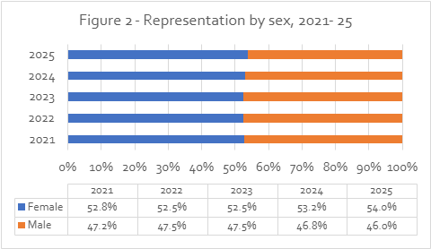

- Female representation across most grades has remained relatively stable over a three year period, with small year on year fluctuations rather than major shifts. Grades 4, 5, 6 and 7 continue to show strong female representation, with only marginal movements each year, and grade 6 consistently recording the highest proportion of women despite a slight dip in 2025.

- At the Professor level, representation has remained almost unchanged, staying around one third female with minimal movement over the three years. Currently at 33.6% we are below the S10 2024/25 benchmark (36%). Grade 10 shows more volatility due to its small cohort size, but overall remains broadly balanced, with female representation returning to 50% in 2025 after a dip in 2024.

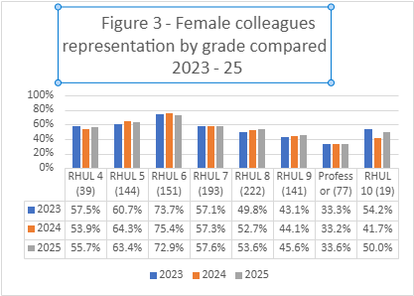
*Numbers in brackets represent staff numbers as at 31 July 2024.

Sex and ethnicity.

- As of 31 July 2025, a slightly higher proportion of female colleagues (23.5%, up from 22.1% in 2024 and 21.7% in 2023) were from a Black and global majority background than male colleagues (22.1%, up from 21.1% in 2024 and 19.2% in 2023).

- This distribution was reflected differently in Academic Schools and departments and in Professional Services. In the former, representation was 26.6% for Black and global majority women (up from 25.8% the previous year, and higher than the 2024/25 S10 benchmark of 25%) and 20.5% for men (up from 19.8%, though lower than the S10 benchmark of 27%). In Professional Services, 24.1% of men were from a Black and global majority background (26.6% in 2024) higher than the 2024/25 S10 benchmark of 21%; and 20.1% of female colleagues (19.0% in 2024), lower than the S10 benchmark at 22%. Overall, the data shows that Black and global majority women are more strongly represented within Academic Schools, while Black and global majority men are more strongly represented within Professional Services.

Trans status.

- This year 13 colleagues (0.7%, up from 0.5% last year) do not identify with their birth gender. Additionally, 27.4% of colleagues did not disclose this information (down from 33.8% last year). Fields relating to gender identity and pronouns were made available within MyView in April 2024 and we are working on communications to encourage colleagues to keep all of their EDI data up to date.

Ethnicity.

- Representation of Black and global majority colleagues has increased from 17.4% in 2021 to 22.7% in 2025 bringing it closer to the S10 benchmark for 2024/25 which is 24%.

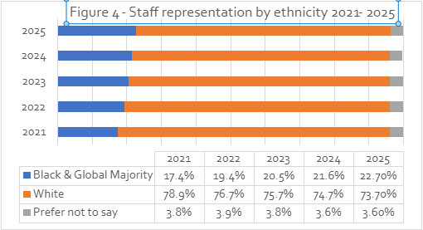

- Within this group (Figure 5a below), Asian colleagues have seen a steady rise (10.2% to 11.5%), exceeding the S10 2024/25 average of 10.0%, while representation of Black colleagues has remained broadly stable (around 2.8–2.9%) below the S10 figure of 4.0%. Chinese representation has shown minimal change and continues to sit just below the sector level of 4.0%. Mixed ethnicity colleagues have decreased slightly (3.1% to 2.5%), now marginally below the S10 3.0%, whereas colleagues identifying with ‘Other’ ethnic backgrounds have risen from 1.4% to 2.3%, although this remains under the sector benchmark of 3.0%.

- The proportion of colleagues with unknown or ‘prefer not to say’ ethnicity has remained stable at 3.6%, significantly lower than the S10 10.0%, suggesting comparatively strong disclosure rates. White colleagues continue to form the majority at 73.7%, though this represents a small decline from 74.7% in 2024. This sits above the S10 figure of 66.0%.

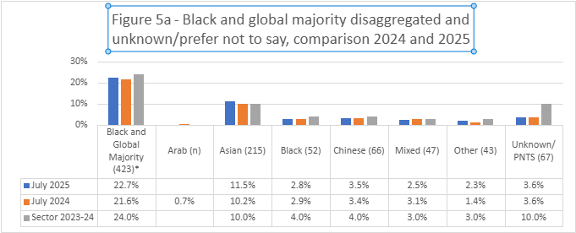

- The increase in representation in Black and global majority colleagues is reflected in Academic Schools and Departments, and in Professional Services. We see an increase in Black and global majority academics from 20.8% in 2023, to 22.5% in 2024 and 23.8% in 2025. The increase in Black and global majority colleagues in Professional Services is from 20.1% in 2023, to 20.6% in 2024 and 21.5% in 2024.

- Figure 5b shows that the proportion of Black and global majority colleagues has increased across most grades from 2023 to 2025, with the largest gains at Grades 4 and 6; Grades 5, 7 and 8 also show steady, smaller rises. Grade 9 improved slightly overall but dipped marginally in 2025, while the professoriate remains largely unchanged at 11.4%, a 0.8pp increase since 2023), lower than the 2024/25 S10 benchmark (17%) indicating progress in the early–mid pipeline but slow movement at the most senior level.

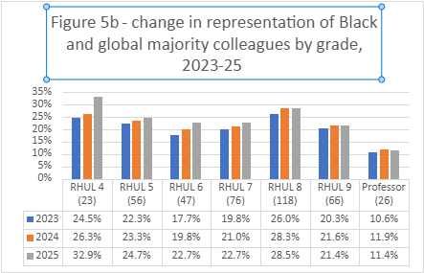
* Actual numbers for population size in 2025 in brackets

- Across 2023-2025, Black and global majority representation among academics shows steady overall improvement (Figure 5c) with a rise at Grade 7 from 20.1% to 26.7%, and Grade 8 from 29.6% to 34.7%, with momentum easing slightly in 2025. Representation in Grade 9 shows small increases from 21.8% to 22.9%. As mentioned above, at Professor representation remains low and dips to 11.2% after an 11.9% 2023/24 peak, lower than the S10 benchmark (17%), indicating that gains at earlier grades are not yet translating into senior progression. Recruitment is diversifying at entry and mid-career levels, but progression, retention and senior hiring need targeted attention to convert these gains into sustained representation at Grade 9 and professorial levels.

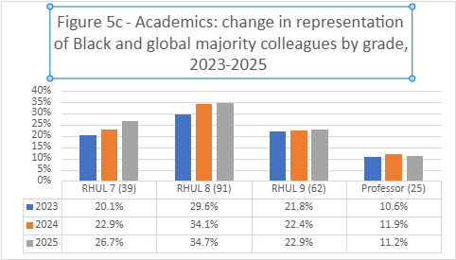

- Professional Services data shows representation is improving at grades 4-6, with steady year on year increases, while grades 7 and 8 remain static or declining slightly.

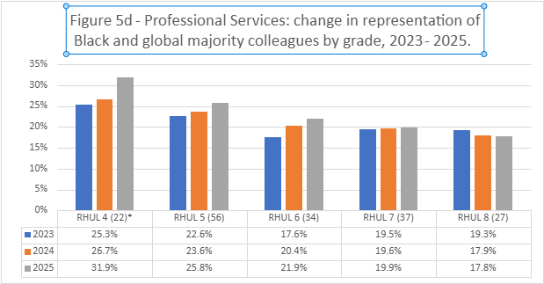

- There were insufficient numbers to report on representation of Black and global majority colleagues at grade 9 and grade 10 in Professional Services, even if the grades are aggregated.

Nationality.
- International representation shows a slow but steady upward trend from 24.9% to 25.8%. Overall, the balance between the two groups has remained relatively consistent over the five year period.

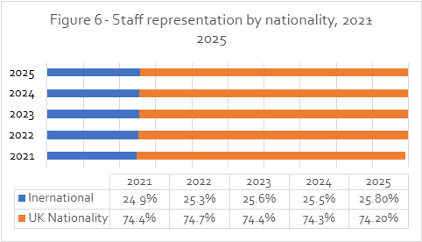

Disability.

- The proportion of colleagues declaring a disability has continued to rise, increasing from 4.6% in 2021 to 6.2% in 2025. This represents the highest level in the five year period and follows the uplift seen in 2024. Over the same timeframe, the proportion of colleagues identifying as not disabled has gradually declined, while the nonreporting rate has remained relatively low and broadly stable, fluctuating between 1.5% and 2%. Although the upward trend in disability declaration is encouraging, the overall figure remains significantly below the S10 sector benchmark (10%), indicating that underreporting and broader structural or cultural barriers to disclosure may still persist.

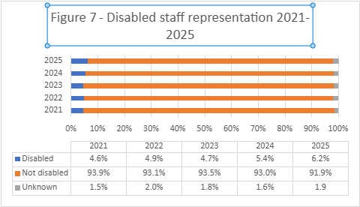

- We see an increase in disabled academic staff from 4.4% in 2024 to 5.4% in 2025 (8% for S10), with non-disclosure remaining relatively steady (2.5% in 2025). For Professional Services, we also see an increase from 6.1% in 2024 to 7.10% in 2025 (S10 is 11%), with a slight increase in non-disclosure (1.1% to 1.4%).

- As in other years, "Long-standing illness/health condition" remains the most commonly declared condition, increasing from 1.4% in 2023 to 2.0% in 2024 and remaining steady at 2.0% in 2025. This is followed by learning differences (0.9% in 2024, very slight rise to 1.02% in 2025) and mental health conditions (0.7%, rising to 0.9%).

- Figure 8 shows changes in the representation of disabled colleagues across four aggregated grade groups, used due to small cohort sizes. As in previous years, the highest proportion of disabled colleagues is found at grades 2, 3 and 4, rising steadily from 8.5% in 2023 to 9.9% in 2025; however, with only 101 colleagues in this group, the numbers remain small and should be interpreted cautiously. Representation increases are also evident at grades 5 and 6 (from 3.5% to 5.1%) and at grades 7 and 8, which show the most marked growth, rising from 5.1% to 7.6% over the same period. In contrast, grades 9, 10 and Professors continue to show the lowest levels of disability representation, remaining broadly stable at around 4.2–4.5%. While the upward trend across most grade groups is encouraging, the persistent gap at senior levels indicates that progression and retention of disabled colleagues into higher‑grade roles remains a key structural challenge.

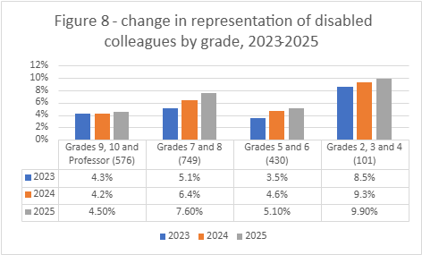

Sexual orientation.

- The proportion of LGBT+ colleagues has continued to rise, reaching 8% in 2025, an increase of 0.9 percentage points since 2024 and building on the steady upward trend observed across previous years. Heterosexual/straight representation has also increased slightly, while the proportion of colleagues who preferred not to record their sexual orientation has continued its year on year decline and now stands at 22.7%. This nonreporting rate remains considerably lower than the most recently reported sector average of 34.7% (Advance HE statistical report covering 2022/23). Overall, the data suggests improving levels of disclosure and growing confidence in recording sexual orientation, alongside continued progress in LGBT+ representation.

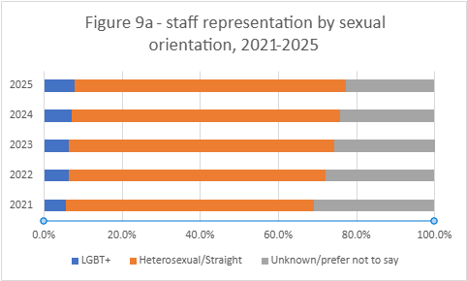

- The proportion of LGBT+ colleagues in academic Schools and departments increased from 8.2% in 2023, to 9.0% in 2024 and 9.7% in 2025, and the non-reporting rate fell from 33.7% in 2023 to 29.1% in 2025. There was a leap in the proportion of LGBT+ colleagues in Professional Services from 4.8% in 2024 to 6.1% in 2025, with the reporting rate remaining relatively stable.

- Figure 9b shows representation of LGBT+ colleagues across the three aggregated grade groups. This year, the most notable increase is at grades 7 and 8, rising from 7.8% in 2024 to 9.3% in 2025. Representation at grades 5 and 6 has also continued to increase, reaching 7.4%, compared with 6.2% the previous year. In contrast, grades 9, 10 and Professor show a slight decrease from 7.4% to 7.1%, following last year’s growth. Overall, the data indicates strengthening representation in the mid-career grades, with more modest movement at senior levels.

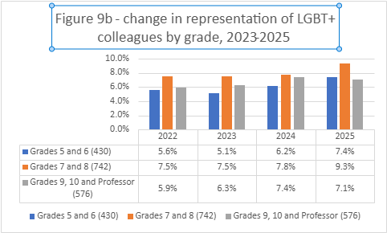
*Numbers in brackets relate to staff numbers as at 31 July 2025
- The disaggregated data for sexual orientation shows that 69% of colleagues identify as heterosexual/straight, 3.3% identify as gay or lesbian, and 3.3% identify as bisexual. A further 1.3% of colleagues fall under a merged “other” category, which includes those identifying as asexual, queer, ‘in another way’ or who prefer to self-describe (combined due to small numbers). Additionally, 22.7% of colleagues chose not to disclose their sexual orientation.

Age.

- We continue to see only minor fluctuations across age groups, with no prominent shifts over the period. Compared with 2024, there is a modest increase in the 51–60 group (24.6% to 26.1%), while the <30 and 41–50 groups dip slightly (11.6% to 10.9% and 28.1% to 27.8% respectively). The 31–40 group remains broadly stable (24.0% to 24.3%), and the 61+ group edges down marginally (11.6% to 10.9%). Overall, the distribution remains steady, with a small uptick in the 51–60 band.

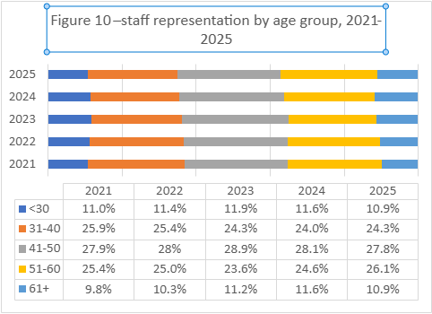

Religion and belief.

- At 38%, the proportion of colleagues who declare a religion or belief was slightly lower to the proportion who declare no religion or belief (40%). 22% of colleagues prefer not to say, slightly lower than 2024 (23%).

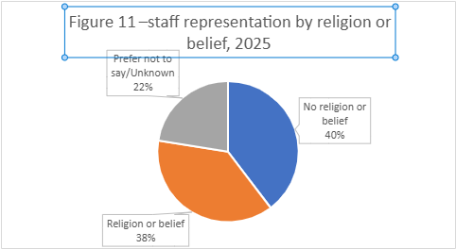

- The largest representation was of Christian colleagues (25.4%) followed by Muslim (4.1%), Hindu (3.0%), Spiritual (1.3%), any other religion or belief (1.1%), Sikh (1.0%) and Buddhist (1.0%), and Jewish (0.8%).

 | No religion or belief | Christian | Muslim | Hindu | Any other religion/ belief | Spiritual | Buddhist | Jewish | Sikh | Prefer not to say
2025 | 39.70% | 25.40% | 4.10% | 3.00% | 1.10% | 1.30% | 1.00% | 0.80% | 1.00% | 22.50%
2024 | 38.9% | 25.5% | 4.0% | 3.0% | 1.0% | 1.6% | 0.8% | 0.8% | 1.1% | 23.3%
2023 | 38.6% | 25.4% | 3.8% | 2.5% | 0.7% | 1.4% | 0.9% | 1.0% | 1.0% | 24.7%
2022 | 36.8% | 25.6% | 3.4% | 2.3% | 0.8% | 1.1% | 0.7% | 1.0% | 1.0% | 27.3%
Figure 12 Representation across religion

Marital status.

- 43.2% of colleagues have recorded that they are married, and 1.0% that they are in a Civil Partnership. 17.2% of colleagues have not answered this question.

Factors which influence representation.

- The following sections of this report focus on staff turnover, recruitment and promotion, all of which influence representation within the University. This data indicates where changes to practice may help increase the diversity and representation across grades within the workforce.

Staff turnover.

- Overall turnover has steadily declined over the three year period, falling from 14.1% in 2022–23 to 11.3% in 2023–24, and then to 9.1% in 2024–25. Most demographic groups follow this downward trend, though the pace varies. Female turnover dropped notably in the first year and then levelled off, while male turnover reduced initially before rising again in 2024–25. The differences between BGM and White staff have narrowed over time, as both groups have seen reductions, with the largest improvement occurring among BGM colleagues. A similar pattern is visible for sexual orientation: both LGBT+ and heterosexual/straight staff show a clear decline in turnover year on year, and by 2024–25 the rates for the two groups are identical, indicating no remaining gap for that year.

- Across disability status, the data show more fluctuation. Disabled staff experienced particularly high turnover in 2022–23 but saw a marked improvement over the following two years, bringing them closer to the rate of nondisabled staff by 2024–25, though a small difference remains. When comparing organisational areas, both Academic Schools and Professional Services have shown consistent year on year improvement, with Academic Schools seeing the largest overall reduction. Taken together, the data point to a positive overall trajectory in turnover, with several previously wider disparities narrowing over time, including the complete alignment of LGBT+ and heterosexual/straight turnover in the most recent year.

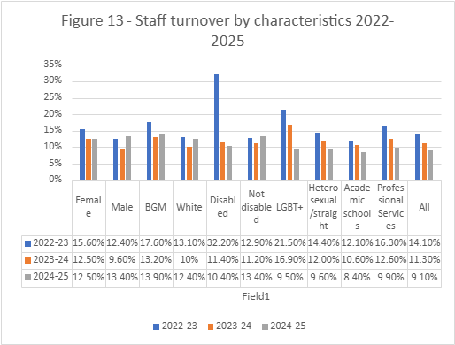

- Overall turnover declines from 14.1% in 2022–23 to 9.1% in 2024–25, with the lowest rates consistently in the 41–60 age bands and a steady improvement in 31–40. The highest and most variable rates are at ‘30 and under’ which remains elevated (27% in 2024/25) while 61+ increases sharply to 27.0% in 2024/25 after two lower years.

Recruitment.

- The University attracts a diverse set of applications from across different protected characteristics. The full applicant profile is shown below in figure 15.

- A total of 7,541 applications were received in 2025, compared with 7,887 in 2024 (a reduction of 346 applications, 4.4%). The gender distribution of applicants was stable year on year, with 50.6% identifying as female and 46.7% as male; gender nondisclosure increased slightly to 2.7%. Applicant nationality was evenly split between UK (50.0%) and overseas (50.0%), continuing the longer term shift since 2023 toward a higher proportion of UK applicants.

- The most significant shift in applicant composition relates to ethnicity. In 2025, 62.7% of applicants identified as Black and global majority, compared with 54.2% in 2024 (+8.5 pp), while the proportion identifying as White reduced from 41.7% to 29.8% (−11.9 pp). At the same time, ethnicity non-disclosure increased, with “prefer not to say” rising from 4.1% to 7.4%.

- Disability declaration increased from 6.7% in 2024 to 7.5% in 2025 (and 5.1% in 2023), suggesting a continued improvement in disclosure and/or changes in the applicant pool. Sexual orientation data shows 12.1% of applicants identified as LGBT+ in 2025, down from 14.1% in 2024 but broadly consistent with 2023 (12.3%). Sexual orientation remains the area with the highest non-disclosure, with 9.4% selecting “prefer not to say” (up from 8.6% in 2024), which should be considered when interpreting trends.

Characteristic | 2025 |  | 2024 |  | 2023
Characteristic | Number of applicants 2025 | % of applicants 2025 | Number of applicants 2024 | % of applicants 2024 | % of applicants 2023
Female | 3817 | 50.6% | 4027 | 51.1% | 47.8%
Male | 3522 | 46.7% | 3692 | 46.8% | 49.9%
Prefer not to say | 202 | 2.7% | 168 | 2.1% | 2.3%
Black and global majority | 4731 | 62.7% | 4274 | 54.2% | 51.7%
White | 2250 | 29.8% | 3285 | 41.7% | 39.0%
Prefer not to say | 560 | 7.4% | 327 | 4.1% | 9.3%
Overseas | 3771 | 50% | 3883 | 49.2% | 54.2%
UK | 3770 | 50% | 4003 | 50.8% | 44.8%
Disabled | 563 | 7.5% | 525 | 6.7% | 5.1%
Not disabled | 6584 | 87.3% | 6995 | 88.7% | 90.7%
Prefer not to say | 394 | 5.2% | 367 | 4.7% | 4.2%
LGBT+ | 914 | 12.1% | 1110 | 14.1% | 12.3%
Heterosexual | 5916 | 78.5% | 6095 | 77.3% | 77.1%
Prefer not to say | 711 | 9.4% | 682 | 8.6% | 10. 6%
.
Figure 15 – Applicant profile 2025

- Analysis of selection outcomes by protected characteristics (Figure 16a) shows that the most significant differences occur at the shortlisting stage, where some groups progress at notably lower rates than others. International applicants experience the lowest shortlisting rate (8.9%), followed by Black and global majority applicants (11.2%). In contrast, White (19.9%) and UK applicants (18.6%) have the highest shortlisting rates. This indicates that the principal point of divergence in outcomes sits early in the recruitment process, during application screening.

Shortlisting rate (100% minus Not shortlisted)
White | 19.9% (highest)
UK | 18.60%
Disabled | 16.90%
Women | 15.60%
LGBT | 15.90%
Straight | 13.40%
Not disabled | 13.30%
Men | 11.90%
BGM | 11.20%
International | 8.9% (lowest)
Figure 16a Shortlisting rates across characteristics

- Differences at the offer stage, after shortlisting, are considerably smaller (Figure 16b). Offer rates from shortlisted candidates fall within a narrower range, from 25.8% to 34.8%. Black and global majority applicants, despite lower progression at shortlisting, have the highest conversion rate once shortlisted (34.8%); international applicants have the lowest (25.8%). Disabled applicants show a relatively strong shortlisting rate (16.9%, noting that all disabled candidates who fulfil the essential criteria are shortlisted)) but a lower offer conversion rate compared with nondisabled candidates (26.0% compared with 30.8%), suggesting that disabled applicants experience disadvantage for this group later in the process.

- Overall, the data suggests that the key disparities affecting ethnicity and nationality emerge before interview, whereas for disability variation appears during assessment and decision stages. Gender and sexual orientation differences are present but comparatively small at each stage. These patterns indicate a need to explore the consistency of screening criteria, and the accessibility and inclusivity of assessment methods for shortlisted candidates.

- At the intersection of domicile and ethnicity, there is a clear pattern in shortlisting outcomes (Figure 17). UK White applicants have the highest shortlisting rate (25.6%), followed by UK BGM applicants (15.9%), while both International groups have noticeably lower rates. Among International applicants, White candidates are shortlisted at 13.40%, compared with only 6.61% for International BGM applicants, making this the lowest performing group.

- Even when we remove ‘right to work’ considerations, which could otherwise explain some of the international differences, the pattern remains almost identical. Specifically, within the right to work eligible international pool, International White applicants are shortlisted at 13.67%, while International Black and global majority applicants are shortlisted at 6.84%, meaning White applicants continue to be around twice as likely to progress.

- Overall, this intersectional view shows that the combined effect of being both International and Black and global majority is linked to the lowest shortlisting likelihood, and that this persists even after controlling for eligibility factors such as right to work. This suggests that other elements of the shortlisting process may be influencing outcomes for candidates in this group.

- Figure 18a provides a helpful illustration of who is receiving offers across the years providing a comparison with respective staff proportions in each year, and a clear pattern emerges across several characteristics. In 2025, offers were made in higher proportions to Black and global majority applicants, international applicants, disabled applicants, LGBT+ applicants, and women compared with their current representation within the workforce. Taken together, this suggests that recruitment is beginning to shift the organisation’s demographic profile in a more diverse direction. The pace of change is not uniform across all groups, but the overall trend indicates that new entrants are gradually broadening the diversity of the workforce and helping to build a more representative organisation over time.

Characteristic | Offer profile |  |  | Staff proportion
Characteristic | 2023 | 2024 | 2025 | 2023 | 2024 | 2025
Female | 58.5% | 57.1% | 60.0% | 52.5% | 53.2% | 54.0%
Male | 39.7% | 38.6% | 38.0% | 47.5% | 46.8% | 46.0%
Total | 100% | 100% | 100% | 100% | 100% | 100%
Black and global majority | 27.6% | 29.6% | 59.0% | 20.5% | 21.6% | 22.7%
White | 65.0% | 66.9% | 40.0% | 75.7% | 74.7% | 73.7%
Prefer not to say | 7.4% | 3.5% | 2.0% | 3.8% | 3.6% | 3.6%
Total | 100% | 100% | 100% | 100% | 100% | 100%
International applicant | 29..0% | 26.3% | 27.7% | 25.6% | 25.5% | 25.8%
UK applicant | 71.0% | 73.7% | 72.3% | 74.4% | 74.5% | 74.2%
Total | 100% | 100% | 100% | 100% | 100% | 100%
Disabled | 7.3% | 8.6% | 8.4% | 4.7% | 5.4% | 6.2%
Not disabled | 88.1% | 84.8% | 87.5% | 93.5% | 93.0% | 91.9%
Prefer not to say | 4.6% | 6.6% | 4.1% | 1.8% | 1.6% | 1.9%
Total | 100% | 100% | 100% | 100% | 100% | 100%
LGBT+ | 10.4% | 15.1% | 14.2% | 6.4% | 7.1% | 8.0%
Heterosexual | 65.4% | 75.0% | 76.5% | 68% | 68.8% | 69.3%
Prefer not to say | 24.2% | 9.9% | 9.3% | 25.7% | 24.1% | 22.7%
Total | 100% | 100% | 100% | 100% | 100% | 100%
Figure 18 comparison offer profile and staff proportion

- Recruitment to senior posts – Grades 8, 9 and Professor for academic schools and departments, and Grades 8, 9 and 10 in Professional Services – has been examined in more detail, with data for these grades aggregated for reporting purposes.

Sex.

- For senior academic posts (grades 8, 9 and Professor), 34.4% of applicants were female. This represents a slight decrease compared with the previous year (38.3%) but remains higher than the year before that (32.8%).

- Female academic applicants continued to experience higher success rates at key recruitment stages. Women were shortlisted at a rate of 12.7% of applicants, compared with 6.2% of male applicants. Of those shortlisted, 34.2% of women were made an offer, compared with 23.5% of men. Overall, 4.3% of women applicants received an offer, compared with 1.5% of male applicants.

- Professional Services also has a lower proportion of female applicants for grades 8, 9, and 10, at 44.4%, though higher than in 2023/4 which was 39.5%. Women also demonstrate higher success rates at all stages of the recruitment process. Of those who applied, 26.8% of women were shortlisted compared to 17.1% of men. Among those shortlisted, 29.1% of women received offers, while 18.3% of men were offered a position. Overall, 7.9% of female applicants secured roles, whereas 3.1% of male applicants were successful.

Ethnicity.
- Applications for academic posts at Grades 8, 9 and Professorial level from Black and global majority candidates have remained high and continue to rise over time. In 2024/25, 65.5% of applicants were from Black and global majority backgrounds, compared with 60.9% in 2023/24, 61.8% in 2022/23, and 48.9% in 2021/22. This demonstrates a sustained and positive trend in the diversity of the applicant pool for senior academic roles. However, disparities remain evident in progression through the recruitment process.

- Shortlisting rates for academic candidates continue to show a clear gap. In 2024/25, only 6.7% of Black and global majority applicants were shortlisted, down from 8.4% last year, compared with 13.6% of White applicants (down from 20.3%). While both groups saw reductions compared with the previous year, the relative difference between them persists. Notably, the pattern shifts at the offer stage. Among shortlisted candidates, 33.8% of Black and global majority applicants received an offer, compared with 25.0% of White applicants. This represents a significant change from last year, when 18.8% of shortlisted BGM candidates received offers compared with 26.7% of White candidates.

- Despite this stronger conversion rate at the final stage for Black and global majority academic candidates, overall offer rates remain uneven because fewer candidates reach shortlist. In total, 2.3% of all Black and global majority applicants received an offer (up from 1.6% last year), compared with 3.4% of White applicants (up from 5.4% last year). This indicates that while interview and final-stage decisions appear positive for Black and global majority candidates, the shortlisting stage continues to present a key barrier to equitable outcomes across the full recruitment pipeline.

- For Professional Services posts at Grades 8, 9 and 10, 61.7% of applications (410 applicants; up from 40.9% and 272 applicants last year) came from Black and global majority candidates. In contrast, 31.9% of applications (212 applicants; down from 51.3% and 393 applicants last year) came from White applicants. However, success rates for Black and global majority candidates were significantly lower at every stage of the recruitment process. Only 14.4% of Black and global majority applicants were shortlisted, compared with 35.8% of White applicants. Among those shortlisted, 28.8% of Black and global majority candidates received an offer (an increase from 19.2% last year), which represents 4.1% of total Black and global majority applicants (up from 3.1% last year). For White applicants, 23.7% of shortlisted candidates received offers (27.2% last year), equating to 8.8% of all White applicants, broadly consistent with the previous year.

Sexual orientation.
- Analysis of recruitment to senior posts by sexual orientation is constrained by small numbers, so data for Grades 8, 9, 10 and Professor were aggregated to provide an overview. LGBT+ applicants comprised 9.3% of the applicant pool, slightly below last year (10.4%) but above the previous year (8.8%), with non‑reporting at 10.5% (9.6% last year; 11.1% the year before). As in previous years, LGBT+ candidates were more likely to be shortlisted than heterosexual applicants (12.1% vs 7.5%, both down from 16.9% and 15.3% respectively). At the final stage, LGBT+ candidates converted to offers at a lower rate than heterosexual candidates (37.0% vs 44.1%), yet their higher shortlisting rate produced a higher overall offer‑to‑applicant rate for LGBT+ applicants (4.5% vs 3.3%). Results should be interpreted with caution given small numbers and the level of non‑reporting

Disability.
- Analysis of recruitment to senior posts in relation to disability is also difficult because of small numbers. Data in relation to disability for recruitment to all posts at grades 8, 9, 10 and Professor was aggregated to create a picture of the current position. It shows that shortlisting rates for disabled applicants (13.6%) were slightly higher than for non-disabled candidates (11.8%), a similar picture to last year and disabled applicants had similar offer rates to non-disabled applicants (27.8%, and 26.5% respectively). At the same time, 3.8% of disabled applicants, and 3.1% of non-disabled applicants were made offers.

Professional Services progression.

- Upward grade changes for colleagues in Professional Services over a single year has been analysed through comparing the snapshot population on 31 July 2024 with that of 31 July 2025. Colleagues who left the University over the course of the year were removed (112), and of the remaining 745 colleagues it was found that 26 had progressed to a higher grade (3.0%). 53.8% were female (down from 61.8% last year) and 46.2% male.

- In the same year there were 78 new starters in Professional Services. As the number of promotions is small it is not possible to split these figures out by grade. In 2024-25, 25% of movements into each grade came from promotions (down from 31.4% last year) and 75% from recruitment.

Pay gaps.

- The Equality Act 2010 (Gender Pay Gap Information) Regulations 2017 introduced an annual duty on all employers with more than 250 staff to publish information relating to the gender pay gap: the difference between the average hourly pay of male and female colleagues within the workforce. Information is required each year as of a snapshot date of 31 March. Employers are also required to show the gender distribution for the workforce, divided into four pay quartiles. Under the Employment Rights Act 2025, action plans to reduce an organisation’s gender pay gap will become mandatory from Spring 2027 (for employers with 250+ staff), subject to secondary legislation.

- The gender pay gap is a different measure to ’equal pay’ which refers to male and female colleagues in the same employment doing the same work receiving the same pay. The gender pay gap highlights the gender distribution in different roles at the University. Royal Holloway is committed to equity and inclusion, and to becoming an anti-racist university. Although this is not yet a mandatory requirement, since 2021 we have also reported our ethnicity and disability pay gaps, based on the same data and methodology as calculating the gender pay gaps, and we now have five years’ worth of data in relation to these measures. We do not produce the same statistics for LGBT+ pay gaps because the non-reporting rate for sexual orientation is high – 22.7% in 2025. As pay gaps are overall workforce data statistics, the absence of this information means that any figure produced would be inaccurate and could be misleading.

- For the purposes of mandatory reporting, these calculations include the whole workforce including those on hourly paid contracts, many of whom are student casual workers. Figure 19 below shows the staff numbers involved for each group over the last three years. Colleagues who “prefer not to say” are not included within these figures.

 | 2023 | 2024 | 2025
Female | 1701 | 1795 | 1656
Male | 1325 | 1308 | 1270
Black and global majority | 726 | 763 | 698
White | 2193 | 2231 | 2112
Disabled | 171 | 176 | 179
Non-disabled | 2803 | 2847 | 2677
Figure 19 –staff numbers in pay gap reports, as at 31 March in 2023, 2024 and 2025

- The mean pay rate (or average) is calculated by adding up the hourly rates of all colleagues and dividing the figure by the number of colleagues. The mean pay gap is the percentage difference between the mean pay of different groups of colleagues, for example female and male.

- The median pay gap (or midpoint) is the figure that falls in the middle of a range, so if all the hourly rates of every individual are lined up from smallest to largest, the median pay is the one that falls in the middle. The median pay gap is the percentage difference between the median hourly pay of different groups of colleagues, for example female and male.

Gender pay gaps.

- Figure 20 below shows the gender pay gaps as of 31 March 2025, and the change in these gaps since March 2021.

 | 2021  (%) | 2022  (%) | 2023  (%) | 2024  (%) | 2025  (%)
Gender pay gap mean pay rate | 19.3 | 17.6 | 15.2 | 17.9 | 15.7
Gender pay gap median pay rate | 18.6 | 15.4 | 14.7 | 19.1 | 17.1
Figure 20 –gender pay gaps, 2021 - 2025

- In 2025 the mean gender pay gap fell by 2.2 percentage points since the previous year and the median by 2 percentage points. The reasons for this change are explained below (points 62 to 67). These reductions come after a rise in both pay gaps in 2024 caused by a significant change in the number of female colleagues in the lower pay quartile.

Gender representation.

- Figure 21 shows the representation of male and female staff within four pay quartiles. It demonstrates that for Royal Holloway, there is a higher proportion of males in higher paid roles than females, and a higher proportion of females in lower paid roles than males. It is this imbalance that produces the gender pay gap.
Figure 21 – gender distribution by pay quartile, 31 March 2025

- The overall gender distribution in March 2025 was 56.6% female and 43.4% male. This represents a 1.2 percentage point decrease in the proportion of female colleagues. This decrease is reflected in falls in both the lower pay quartile (by 3.7 percentage points) and in the upper middle quartile (by 2.4 percentage points). This is balanced by an of 1 percentage point in the representation of female colleagues in the upper pay quartile.

- The lower quartile includes 75.2% of colleagues who are employed on a casual contract, many of whom are students. The size and distribution of the casual workforce fluctuates each year, and this can have a significant impact on pay gaps. This year, the number of female colleagues on a casual contract fell by 13.5%, while the number of male colleagues on a similar contract rose by 0.9%. This, along with the increase in female colleagues in the upper pay quartile, has driven the decrease in the gender pay gap across the whole University.

- It is noticeable that the gender distribution in the two middle quartiles is much more balanced in line with the overall distribution of female colleagues of 56.6%. The proportion of female colleagues in the upper middle quartile is only 1.3 percentage point lower than the overall distribution, and in the lower middle quartile only 3.2 percentage points higher. The changes in distribution in the lower and upper quartile are the most significant influence on the pay gaps.

Figure 22– Female distribution by pay quartile, 2021 - 2025

- Figure 22 above shows how the representation of female colleagues has changed across the last five years of gender pay gap reporting. There has been slow but consistent growth in the number of female colleagues in the upper pay quartile, which in 2025 increased to 42.9%. This is the largest increase in the proportion of female colleagues in the upper pay quartile since 2022.

- A bigger rise over time in the proportion of female colleagues in the upper middle pay quartile has fallen back a little in 2025, while the proportion of women in the lower middle pay quartile has changed little in the last five years. In the lower quartile we see bigger fluctuations. For the gender pay gap to decrease, the distribution of female colleagues across all four pay quartiles needs to be more even and reflective of the overall representation of female colleagues at 56.6%.

Gender bonus gap.

- This analysis relates to awards made under the University’s annual performance awards scheme. Analysis of gender bonus gaps indicates that the mean gap was 13.3% in favour of female colleagues in 2025, whilst the median was 0%. A greater proportion of female colleagues received a bonus (1.6%) compared to male colleagues (1.1%). Bonuses are small in number and as a result gaps fluctuate significantly each year.

 | 2021  (%) | 2022  (%) | 2023  (%) | 2024  (%) | 2025  (%)
Mean Gender Bonus Gap | 4.5 | 35.3 | -25.3 | 7.7 | -13.3
Median Gender Bonus Gap | 0.0 | 0.0 | 0.0 | 0.0 | 0.0
Figure 23 – gender bonus gaps 2021 - 2025

 | 2021  (%) | 2022  (%) | 2023  (%) | 2024  (%) | 2025  (%)
Male employees receiving a bonus | 5.9 | 2.8 | 1.2  (n=16) | 0.8  (n=11) | 1.1  (n=14)
Female employees receiving a bonus | 3.9 | 3.5 | 2.3  (n=39) | 1.7  (n=30) | 1.6  (n=27)
Figure 24 –bonus distribution by gender, 2021 – 2025 (n= number of individuals)

Ethnicity pay gaps

- Figure 25 shows that in 2025, the mean ethnicity pay gap was 12.0%, a fall of 0.9 percentage points since 2024. The median pay gap was 10.2%, a rise of 4 percentage points since 2024.

 | 2021  (%) | 2022  (%) | 2023  (%) | 2024  (%) | 2025  (%)
Ethnicity pay gap mean pay rate | 12.6 | 12.2 | 12.8 | 12.9 | 12.0
Ethnicity pay gap median pay rate | 12.1 | 15.0 | 11.4 | 6.2 | 10.2
Figure 25– ethnicity pay gaps, 2021 - 2025

Ethnicity representation.

- Figure 26 shows the representation of White and Black and global majority colleagues within four pay quartiles, giving indications as to why we have pay gaps, and why they have changed between 2024 and 2025.

Figure 26 –pay quartile distribution by ethnicity, 2025
- The overall ethnicity distribution is 75.2% White (up from 74.5% in 2024) and 24.8% Black and global majority (down from 25.5% in 2024). This decrease in Black and global majority representation is reflected in all quartiles except for the lower middle pay quartile, and is most pronounced in the lower pay quartile, where the representation of Black and global majority colleagues fell by 3.5 percentage points.
Figure 27 – Black & global majority colleagues pay quartile distribution 2021 - 2025

- The upper quartile holds 27.5% of all White colleagues and 17.3% of all Black and global majority colleagues. By contrast the lower quartile holds 23.4% of all White colleagues and 29.9% of all Black and global majority colleagues. This difference is a key factor in our ethnicity pay gaps.

- Growth in representation of Black and global majority colleagues in the lower quartile and the upper middle pay quartile both fell in 2025, by 3.5 and 2.1 percentages points respectively between 2024 and 2025. Representation also fell in the upper quartile, but by a much smaller amount (0.7 percentage points). The balance of these factors is likely to have caused the small fall in the mean pay gap, from 12.6% to 12.0%. In 2025, 57.4% of Black and global majority colleagues were in the lower and lower middle pay quartiles, compared to 55.8% in 2024. This factor is likely to have contributed to the rise in the median ethnicity pay gap.

Ethnicity bonus gaps

- Analysis of ethnicity bonus gaps indicates that the mean gap was 16.5% in 2025, whilst the median was 0%. A greater proportion of White colleagues received a bonus (1.5%) compared to Black and global majority colleagues (1.4%). Bonuses are small in number, and as a result gaps fluctuate significantly each year. Ethnicity bonus gaps could not be reported in 2024 due to low numbers.

 | 2021  (%) | 2022  (%) | 2023  (%) | 2024  (%) | 2025  (%)
Mean Ethnicity Bonus Gap | 8.2 | 26.8 | 8.9% | - | 16.5%
Median Ethnicity Bonus Gap | 0.0 | 0.0 | 0.0 | - | 0.0
Figure 28 – ethnicity bonus gaps 2021 - 2025

 | 2021  (%) | 2022  (%) | 2023  (%) | 2024  (%) | 2025  (%)
White employees receiving a bonus | 5.3 | 3.6 | 2.0  (n=44) | - | 1.5  (n=31)
Black and global majority employees receiving a bonus | 3.1 | 2.1 | 1.4  (n=10) | - | 1.4  (n=10)
Figure 29 –bonus distribution by ethnicity, 2021 – 2025

Disability pay gaps

- In 2025, the mean disability pay gap was 11.9%, an increase of 8.1 percentage points since 2024. Having been zero in 2024, the median disability pay gap rose to 11.1%. Disability bonus gaps are not shown due to low numbers.

 | 2021  (%) | 2022  (%) | 2023  (%) | 2024  (%) | 2025  (%)
Mean disability pay gap | 8.5 | 10.0 | 5.3 | 3.8 | 11.9
Median disability pay gap | 17.5 | 9.9 | 0.9 | 0 | 11.1
Figure 30 – disability pay gaps, 2021-25

Disability representation

- Figure 31 shows the distribution of disabled and non-disabled staff in 2025, across the four pay quartiles. giving indications as to why we have pay gaps, and why both pay gaps have increased.
Figure 31 – quartile distribution by disability, 2025

- 6.3% of colleagues across the reporting University population have indicated that they have a disability, and 93.7% that they do not. The upper pay quartile holds 25.7% of all non-disabled colleagues and 14.5% of all disabled colleagues. The lower quartile holds 24.6% of all non-disabled colleagues and 30.7% of all disabled colleagues.

Figure 32 – quartile distribution by disability, 2025

- Figure 32 above shows how the distribution of disabled colleagues across the four pay quartiles has changed since 2021. Representation of disabled colleagues in the upper pay quartile has fallen back since 2023, and it has risen in the lower pay quartile. This year there has also been a fall in the representation of disabled colleagues in the upper middle pay quartile. These changes are likely to have brought about the change in the mean disability pay gap. In 2024, 51.1% of disabled colleagues were in the lower and the lower middle pay quartile, and this has risen significantly to 61.5% in 2025. This change is likely to be the cause of the substantial rise in the median disability pay gap, from zero in 2024, to 11.1% in 2025.

Appendix 3 - Review of KPIs (Colleagues)
Aim 1: Achieve diversity in our staff and student body | 2021-22 (benchmark) | 2022-23 | 2023-24 | 2024-25
- Increase the proportion of disabled staff to 8% academics, 10% for Professional Services. | 4.7% academics | 4.3% academics | 4.4% academics | 5.4%
 | 5.2% Professional Services | 5.1% Professional Services | 6.1% Professional Services | 7.1%
- Increase the proportion of Black and global majority academic staff to 24% (stretch to 27%). | 19.2% | 20.8% | 22.5% | 23.8%
Aim 2: Establish an equitable and fair environment | 2021-22 (benchmark) | 2022-23 | 2023-24 | 2024-25
- Increase the proportion of Black and global majority Professors to 15% (stretch to 18%). | 11.2% | 10.6% | 11.9% | 11.4%
- Increase the proportion of Women Professors to 43% (stretch to 48%) and Women Readers. | 32.7% | 33.3% | 33.2% | 33.6%
- Increase the proportion of Black and global majority Professional Services staff at Grade 9 and 10 to 20% (stretch to 25%). | 9.6% | 8.5% | 11.3% | 8.6%
- Increase proportion of Disabled Professional Services staff at grade 9 and 10 to 5%. | 3.8% | 5.1% | 5.1% | 8.6%

Aim 3: Ensure everyone is included and feels a sense of belonging | 2021-22 (benchmark) | 2022-23 | 2022-23
- Year-on-year increase in positive responses to culture change and sense of belonging in annual university Culture survey.
- Decrease in turnover for disabled staff. | 20.5%  (18 leavers) | 32.2%  (29 leavers) | 11.4%

