
AHRC Techne PhD Studentship

Economic Botany and the Chinese Maritime Customs Service
Networks of knowledge exchange and material legacies in the collections of the Royal Botanic Gardens, Kew.

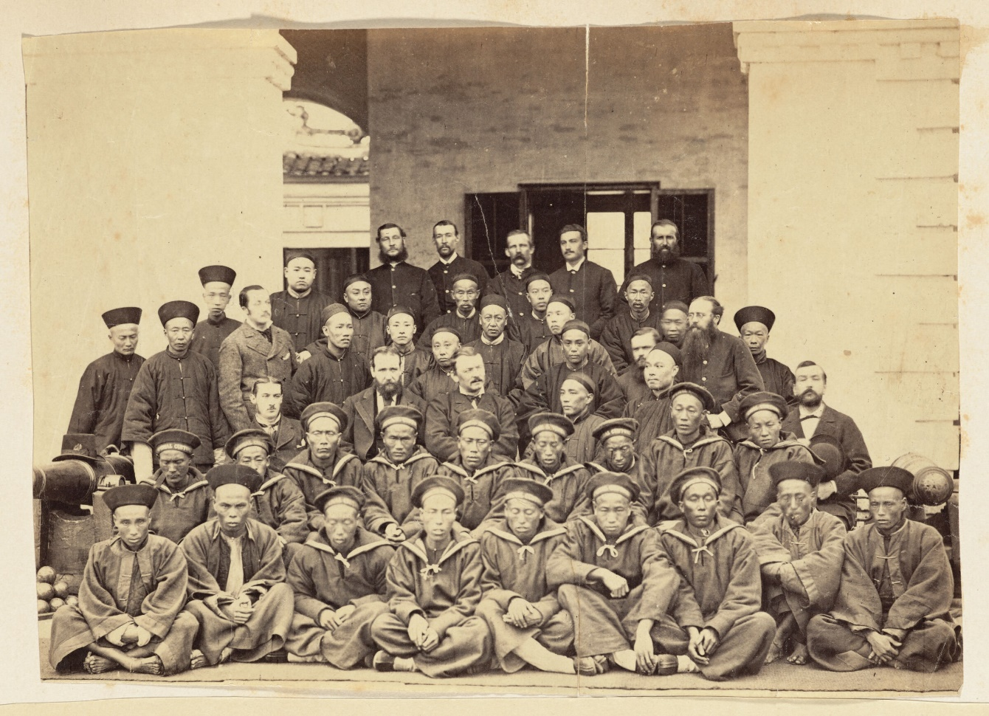

Customs staff at Ningpo c. 1876 © President and Fellows of Harvard College

Royal Holloway, University of London (RHUL) and the Royal Botanic Gardens, Kew (RBG Kew) are delighted to invite applicants for a collaborative AHRC Techne PhD studentship commencing October 2025, approved under the Collaborative Doctoral Award scheme funded by Techne.

The studentship will focus on archive, specimen, illustration, and artefact collections at RBG Kew and publications and archival materials of Chinese Maritime Custom Service, as well as material from archives elsewhere in the UK and China. The successful applicant will have the opportunity to work across academic, heritage, and archival contexts.

The project will be supervised by Dr Weipin Tsai and Professor Jane Hamlett (Department of History, Royal Holloway, University of London); and Dr Caroline Cornish and Professor Mark Nesbitt (Interdisciplinary Research, RBG Kew). The student will spend time at RHUL and at Kew, as well as becoming part of the wider cohort of Techne-funded students and the Plant Humanities PhD cohort at Kew. They will also have the opportunity to undertake placements at Kew or elsewhere. The studentship can be undertaken on either a full- or part-time basis.

We encourage the widest range of applicants for this studentship and are committed to welcoming those from different backgrounds and non-standard pathways. Applicants should have a master’s degree in a relevant subject or equivalent experience in a professional setting. If you have knowledge of reading Chinese script, we would also be interested to hear about it.

Project Overview
This project focusses on the role of the Chinese Maritime Customs Service (CMCS) in generating economic and botanical knowledge in the late nineteenth and early twentieth centuries. CMCS was the only institution operating in China during this period which had direct contact with large varieties of plant specimens and commodities, due to its role in recording the transit of imports and exports and inspecting cargos.
Many CMCS employees were skilled amateur naturalists who corresponded with and sent specimens to botanists at Kew Gardens. Beyond these direct associations, CMCS officers also acted in wider networks which incorporated Kew, the Consular Service of China, and regional botanic gardens. Many of these individuals left material traces in Kew’s collections.
Despite rich evidence of collaboration between Kew and CMCS at the institutional and personal levels, there has been little focused academic attention on this important chapter in Sino-European relations and the broader story of plant collection, economic botany, and knowledge exchange between these institutions and the networks in which they participated. This offers an exciting opportunity for the student to explore new territory, make new connections, and write new narratives.
The student will have the opportunity to be embedded at Kew and will have staff-level access to the archive. They will also be able to conduct wider public engagement, and this may take the form of, for example, an exhibition of visual materials, or an educational or community project, supported by Kew staff.

Details of Award
The Techne CDA Studentship will fund a full-time studentship for 3.5 years (42 months), with an option to extend this by up to a further 6 months for placement/career enhancing activity. Students must submit their thesis within their funded period.
The award includes a full maintenance grant for both home and international students. The National UKRI Doctoral Stipend for 2024/25 is £21,237/year, inclusive of London weighting. Plus an additional CDA maintenance payment of £600/year to enable travel and engagement with the partner organisation.

2025/26 figures have not yet been published. The award pays tuition fees up to the value of the full-time home UKRI rate for PhD degrees.

Note for international applicants: where an international student is successful, RHUL will make an additional tuition fee award, wholly covering the difference between the home and the international tuition fee, meaning that no additional fees are payable.

Further details of AHRC Studentships can be found on the UKRI website: https://www.ukri.org/what-we-do/developing-people-and-skills/find-studentships-and-doctoral-training/get-a-studentship-to-fund-your-doctorate/
The successful candidate will be a Techne Doctoral Training Partnership (DTP) student and will be required to attend mandatory events as part of their studentship terms and conditions with Techne. Please see the Techne website http://www.techne.ac.uk/ for more information.

Eligibility**
This studentship is open to both Home and International applicants.
To be classed as a home student, candidates must meet the following criteria:
• Be a UK National (meeting residency requirements), or
• Have settled status, or
• Have pre-settled status (meeting residency requirements), or
- Have indefinite leave to remain or enter.

Further guidance can be found here: https://www.ukri.org/wp-content/uploads/2021/02/UKRI-030221-Guidance-International-Eligibility-Implementation-training-grant-holders-V2.pdf

- Applicants will need to demonstrate experience of independent research to Masters’ level and hold a Masters-level qualification or equivalent professional experience in a field connected to the subject and skills orientation of the project, which can include history, East Asian Studies, Sino-British history (19th and early 20th centuries), history of science, and historical geography. Previous experience of archival research would be essential. Experience of using material culture and visual sources would be desirable. If you have knowledge of reading Chinese script, we would be interested to hear about it.

- The studentship offers a distinctive opportunity to undertake a collaborative PhD with a university and a heritage institution. As such, we would like to hear about your interests and aptitude for exploiting the unique possibilities of a studentship that will allow you to develop career-enhancing skills in heritage and public engagement, and to contribute to the cultural and intellectual life of both institutions.

- As part of our commitment to challenging the under-representation of Black and Global Majority students amongst doctoral researchers, we particularly welcome applications from applicants who identify as POC, BAME and/or part of Black and Global Majority racial and ethnic groups.

All applicants must meet UKRI terms and conditions for funding. See: https://www.ukri.org/funding/information-for-award-holders/grant-terms-and-conditions/

Project details and how to apply.
Please include in your application:
• Your CV
• A cover letter (1,500 words max.) explaining why you are interested in researching this topic, including what you would bring to the project and how you think you would develop it to reflect your own interests and expertise
• A sample of writing. This could be a piece of academic writing (e.g., an MA dissertation); or a text written in the course of any current or previous employment or voluntary/community work.
- Candidates invited to an online interview will be asked to supply a transcript of their university-level grades.
• The successful applicant will be expected to apply formally through RHUL’s doctoral school following notification of the interview outcome.
• All prospective students are strongly advised to first make informal contact with the lead supervisor, Dr Weipin Tsai (Weipin.Tsai@rhul.ac.uk)

Please send your application documents to Weipin.Tsai@rhul.ac.uk by the deadline of 17th January 2025.
Closing date: 17th January 2025
Interview date: 22nd January 2025
Candidates notified: 30th January 2025

The successful candidate will work closely with the project supervisors to revise the proposal, taking into account the interests of the student, and submitting the revised proposal to the Techne consortium by 19 February 2025. A final decision on funding will be received from Techne in April 2025.

Further Information
- For informal enquiries about the project, please contact Dr Weipin Tsai (Weipin.Tsai@rhul.ac.uk)
- For information or queries about the RHUL application process, please contact techneRHUL@rhul.ac.uk

The AHRC Techne consortium is comprised of Royal Holloway, University of London; Brunel University, London; Kingston University; University of Brighton; University of Roehampton; University of the Arts London; University of Surrey; University of Westminster.
For further information about the research environment at Royal Holloway, see: https://www.royalholloway.ac.uk/research-and-teaching/departments-and-schools/history/ and https://www.royalholloway.ac.uk/research-and-teaching/research/research-environment/research-institutes-and-centres/humanities-and-arts-research-institute/
For information about Interdisciplinary Research at Kew, including the Plant Humanities, see https://www.kew.org/science/interdisciplinary-research

**The project has been shortlisted in the Techne Collaborative Doctoral Award competition and, as such, still has to progress through the final judging round of the competition. Therefore the scholarship is not yet guaranteed.

