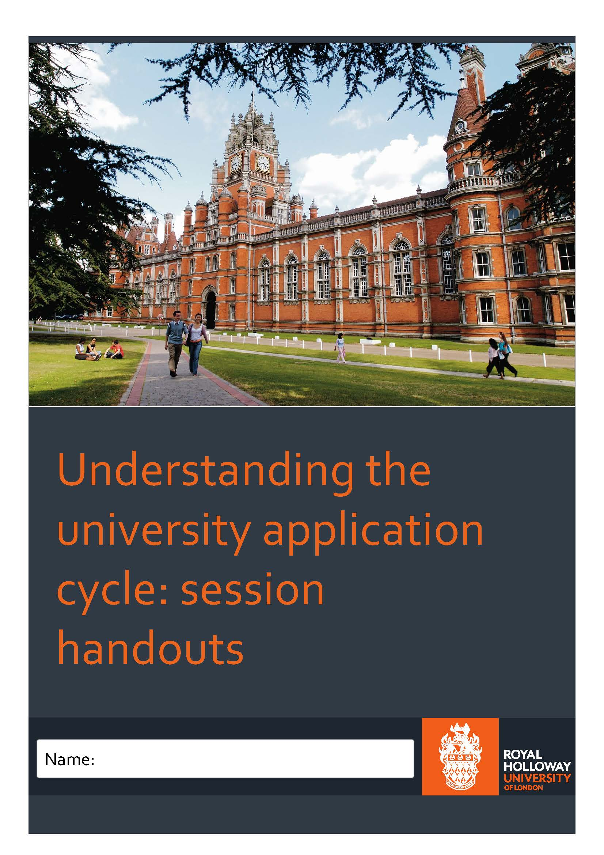
cycle
1
Introduction
We understand the vital role teachers and advisers play in their students’ journey to university. That’s why we want to support you in your teaching, and keep you informed on the latest developments in Higher Education.

This handout contains 10 quick tasks that you can use with your students to help familiarise them with the university application process. These tasks explore topics such as:

- How to choose a degree and university
- Personal statements and what admissions tutors look for in an application
- What happens next - Applicant Visit Days, choosing a firm and insurance option, student finance and accommodation.
- Last minute jitters - how to support students with exam stress, revision and results day.

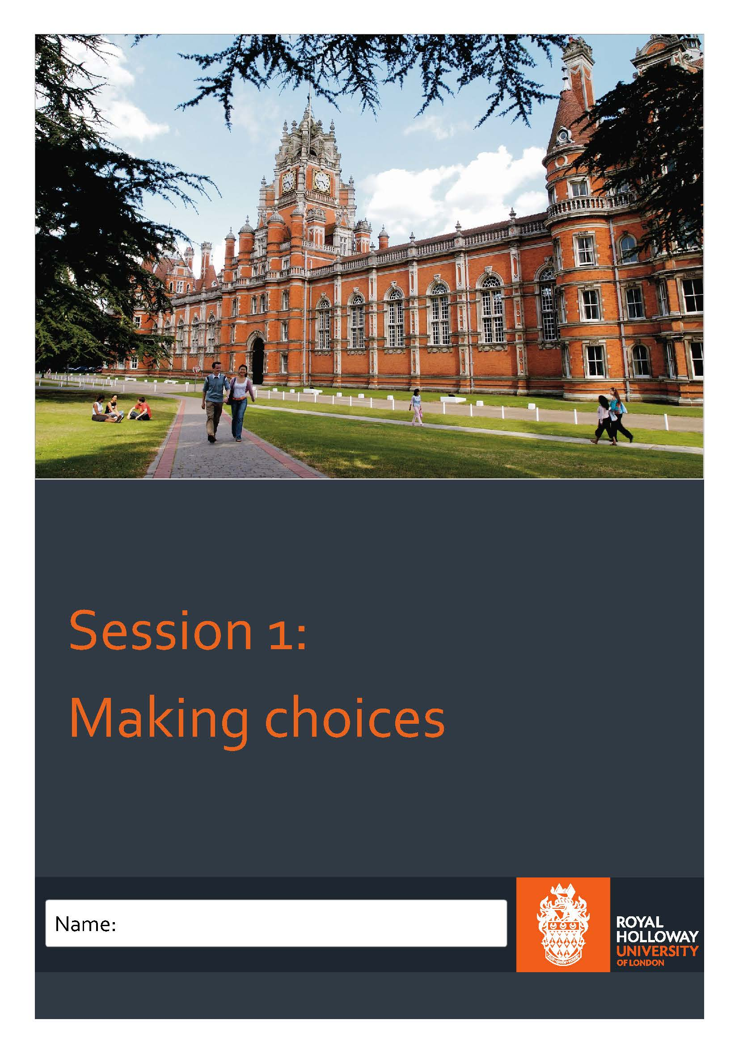
2
Session 1: Making choices

Task 1: What subject/course would you advise that these students study at university?

- Jane is currently studying history, politics and maths at A-Level. She is predicted an A in history, a B in politics and an A in maths. In her spare time, Jane engages in protests and online forums discussing local politics. She always contributes extra research in her politics class and spends her free time catching up with the news. Her parents want her to study maths at university because she finds it easy and is achieving high grades. They also believe that this will enable her to eventually attain a high earning job. Jane is unsure of what to study. What would you advise?

- History b) Politics c) Maths

- Rachel wants to become a journalist. She is undecided on whether she should study English or creative writing at university. She is currently predicted an A* for English and has never studied creative writing before, but she does have an equal interest in both. She is also predicted an A* in history, which she enjoys. What should she study?

- History b) Creative writing c) English

- Candice is considering studying psychology at university. She is particularly interested in social support work. She is currently predicted a D at A-Level psychology and is really struggling to understand the subject as well as keeping on top of the workload. However, she is predicted a B in childcare and a B in media studies. The universities she wants to attend are looking for at least a B or a C in psychology A-Level. Social Work at the same universities would not necessarily require a psychology A-level and would offer her a place based on her other predicted grades. What would you advise?

- Psychology b) Social work c) Media studies

- Kieran is unsure about what to study. He has been predicted an A in physics and has performed consistently. After conversation, you gauge that he enjoys the subject more than he enjoys maths and chemistry, in which he is achieving the same grades. For the career he wants to pursue, maths would be the best option. However, this career choice keeps changing and he would still cover some of the maths required in chemistry and physics. What would you advise?

- Physics b) Maths c) Chemistry
3

Task 2: Match the student profiles with the universities provided:

University E is situated in Greater London. There is plenty to do, both day and night. In terms of public transport, it is well connected and there is a night tube.
Student E wants to attend a university that has a busy night life.
University D is situated in central London. This university has many connections with recreational organisations across London.
Student D wants to travel far from home, is enthusiastic about culture and ready to take on full independence.
Student C wants to be at a university with a busy surrounding area in order to take up as many drama and acting opportunities as possible.
University C is situated in Manchester; the town has many shops and cafes to explore. There is a public library and many public services available.
University B is quaint and situated in Surrey; it is close to London, but also has its own quiet atmosphere.
University A is situated in a small town in France; it offers many Erasmus opportunities and “study abroad” is welcomed.
Student B wants to attend a university that is quiet and feels comforting.
Student A is looking for a university that offers the opportunity to work while studying.

4
Session 1 Answers:
Task 1: Answers
- b) Politics

Either history or politics could be advised here. However, politics may be a preferred choice as it is evident that Jane participates in politics related extra-curricular activities as well as having a high predicted grade in it.

- c) English

- b) Social work

- a) Physics

Task 2: Answers

- Student A + University C
- Student B + University B
- Student C + University D
- Student D + University A
- Student E + University E
5
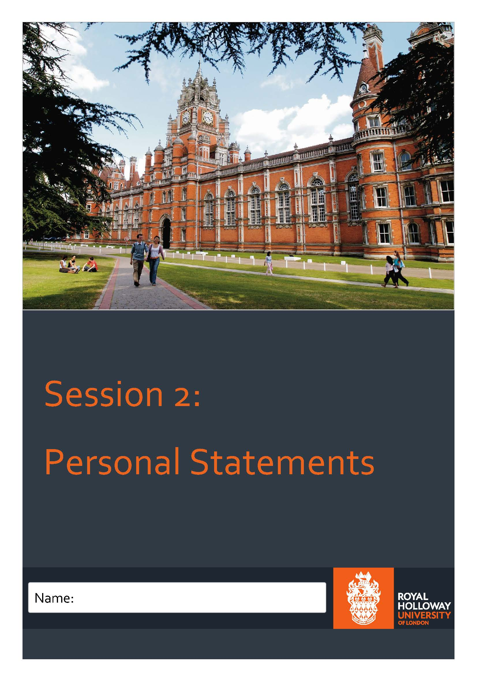
6
Session 2: Personal Statements

Task 1: Read the scenarios provided and circle the answer you would suggest

- Your student is running out of characters and is not sure which of their extra-curricular activities they should include in their personal statements. They have already included 70% academic content at this point. They are applying to study law at university. Please circle which activity would be most relevant to include.

- Work experience at Citizens Advice Bureau
- Part-time job at supermarket
- Playing tennis
- Volunteering in an old people’s home

- Your student is struggling to get to the point in their personal statement and includes a lot of unnecessary detail. What would you advise?

- Cut chunks of their statement out
- Re-write/rephrase it for them
- Suggest the PEE structure
- Get them to read it aloud

- Your student is unsure on how to start their personal statement and asks you to help them. What help do you provide?

- Write an opening sentence
- Tell them to have a break and start again
- Ask them one-to-one why they are applying to get them thinking
- Advise them to look at the UCAS website

- Your student repeatedly keeps using incorrect punctuation. The content and spelling are good, but it does not seem to flow well. Which two actions would you take?

- Remind them of punctuation rules
- Tell them it’s wrong and make them rewrite it
- Get them to read it aloud and see if the commas allow it to flow
- Correct all of it for them

7
Task 2: Read the personal statement extracts and assess whether you would keep them or advise against them.

1. Ever since I was a child, I really loved to read. My favourite books were written by Roald Dahl and I dreamt of being a writer
- Keep b) Advise against

2. Having studied psychology for two years, I have grown fond of the subject and I am keen to expand my knowledge at university. In particular, I am drawn to developmental psychology. This is partially due to the fact that my younger brother has autism. It intrigued me that his cognitive/social processes differed from my own and I would be enthusiastic about exploring cognitive processes, such as these, further.
- Keep b) Advise against

3. In particular, I enjoyed studying Nazi Germany and the rise of Hitler as these events have shaped the society that we live in today.
- Keep b) Advise against

4. One day I had a dream that I was a lawyer. I had been to law school and been a success. I climbed the education and experience ladder and I had made it. I woke up from that dream keen to chase it.
- Keep b) Advise against

5. I chose classics because of my keen interest for a broad range of subjects that are significant to our culture. If I successfully made it to your university I’m sure I would have a classic time.
- Keep b) Advise against

8
Session 2 Answers:

Task 1: Answers

- a) Work experience at Citizens Advice Bureau

- d) Get them to read it aloud

- c) Ask them one-to-one why they are applying to get them thinking

- a) Remind them of punctuation rules

It is also important for students to read their personal statements aloud and see if the commas allow the statement to flow.

Task 2: Answers

1. b) Advise against

2. a) Keep

3. a) Keep

4. b) Advise against

5. b) Advise against

9
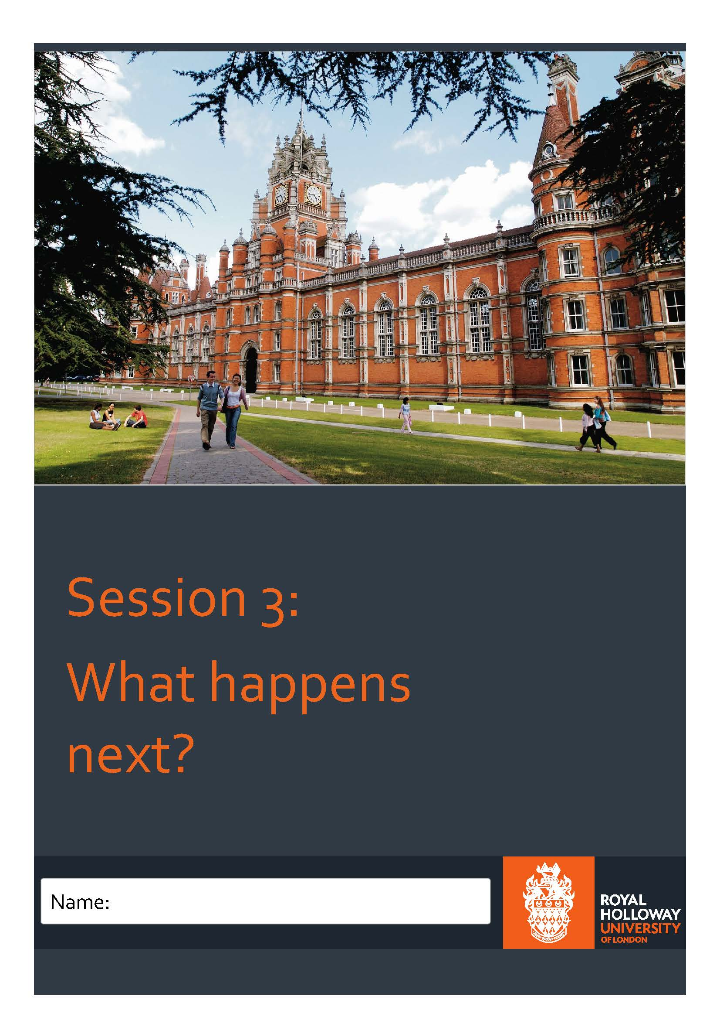
Task 1: Match the date to the UCAS event?
10
1 | 25 February 2019 |  | International Baccalaureate results published. | A
2 | 30 June 2019 |  | If applicants applied by 15 January and they are still waiting, universities/colleges will decide whether they’re making an offer by this date. | B
3 | 1 May 2019 |  | Applications received after this date are entered into Clearing. | C
4 | 15 January 2019 |  | UCAS Extra begins. | D
5 | 5 July 2019 |  | A-level results day. | E
6 | 3 May 2019 |  | If applicants receive all their university/college decisions by 31 March 2019, applicants must reply to any offers by this date or they’ll be declined. | F
7 | 5 July 2019 |  | UCAS deadline for most applicants. | G
8 | 15 August 2019 |  | Final deadline for 2017 entry applications. | H
9 | 20 September 2019 |  | UCAS Clearing opens. | I

Source: www.ucas.com/advisers/getting-started/application-deadlines
11
11

Task 2: UCAS True or False? Put a T or F in the box on the right:

- Once submitted, students can change their mind on their Firm and Insurance choices before the UCAS deadline.

- Students have one Firm choice and two Insurance choices.

- There is no point going to an Open Day if you can just go to an Applicant Visit Day.

- There is no advantage in confirming Firm and Insurance choices early.

- An Insurance choice University must have lower grade requirements than a Firm choice.

12

Task 3: How much am I entitled to?
Student A:
Melanie is a 17-year-old student about to start studying Law at Royal Holloway, University of London. She will be in receipt of a £1,500 bursary every year of her degree, as her family’s income of £22,000 makes her eligible. Melanie has also managed to get a job at LEGOLAND during term time and earns £7 an hour, working five hours on Saturday and another five hours on Sunday (ten hours a week for 35 weeks). Melanie has applied for a full maintenance loan to help cover the costs of studying at university. She will be living away from home in student halls. How much money will she receive each year?

Student B:
Max has dyspraxia and is classed as a disabled student and receives £1,000 allowance each year, as it will cost him more to buy things he needs, such as specialist equipment to help with his studies. He will be studying French and German at university from September and has already sat his A-levels, achieving A*AA. He will be in receipt of an excellence scholarship of £3,000. He is eligible to take the full tuition fee loan, and is planning on taking the full amount at least for the first year so he can live in halls of residence. Max is hoping to get a job on campus, preferably as an ambassador, so he doesn’t have to walk far for work. The pay is £8 an hour, but Max only wants to work four hours a week for 30 weeks of the year. How much will Max receive each year?

Student C:
Lily is going to study computer science at university. She is planning on studying for the four year integrated masters qualification and wants to take a year in industry. She has worked part time throughout her A-levels with a mobile phone company, and has saved up £1,000 of her own money to help support herself in the first year of university. Her parents earn £45,000 a year, meaning the loan available to her is approximately £8,813. How much money will she receive each year?

13
Task 4: What factors may students take into consideration when choosing accommodation?
1.
2.
3.
4.
5.

14
Session 3 Answers:
Task 1:
- G
- D
- F
- B
- C
- A / I
- A / I
- E
- H
Task 2: True or false?
- Once submitted, students can change their mind on their Firm and Insurance choices before the UCAS deadline.
FALSE: Once these have been submitted to UCAS, this is permanent. Any choices that have not been picked as Insurance or Firm, will be automatically rejected and the place on the course will not be retained for applicants.
- Students have one Firm choice and two Insurance choices.
FALSE: Students have one Firm choice and one Insurance choice.
- There is no point going to an Open Day if you can just go to an Applicant Visit Day.
FALSE: Open Days will help applicants narrow down to their five choices and are open to everyone, even if they do not end up applying to the university. Applicant Visit Days are for students to visit after applying to the university and may include an interview or opportunity to sample lectures or facilities.
- There is no advantage in confirming Firm and Insurance choices early.
TRUE: There is no advantage in confirming choices early, as long as these are received by the relevant UCAS deadline.
- An Insurance choice university must have lower grade requirements than a Firm choice.
FALSE: This is not a requirement for Firm and Insurance choices, however it may be sensible so that if the Firm offer is missed and the applicant is declined by that course, the applicant is still able to go to university.

Task 3: How much am I entitled to?
Profile | Loans | Grants / Bursaries / Scholarships | Part time work | Total
Student A | £11,354 | £1,500 | £2,450 | £15,304
Student B | £10,719 | £4,000 | £960 | £15,679
Student C | £8,813 | N/A | £1,000 | £9,813

Task 4: Choosing accommodation:
Factors that may be taken into account:
Cost, size, facilities, number of bedrooms, en-suite, length of contract, distance from university, distance from home, garden, whether parking is available, social life, independence, and any other sensible answers!
15
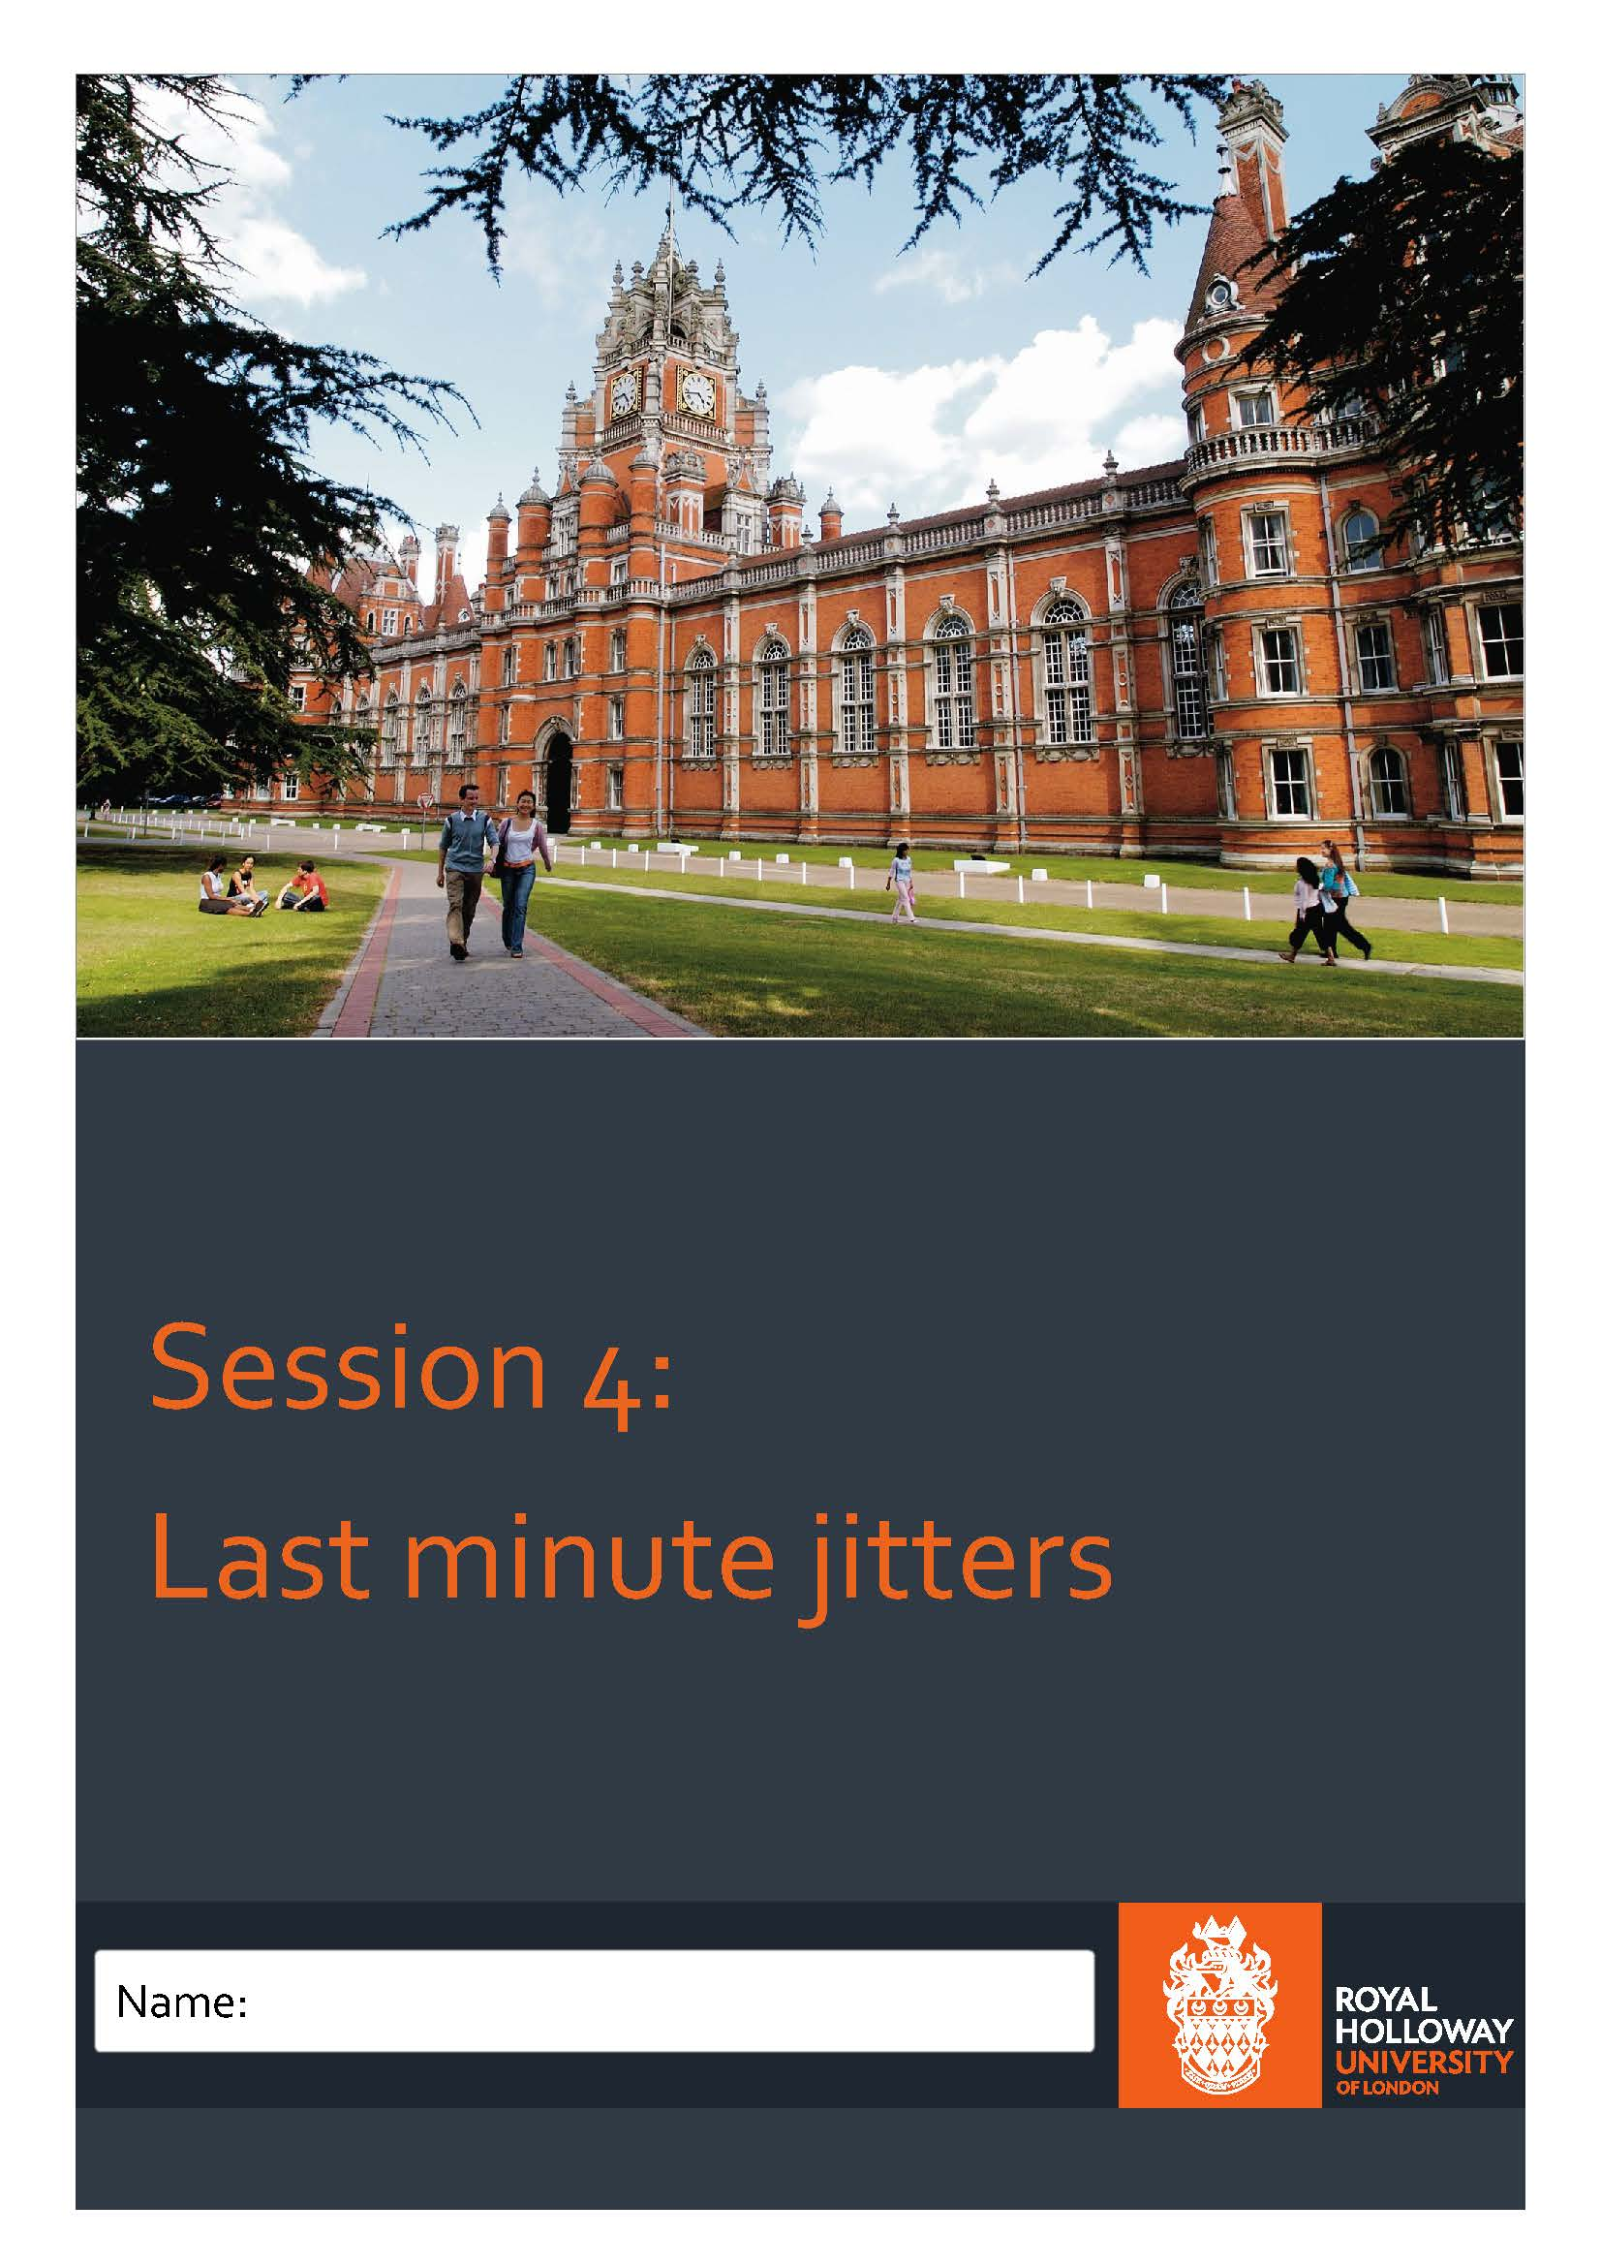
16
Task 1: What would be your top 3 revision tips for students?

17
Task 2: Clearing/Adjustment: True or False?
True/False?
- Clearing opens on A-Level Results Day in August.
- Clearing vacancies are updated regularly by universities and colleges so students may wish to try again later if they can’t see the course they want straight away.
- Students must only apply through Clearing for subjects that they applied for during the main UCAS cycle.
- Adjustment lasts for five 24- hour periods (including weekends) once registered.
- Registering for Adjustment may mean you lose your original place.
18
Task 3:
- What would you say to a student who had missed their offer?

- What would you say to a student who has an offer and is considering Adjustment?

19
Session 4 Answers:
Task 1: What would be your top 3 revision tips for students? Any answers from:
- Plan your time effectively and stick to it. Creating a realistic revision timetable that makes the most of your time is one of the best ways to make sure you cover all of your subjects and course content. You can even find templates online that you can personalise.
- Find a style of revision that suits you: this could be making mind maps of an entire unit or exam, rewriting notes or condensing them, taking past papers, or creating flashcards or Post It notes. One of these activities will suit you best and you should try them all to find out what works best for you.
- Revise in short bursts, taking breaks to relax, for example, by watching TV, browsing the internet or playing games in between.
- Make sure your revision means you are understanding the content rather than just memorising it- to do well in an exam, you need to be able to apply the information.
- Work with others to enhance your knowledge, test each other and use each other’s revision notes. Consult teachers if you are confused or unsure about anything.
- Make sure you balance your work/life ratio. Don’t burn yourself out and make sure you get enough sleep.
Task 2: Clearing/Adjustment: True or False?
1. Clearing opens on A-Level Results Day in August. = FALSE, Clearing opens in July.
2. Clearing vacancies are updated regularly by universities and colleges so students may wish to try again later if they can’t see the course they want straight away. = TRUE
3. Students must only apply through Clearing for subjects that they applied for during the main UCAS cycle. = FALSE, students may apply to any course.
4. Adjustment lasts for five 24-hour periods (including weekends) once registered. = TRUE
5. Registering for Adjustment may mean you lose your original place. = FALSE, Students are able to research their options without losing their original Unconditional Firm.
Task 3:
- What would you say to a student who had missed their offer?
- Tell them to ring up their firm and insurance- they may still offer them a place
- Consider Clearing- many universities will have lower offers than they did during the main cycle
- Consider taking a year out to re-think.

- What would you say to a student who has an offer and is considering Adjustment?
- Reassure them that they won’t lose their place
- Stress that university is a personal choice- if they are happy with their firm, they shouldn’t feel pressure to go to another University.
- If they would like to try Adjustment, they will not lose their original offer.
20

