AHRC Collaborative Doctoral Partnership (CDP) studentship – ‘Home from home? Constructions of identity and the British warship interior, 1880-1939’
Start date: 1st October 2021
Application Deadline: Sunday June 6th
Interviews will take place on the 29th June 2021
Royal Holloway, University of London, and Royal Museums Greenwich, part of the REACH CDP Consortium* are pleased to announce the availability of a fully funded collaborative doctoral studentship from October 2021 under the AHRC’s Collaborative Doctoral Partnership Scheme.
*The REACH Consortium comprises Royal Museums Greenwich (National Maritime Museum), National Portrait Gallery, British Film Institute, Historic Royal Palaces, National Trust.
This studentship is the first devoted to exploring warship interior environments during the late 19th and 20th centuries, and to investigating how they shaped the identities of their inhabitants. The project will be jointly supervised by Professor Jane Hamlett, Royal Holloway (RHUL) and Andrew Choong, Royal Museums Greenwich (RMG). The student will be expected to spend time at both RHUL and RMG, as well as becoming part of the wider cohort of CDP funded students across the UK. The studentship can be studied either full or part-time.
We encourage the widest range of potential students to study for this CDP studentship and are committed to welcoming students from different backgrounds and non-standard pathways. We particularly welcome applications from Black, Asian, Minority, Ethnic (BAME) backgrounds as they are currently underrepresented at this level in this area. Students should have a Masters Degree in a relevant subject or be able to demonstrate equivalent experience in a professional setting.

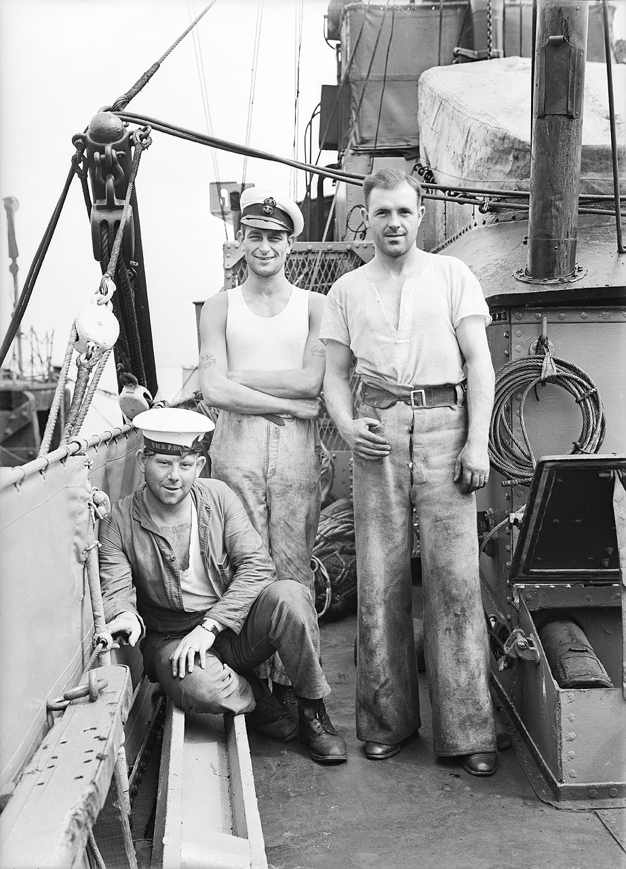

N21754: Three of the crew of the patrol vessel HMS P59 (1917). Copyright; National Maritime Museum

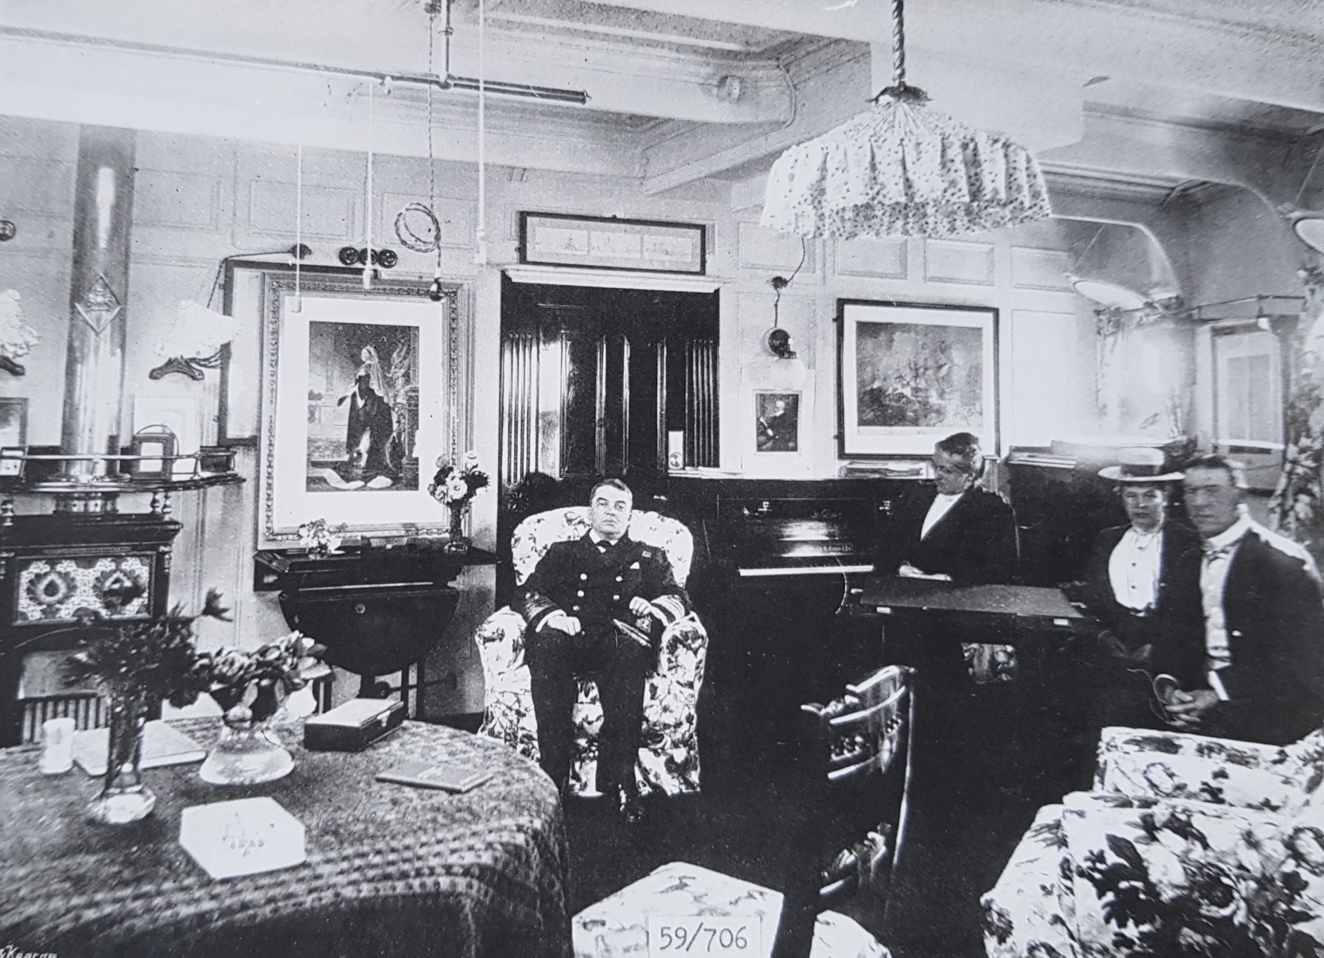Admiral Jackie Fisher in the day cabin of his flagship in the Mediterranean, 1898 Copyright; National Maritime Museum
Project Overview
The Royal Navy’s warships were tools of strategy, naval might, national pride and imperial purpose. They were expressions of technological mastery, and solutions to the challenges of fighting at sea. At the same time, they were also living spaces for hundreds of thousands of men. This accommodation varied greatly, from the grand cabins of senior officers which kept pace with fashions ashore to the cramped messes of sailors with their evocation of an unchanging Nelsonian past of Jack Tars and hammocks. Warships were thus important institutional spaces that shaped personnel and perceptions of age, class, race and gender within and far beyond the maritime world. This studentship is the first devoted to exploring these environments during the late 19th and 20th centuries, and to investigating how they shaped the identities of their inhabitants. The project’s focus will be detailed analysis of space/material culture aboard, surveying a representative selection of vessels. The student will determine how naval authorities intended these spaces to be used and what they were designed to communicate. Equally, they will investigate how personnel experienced the ship. The project will also situate warships in a wider context, examining how they were imagined in contemporary culture. This will be enabled by a wealth of RMG materials. RMG possesses national collections of warship plans and construction documentation, naval historic photography, personal papers from all ranks and published sources. This will be supplemented by Admiralty papers at TNA, filmic resources from BFI, and archival and oral history resources at the BL and IWM. This subject will engage students interested in the representation and experience of national identity, gender, class and race as well as power, modernity and institutional life.
The chronology runs from the Royal Navy’s late-Victorian expansion to the Second World War. This was a period of enormous change as the navy grappled with new technologies and changing socio-cultural, demographic and educational factors regarding personnel. Wider realities of urbanisation, trade unionism, socialism, suffrage and imperialism all impacted on the naval world. The First World War had a dramatic impact, and the interwar years brought new challenges of reduced budgets and imperial overstretch. A key aim of the project will be to map how naval spaces responded to these changes. The broad date range will allow the student scope to narrow this down after a primary source survey.
There are three possible research strands:
- Cultural representations of warships. How were warships imagined and how did this change? What values were they expected to communicate?
- Design of warships. How were living spaces designed and what was the intentionality behind this? Why were provisions made for different ranks/groups? How did this work on different vessel types? Was space designed to control inhabitants? What provision was made for personal space? How did material culture assume/construct different identities, from the gentlemanly officer to the trope of the tough, working-class Jack Tar? How responsive was this to civilian socio-cultural change.
- Shipboard lived experience. How was space used? What was the role of the material culture in rituals/performances? Did the ship’s materiality discipline inhabitants or could they subvert it? Did space assist in creating distinct emotional communities? Were warship interiors used for sociability and entertaining? What impact did the foundation of the Women’s Royal Naval Service have? How did people of colour experience this material world?

As a collaborative award, students will be expected to spend time at both the University and Royal Museums Greenwich. The studentship will offer wide-ranging potential for career development, including the opportunity to carry out a fully funded, long-term placement (defined in consultation with the student) at one of the REACH consortium member institutions within the period of the studentship.
Details of Award
CDP doctoral training grants fund full-time studentships for 45 months (3.75 years) or part-time equivalent. The studentship has the possibility of being extended for an additional 3 months to provide professional development opportunities, or up to 3 months of funding may be used to pay for the costs the student might incur in taking up professional development opportunities.
The award pays tuition fees up to the value of the full-time home UKRI rate for PhD degrees. Research Councils UK Indicative Fee Level for 2021/22 is £4,500. Note for international applicants: where an international student is successful, RHUL will waive the difference between the home and the international fee.
The award pays full maintenance for all students both home and international students. The National Minimum Doctoral Stipend for 2021/22 is £15,609/year, plus London Weighting of £2000/year, plus a CDP maintenance payment of £550/year.
Further details can be found on the UKRI website https://www.ukri.org/skills/funding-for-research-training/
The student is eligible to receive an additional travel and related expenses grant during the course of the project courtesy of RMG worth up to £850 per year for 4 years.
The project can be undertaken on a full-time or part-time basis.
The successful candidate will be eligible to participate in CDP Cohort Development events.
Eligibility
- This studentship is open to both Home and International applicants.

- To be classed as a home student, candidates must meet the following criteria:
- Be a UK National (meeting residency requirements), or
- Have settled status, or
- Have pre-settled status (meeting residency requirements), or
- Have indefinite leave to remain or enter

Further guidance can be found here - https://www.ukri.org/wp-content/uploads/2021/02/UKRI-030221-Guidance-International-Eligibility-Implementation-training-grant-holders-V2.pdf

- We want to encourage the widest range of potential students to study for a CDP studentship and are committed to welcoming students from different backgrounds to apply. We particularly welcome applications from Black, Asian, Minority, Ethnic (BAME) backgrounds as they are currently underrepresented at this level in this area.

- Applicants should ideally have or expect to receive a relevant Masters-level qualification, or be able to demonstrate equivalent experience in a professional setting (potential students may, for instance, already be working in the museum/heritage sector). Suitable disciplines are flexible, but could include History, English, Geography or Design History.

- The studentship offers a distinctive opportunity to undertake a collaborative doctorate with a university and a heritage institution. As such, students should demonstrate their interests and aptitude for exploiting the unique possibilities of a studentship that will allow them to use varied primary materials from archival collections to material culture; and that will also provide opportunities for them to contribute to the activities of the heritage institutions that comprise the REACH consortium.

NB. All applicants must meet UKRI terms and conditions for funding. See:
https://www.ukri.org/funding/information-for-award-holders/grant-terms-and-conditions/
Project details and how to apply
Please include in your application:
- Your CV.

- An outline, of 1000-2000 words explaining why you are interested in researching this topic, including what you would bring to the project and how you think you would take it forward
- A sample of writing (ideally this should be between 5,000 and 10,000 words but this is flexible). This could be a piece of academic writing (e.g. an MA dissertation); or a text written in the course of any current or previous employment; or an exhibition or gallery review; or you may select a museum object to write about (particularly if it is relevant to this project).
- Candidates invited to interview will be asked to supply a transcript of their university-level grades.
- The successful applicant will be expected to apply formally through RHUL’s doctoral school.
- All prospective students are strongly advised to first make informal contact with the supervisors Jane Hamlett (Jane.Hamlett@rhul.ac.uk) or Andrew Choong (achoong@rmg.co.uk)
- Closing date: 11pm, Sunday June 6th
- Interview date: week beginning 28th June

Further information
- For informal enquiries about the project, please contact Jane Hamlett (Jane.Hamlett@rhul.ac.uk) or Andrew Choong (achoong@rmg.co.uk)
- For information or queries about the RHUL application process, please contact Jane Hamlett on Jane.Hamlett@rhul.ac.uk

