Adobe Presenter Video Express Basic Guide

Create/edit the PowerPoint slide you want to use in your presentation and have it ready (or webpage/software: whatever you want to demonstrate or narrate on your computer).
Open Adobe Presenter Video Express (Start, All Programs, Adobe Presenter Video Express) and create a new project (green button at the bottom).
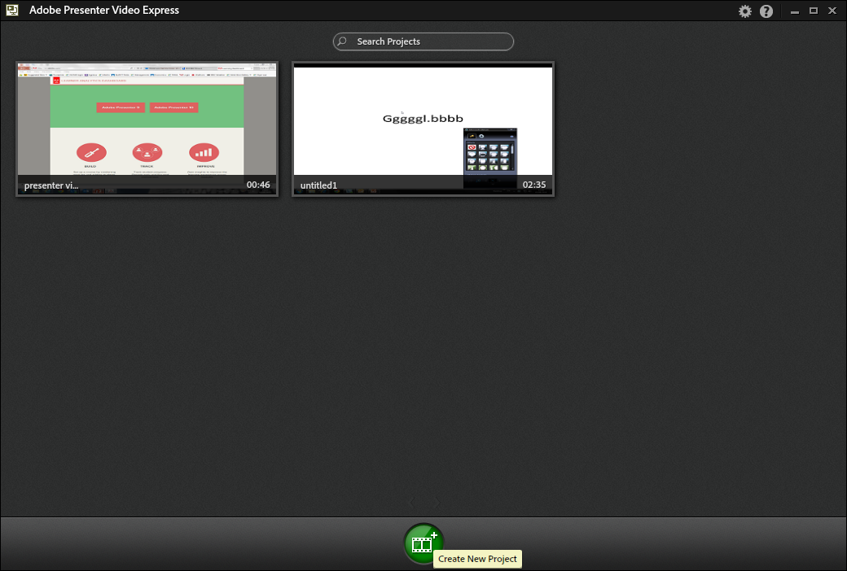
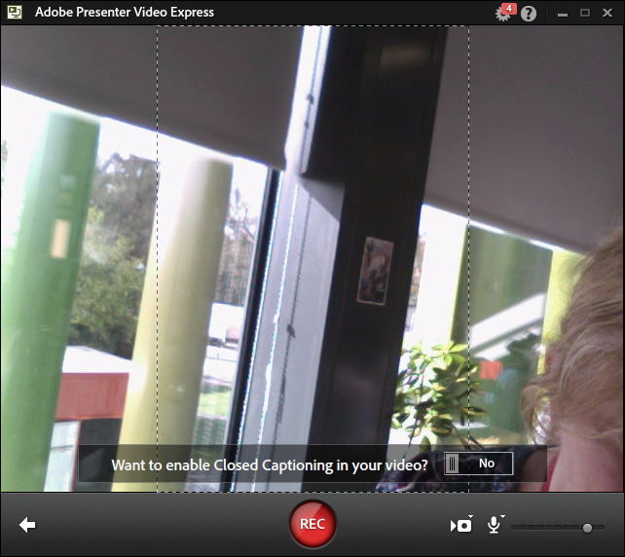
You can do this with or without a webcam – the screenshot above shows the program running with a webcam working (and the webcam not being positioned correctly – you’d adjust it at this stage). Ignore Closed Captioning for now – ask me if you’re interested.
Once you click REC you have 5 seconds to go back to PowerPoint and start your slides playing from the beginning (F5) or whatever it is you want to demonstrate. You need to remember how to end and pause the recording: (Shift + End) and Pause (Fn + B may work if you have no Pause button). The Video Recorder will seem to ‘disappear’ until you stop recording and save the project.
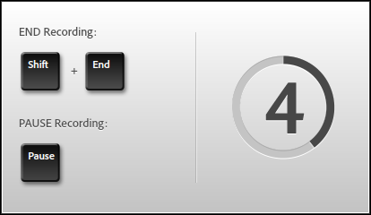
Once you have saved your project, you have the option of dividing it up into segments: showing just the webcam (yellow), just the screen (green), or both webcam and screen (blue). Move the playhead, click on the option you want and the section to the right of the playhead will change.
Also shown below is the branding window (film clapperboard icon bottom left) which will allow you to add the RHUL logo etc. Click the magnifying glass to zoom in and out of the presentation. Use the scissors to trim footage: put the playhead at the beginning of the part you want to delete, click the scissors icon then + by the playhead. When it’s reached the end of the bit you want to cut, click pause on the video controls (II), then click the tick on the timeline to confirm you want that bit omitted from the published version. NB this is non-destructive editing i.e. the deleted bits will remain, but they will be highlighted and the playhead will skip past them.
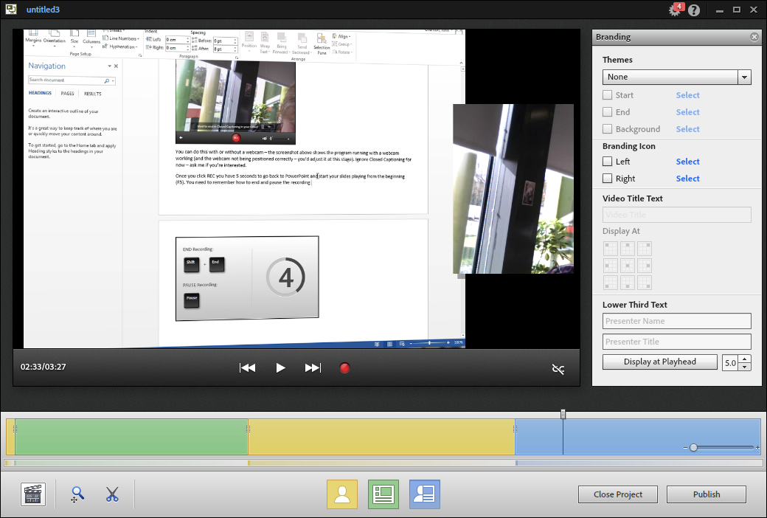

Publishing your project
Once you have finished your project, click Publish, name it something descriptive (if you haven’t saved it already) and select a publishing option. For Moodle, you should choose Publish to Computer. The resulting .mp4 video file can be found in the My Adobe Presenter Video Projects Published folder within your Documents folder (the .bmp file is just a still image from the video footage).
I haven’t managed to get the YouTube option to work, but you can easily log into YouTube and manually upload it from your Documents folder.
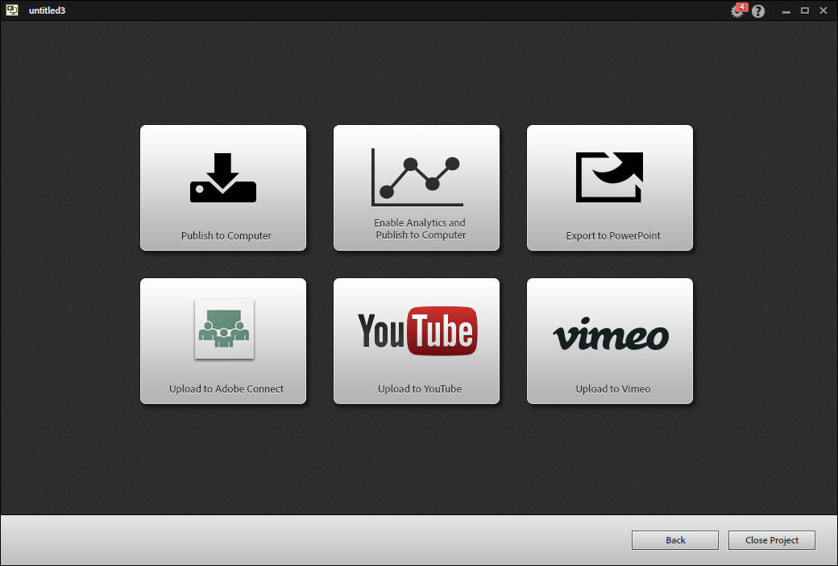

Uploading video to Moodle
N.B. your Moodle course needs to be connected to the RePlay service, if you see “This course has not yet been provisioned” you will need to add your course to RePlay. Download instructions here: https://www.royalholloway.ac.uk/iquad/documents/pdf/it/replay-moodle.pdf
Log into our video streaming server: https://rhul.hosted.panopto.com/
Sign in using “Moodle VLE” and use your usual RHUL username and password
Find your course folder, then click the orange Create button at the top and select Upload media, then drag the .mp4 file or click to browse your computer.

