Kaplan Panopto (RePlay) Quick User Guide

Log into Panopto using the link below
Go to http://rhul.hosted.panopto.com then click on ‘Log in using’. You will see three options. Choose to login via the Moodle VLE. You will be prompted to log in to Moodle first. Use your RHUL username and password to log in and you will be taken to the Panopto pages where you can see the Record button on the top right.

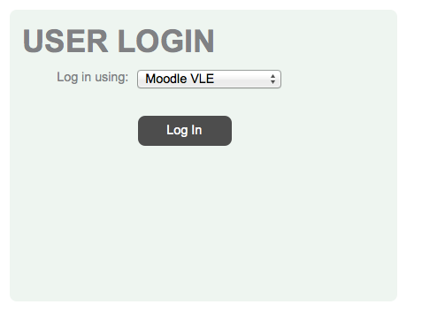
IMPORTANT: Recording instructions below. But please note that we need BOTH audio and powerpoint slides to be shown in the recording. Please record a 5-10 min video introduction welcoming students to the course. You can use slides for this as well, if you think it will be useful.

We have now created accounts on the College moodle page for all Kaplan second year and some final year courses. If you are involved with recording lectures and/or delivering workshops in Singapore for one or more of these courses, then you should see these course codes (ending in ‘K’) on your moodle page along with your other on-campus courses. When you record a lecture, panopto will automatically link your recording to the Kaplan course on moodle. If you cannot see your recordings on your moodle page (under the box titled, REPLAY) then please contact IT Helpdesk at itservicedesk@rhul.ac.uk . Also, if your moodle page does not show your Kaplan course, then contact Marianne in the first instance to make sure the course is set up for you.

Installing RePlay on your own laptop or PC: http://www.rhul.ac.uk/iquad/services/itforstaff/replay/gettingstarted.aspx

Recording instructions:
http://support.panopto.com/focus-4-articles/23-windowsrecorder/339-basic-recording

Editing instructions:
http://support.panopto.com/30-articles/34-editor/210-basic-editing30

FAQs: http://www.rhul.ac.uk/iquad/services/itforstaff/replay/replayfaqs.aspx.

Moodle set up
When a user accesses a Kaplan Moodle course they will see information in the RePlay block:

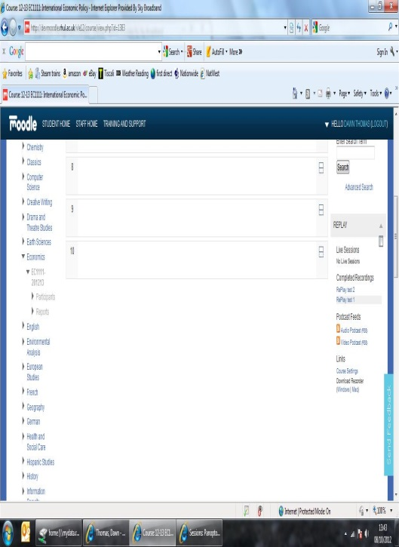

The three most recent recordings are displayed. To show all recordings click on the Show All link to expand the list of recordings.

Clicking on a link will launch a new window and start playing the recording in the viewer.

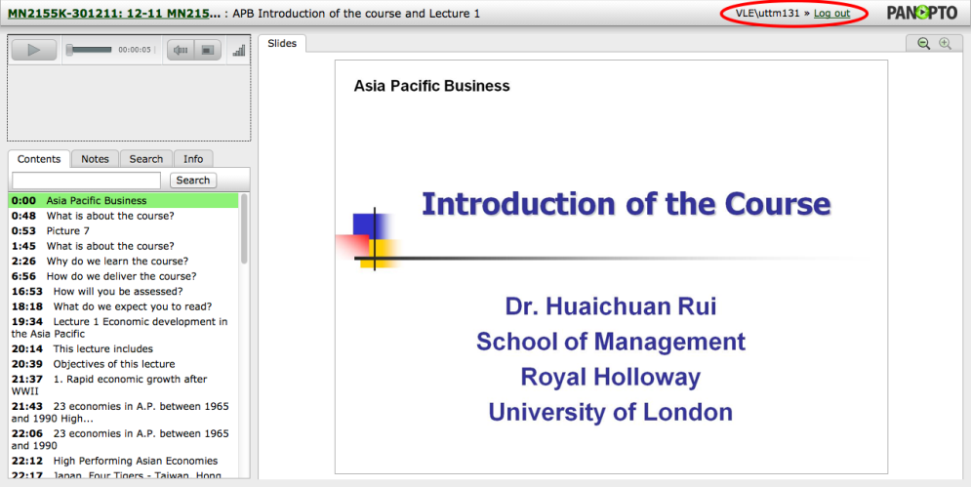

Linking recordings
To link the recordings in the main section of the course, you can right-click on the recording and select ‘copy link address’:

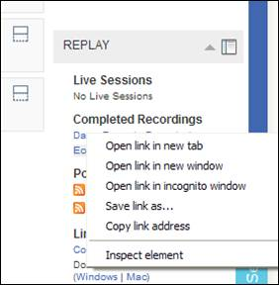

You will get a url like this one:
http://rhul.hosted.panopto.com/Panopto/Pages/Viewer/Default.aspx?id=22a760a1-3954-4fe4-9da6-bd1ddc4a57f

You can then use the url to add links wherever you want them.

Accessing recordings to edit
If the tutor clicks on the Course Settings link under the Links section in the block they will be taken through to Panopto and can modify the folder settings.

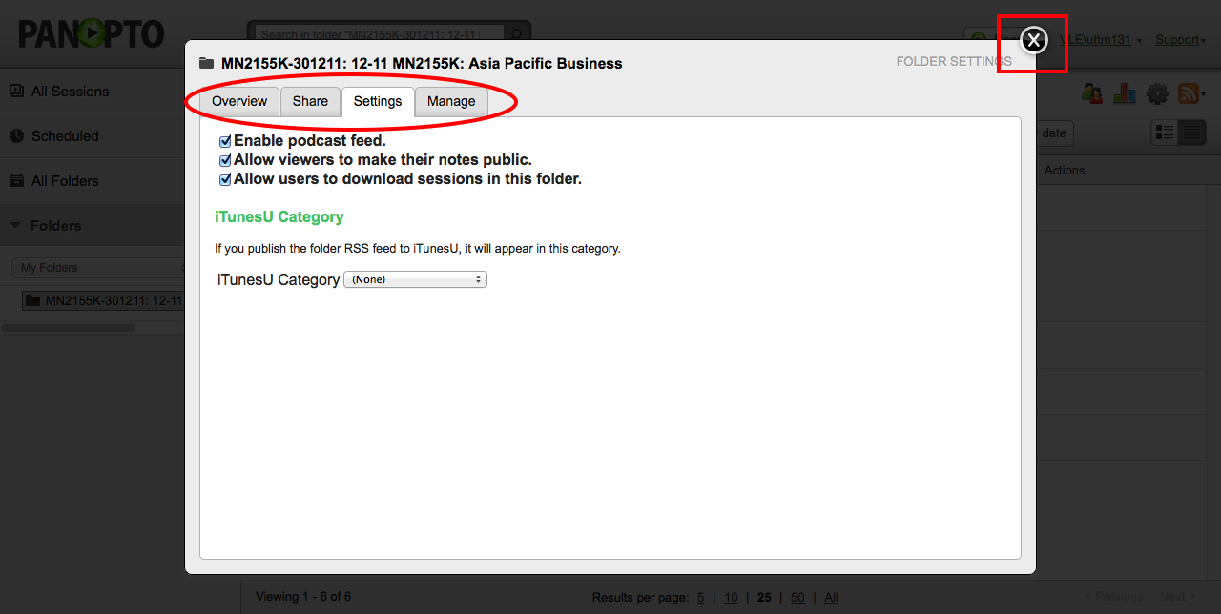

You can use any of the tabs to change settings or click the X button in the top right and close the course settings box to go to your personal Panopto view.

This is an example of how Panopto will look to a tutor who has logged in via Moodle.

