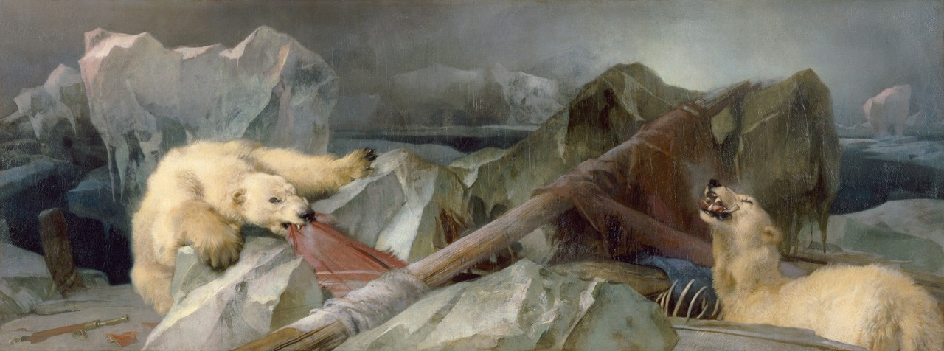

Picture Gallery Talk
Man Proposes, God Disposes:
A Haunted Painting?
Come and see RHUL’s most iconic painting.
Hear Curator Laura MacCulloch talk about
the grisly story that inspired it & find out the truth behind its haunting.
All are welcome to attend the tour and there is no need to book.
Location: Meet in the Picture Gallery.
Wednesday 27 February
Time: 1-2pm
For further information please email the College Curator,
Laura MacCulloch at laura.macculloch@rhul.ac.uk
The Picture Gallery is located on the North Quad of the Founders Building. For directions on how to locate the Picture Gallery please see the Campus Plan| (the Picture Gallery is located at 1B).

Future Talks:
Tuesday 5 March 1-2pm
The Railway Station: Life and Morality in Victorian Britain

Friday 8 March 1-2pm
International Women’s Day Talk
A Woman’s Triumph over an all Boys Club:
Annie Swynnerton and the Royal Academy

