`

[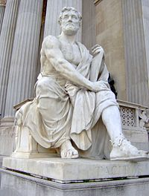](https://en.wikipedia.org/wiki/File:Wien-_Parlament-Tacitus.jpg)[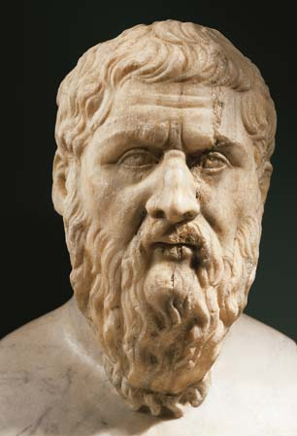](http://www.google.co.uk/url?sa=i&rct=j&q=&source=imgres&cd=&cad=rja&uact=8&ved=0ahUKEwji7s6uxLnMAhUqLcAKHRKTDBcQjRwIBw&url=http://www.britannica.com/biography/Plato&psig=AFQjCNHneDEQq2FWCIA7w9RP0m0dhkUiQQ&ust=1462214696368020)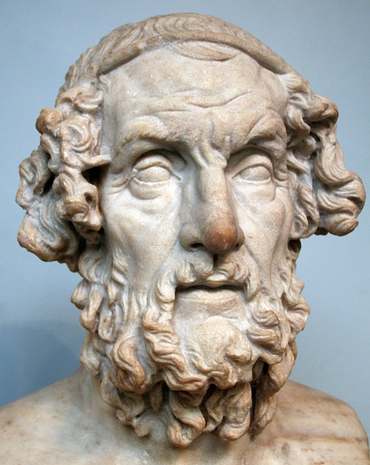[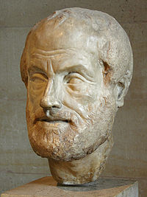](https://en.wikipedia.org/wiki/File:Aristoteles_Louvre.jpg) 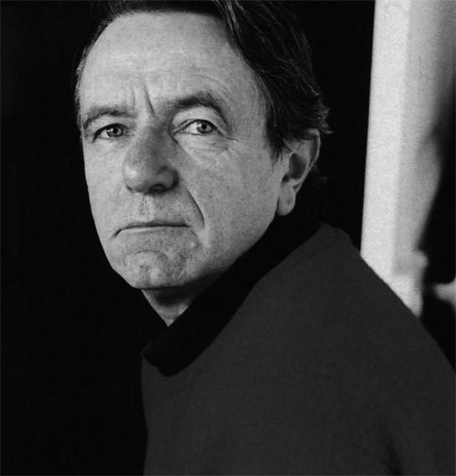

*Disagreement: Politics and Philosophy*

*Mute Speech: Literature, Critical Theory and Politics*

*The Philosopher and His Poor*

*The Names of History: On the Poetics of Knowledge*

*The Future of the Image*

*Dissensus: On Politics and Aesthetics*

*Figures of History*

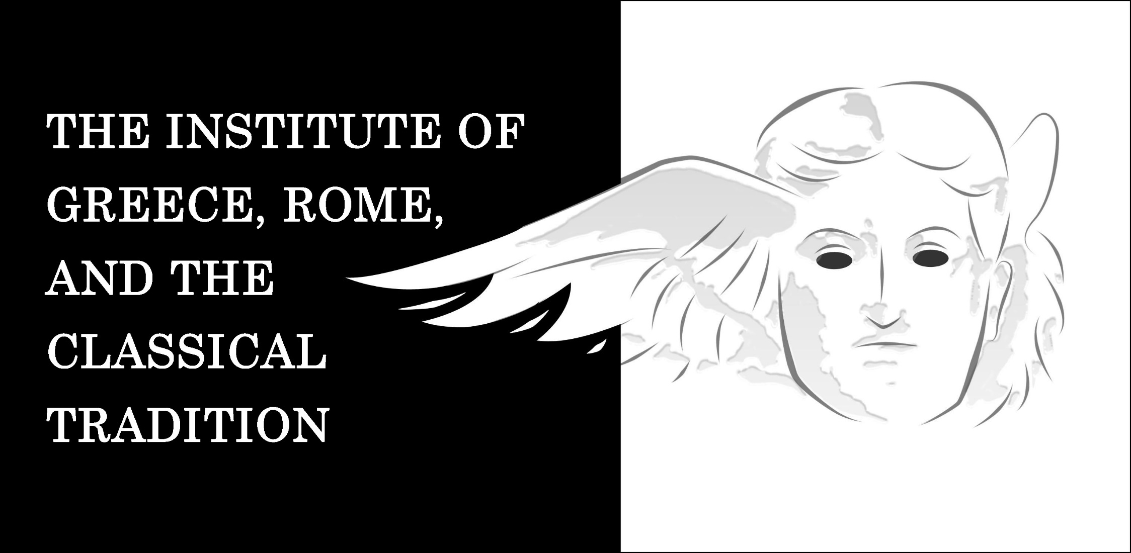  [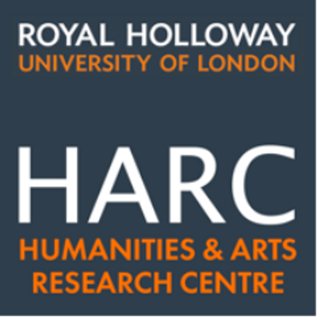](https://pbs.twimg.com/profile_images/522760409397227521/xTZbRHg_.png)  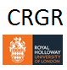

**Reading Rancière**

**Reading the Classics**

**An International Interdisciplinary Workshop**

**11 Bedford Square WC1B 3RA**

**RHUL Central London**

**Sept. 7-8, 2016**