English Department Graduate Conference

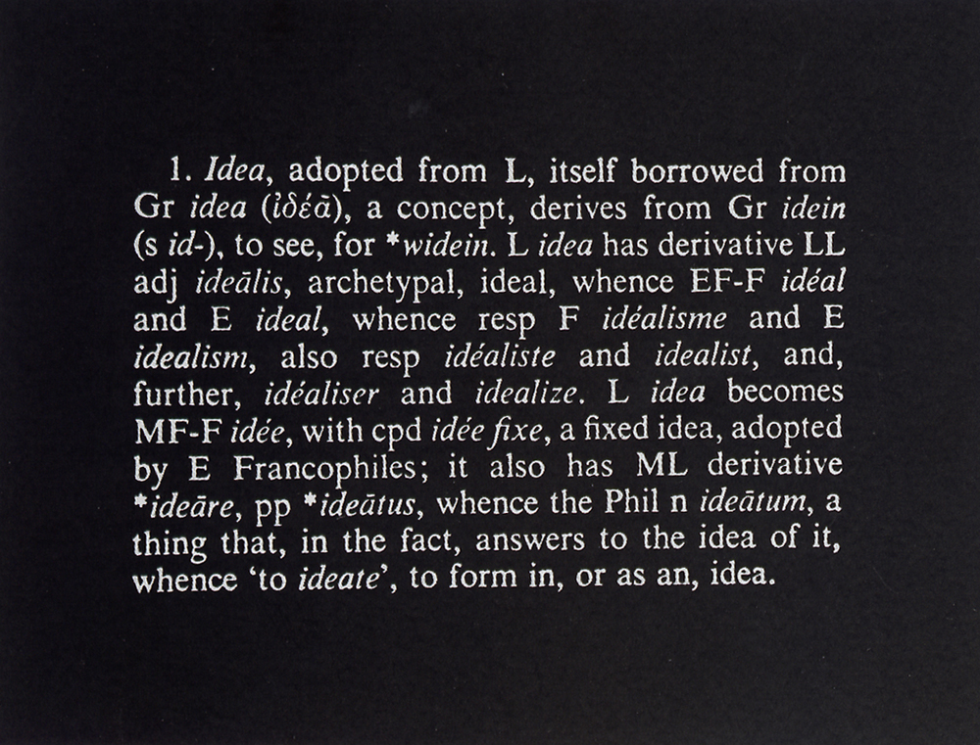
Joseph Kosuth, Art Idea (1967)

9 November 2012
IN243

Schedule and Abstracts

10.30 - 11.30 Panel 1: Illusions and Language: Timo Uotinen, Leda Kalogeropoulou-Mellou
11.30 - 11.45 Break
11.45 - 1.15 Panel 2: Madness and Folly: Sam Hall, Kelly Centrelli, Helen Goodman
1.15 - 2.00 Break
2.00 - 3.30 Panel 3: Definitions: Eley Williams, Nisha Ramayya, Kate Potts
3.30 - 3.45 Break
3.45 - 4.45 Panel 4: Total Art and the Freedom of Fiction: Helen Taylor, Lia Deromedi
4.45 - 5.00 Break
5.00 - 6.00 Panel 5: Education: Dominic Wright, Natasha Periyan
6.00 - 7.00 Exegesis launch and drinks

10.30-11.30 Panel 1: Illusions and Language

1. Timo Uotinen, ‘Dissembling nature’: Shakespeare’s Richard III and Bacon’s Idols

In the opening soliloquy Richard is ‘determinèd to prove a villain’ because he is ‘rudely stamped’, ‘cheated of feature by dissembling nature’, and ‘deformed’ and cannot therefore be the lover that his brother, King Edward, is (1.1.30, 16, 19, 20). Richard’s comparison with his brother seems to be ingrained in the imagery: Edward is called ‘the sun of York’ and Richard, in the time of peace, is only left ‘to spy [his] shadow in the sun’(1.1.2, 26). Moreover, as Richard mentions that he ‘was born so high’ that he ‘scorns the sun’, the old queen, Margaret, prophesises that Richard will ‘turn the sun to shade’ (1.3.263-6). Furthermore, along this allegory of sun and shadow is a mirror metaphor, which the Duchess of York, Richard’s and Edward’s mother, explicates. Edward reminded her of her husband (his father) calling him and his brother Clarence ‘the mirrors of his princely semblance’; whereas Richard is a ‘false glass’ (2.2.50, 52). Indeed, Richard is termed as a ‘dissembler’ twice in the play (1.2.170 and 2.2.30)—reflecting the ‘dissembling nature’ that formed him so.
The play’s plot necessitates Richard’s ability to dissemble, to make others believe that he is not what he seems to be. Writing a few decades after Shakespeare, Francis Bacon warns of illusions, or idols inherent in human senses or social practices that deceives us and prevents us from seeing the true nature of things. For him, ‘human understanding is like an uneven mirror receiving rays from things and merging its own nature with the nature of things, which thus distorts and corrupts it.’ Bacon is discussing the inherently anthropomorphic quality of human understanding and, interestingly, uses the same mirror metaphor that describes Richard’s dissembling activity. This suggests that the success of villainous activity is premised on the human inability to see the truth, which is in Bacon’s terms ‘the light of nature’, and leaving us ‘grasping at shadows’. In this paper I will argue that Richard III’s ethical framework—read through Bacon’s theory of idols—is fundamentally centred on the creation and perception of illusions.

2. Leda Kalogeropoulou-Mellou, ‘Language and Setting in the Short Fiction of Ella D’Arcy’

This paper is an extract from the last chapter of my thesis. In it I focused on one of the two Yellow Book women writers I am discussing in my thesis, Ella D’Arcy. Although the focus is on D’Arcy, I also made connections with the other female writer, Mrs. Murray Hickson, as well as other women writers of the periodical. I also linked this chapter to the previous two in which I had discussed the woman writer in the late nineteenth century and the periodical as commodity respectively, both of which serve as contextual background for the analysis of D’Arcy’s short stories.
The paper will be discussing the conflict between urban and suburban environments and the role of language in Ella D’Arcy’s stories that appeared in the Yellow Book. More specifically, I will be focusing on one short story which is one of D’Arcy’s most in-depth bleak analyses of marriage (‘A Marriage’). This story provides material for the understanding of public (urban and suburban) and domestic spaces as occupied by men and women, or rather husbands and wives. D’Arcy makes specific connections between setting and language within marriage. What happens when language or marriage become commodities and how are these affected by and reflected in the move of the couple from a suburban to an urban setting? More importantly, what is the result of these changes on the concept of the individual and his/her position in marriage and more generally the fin-de-siècle society? Drawing mainly on French theorists, I will be discussing the use of language in relation to the setting and reaching conclusions with regards to the self and identity.

11.45-1.15 Panel 2: Madness and Folly

As Ned Ward walked through Bedlam, reporting for the London Spy, he noted ‘All that I can say of Bedlam, is this, 'tis an almshouse for madmen, a showing room for harlots, a sure market for lechers, a dry walk for loiterers’(A Visit to Bedlam). This multitudinous chaos illustrates the varying degrees to which madness was perceived through history: it included mental instability, hypersexualisation, and—of course—a willing audience which paid to partake in the spectacle.
Literature has frequently utilised this ‘spectacle of madness’ as a means to critique and satirise society. It was not to illustrate the plight of the mad, but rather to expose foolishness and naivety. The ways in which madness was incorporated in literature varies greatly however, and it is my hope this panel will show a variety of techniques and types of texts which explore madness.
First, Sam Hall will explicate folly in the Renaissance and Shakespeare’s rhetorical styling of folly. Kelly Centrelli will follow with a study of the ‘ultra-violence’ in attacks against Alexander Pope as a form of ‘Dulness’ and monomania. To conclude, Helen Goodman will present a paper on masculinity, mesmerism, and madness in George Eliot’s novella, The Lifted Veil.

3. Sam Hall, ‘Folly’s Janus Face’
As Foucault and Auerbach contend, during the Renaissance the image of the Silenus head, used in The Symposium to explain the contrast between Socrates’ grotesque appearance and his brilliant intellect, is ubiquitously associated with the truth-claims of the paradoxical wisdom of folly. First, this paper will survey the complex ironies generated by different uses of this perplexing image, from its apotheosis by Erasmus, for whom Christ is ‘the most extraordinary Silenus of all’ (Adages, 2201) to its more equivocal function in shaping the form and content of his Praise; from Rabelais’ paratextual suggestion that it provides a way of gleaning philosophical marrow out of the scurrility of his book, to Montaigne’s re-deployment of it to encapsulate the vanity of modern man. Second, through a close reading of Bassanio’s discovery of the beautiful miniature of Portia in the lead casket in The Merchant of Venice, this paper will argue that Shakespeare’s ambivalent dramatization of this paradoxical idea is characteristic of how his reflexive speculation—commonly expressed through various rhetorical doubles—offers a profound ‘foolosophy’ (The Praise, p. 10), which exposes the folly inherent in the violent claims of reason to any kind of singular, hypostatized truth.

4. Kelly Centrelli, ‘“Joy to Great Chaos!”: The Mad Madness of Popiana’

In Book One of the Dunciad, Pope declares ‘Dulness here is not to be taken contractedly for mere Stupidity, but in the enlarged sense of the word, for all Slowness of Apprehensions, Shortness of Sight, or imperfect Sense of things. It includes […] a ruling principle not inert, but turning topsy-turvy the Understanding, and inducing an Anarchy or confused State of Mind’ (Dunciad fn. 15). Although Pope’s depictions of madness and dullness within the Dunciad are well-documented, there are no studies considering the ‘maddened’ relationship between Pope and his readers/victims. Attacked in the press by gruesome images and language, the Dunces amply supplied the behaviour Pope sought to satirise. This presentation will examine the ephemeral attacks made against Pope in light of his definition of ‘Dulness’ and the obsessive monomania of his attackers.
5. Helen Goodman, ‘ “Miserable ghost-seers” and haunting eyes: melancholic masculinity and psychic power in George Eliot’s The Lifted Veil’

‘The Ghost is the fiction of our relationship to death, concretized by the spectre in literature,’ according to Hélène Cixous. This paper discusses the gendering of this relationship, engaging with mid-nineteenth century prescriptions of masculinity to explore literary instances of psychic messaging and ghost-seeing. It suggests that 1859, the year in which George Eliot’s The Lifted Veil and Wilkie Collins’s The Woman in White were written, marks a highpoint for the intersection of such discourses, in a period when popular séances actively sought psychic messages. Previous studies have stressed the dominance of female psychics, whose sympathetic spirits were particularly well attuned. Nonetheless, given the recurrence of male clairvoyancy in fiction, I contend that masculine psychic power was less anomalous than has previously been argued. Helen Small has observed, ‘That a man should be mesmerized by a woman was an inversion of the expected gender relation, though by no means an unprecedented one.’ Male ghost-seers, loathed to receive psychic messages, are especially intriguing, representing a countercultural challenge. Eyes, signifying visibility and veiling, are a central focus in many narratives of such hauntings. Dr William Clifford spoke for the majority in declaring that the brain ‘is made of atoms and ether, and there is no room in it for ghosts.’

2.00-3.30 Panel 3: Definitions

6. Eley Williams, ‘“My word against theirs”: The Violated Dictionary as a Source and Site of Fiction’

The insertion of deliberately composed misinformation within dictionaries, including the false entries of Appleton's Cyclopaedia of American Biography (1888) and copyright traps hidden within The New Oxford American Dictionary (2001), reveal that such works of reference intended for factual consultation can contain purposively constructed, codified gestures by an author. Given such entries appear to demonstrate both artifice and verisimilitude in their creation, my contention is that a number of dictionaries have become sites of fiction as well as records of fact.
The relationship between works of reference and the production of creative writing is, for the most part, one-way; the format of a dictionary has provided a structual apparatus for many original written compositions (such as Ambrose Bierce's parody The Devil's Dictionary and David Leviathan's The Lover's Dictionary pastiche) and lexicons have also been used by creative writers according to their intended function as a lemmatic resource (such as the OuLiPo transformational technique of S+7, or as a location for lemmatic objets trouvé as with Oli Hazzard's hymn to lethologica 'The Inability to Recall the Precise Word for Something'). My proposal is to explore the ways in which the dictionary itself is locus for fiction and whether such lexical isolates as nonce words, ghost words and mountweazels - those fictitious insertions that enter a Dictionary in order to snare potential plaigarists - can be understood as instances of creative, rather than merely nonfactual, assertions.
Metalexicographer Alain Rey described lexicons as 'represent[ing] an illusion of totality, of an immoble order of things, of harmony': precisely because of this perceived immutability, the refiguring of dictionaries' format and content into creative literature has a particular ludic appeal. The constraints of the lexicographic form have been artistically generative in this way and the very 'trustworthiness' or authority of the dictionary provides a site for transformation and subversion. By taking a survey of contemporary as well as historical instances of dictionaries being used as sites for fiction, I propose to explore instances of creative expression within dictionaries and to investigate the nestled relationship between creative writing and the tenets of lexicography.

7. Nisha Ramayya, ‘The Relationships between Women Writers and their Dictionaries’

I would like to present a paper on the differing relationships between women writers and their dictionaries. The Dictionary holds the position of an authoritative text, which the reader is expected to trust and depend on, learn from and respect. Thus, the Dictionary is necessarily a closed text, according to Lyn Hejinian’s definition: ‘[a text] in which all the elements of the work are directed toward a single reading of it. Each element confirms that reading and delivers the text from any lurking ambiguity.’ However, as a container of words, the Dictionary has all the potential of the ‘open text’: ‘all the elements of the work are maximally excited; here it is because ideas and things exceed (without deserting) argument that they have taken into the dimension of the work.’ I would like to suggest that Mary Daly, Harryette Mullen, Tina Darragh, and Susan Howe explore the potential of the Dictionary as open text in their poetic experiments with dictionaries (including monolingual, bilingual, etymological, rhyming and slang dictionaries). These women writers engage in dialogue with their lexicographers, they subvert the strict forms and functions of their dictionaries, and they rewrite entries and definitions to suit their own artistic and political purposes. The Dictionary seems to function as both mirror and measuring stick – a critique of the Dictionary is simultaneously a critique of dominant cultures; remaking the Dictionary equates to remaking a world.
In my creative practice I have chosen to work closely with the Sanskrit-English dictionary written by Victorian Evangelist Sir Monier-Williams – I deliberately rely on this man, although the historical, political, and personal distances between us are immense. However, I suggest that forcing connections between apparently disparate sources yields interesting and important results – hence the dialogues between Monier-Williams, feminist theory, and Tantric-Hinduism set up in my work. Through analysis of selected works of Daly, Mullen, Darragh, and Howe, I will discuss the complex relationships between poets and lexicographers, concluding with reference to my own practice.

8. Kate Potts ‘“All things are words of some strange tongue”: The Dictionary Definition in Contemporary Poetry’

This paper examines and explores the utilisation of dictionary definition formats and conventions in contemporary poetry. Reference dictionaries as we currently experience them are authoritative and, to some degree, selective and exclusive. They preserve the purity of the language, presenting an officially sanctioned version of a language which, as part of the process of globalisation, makes clarification and translation of meaning and therefore cross-cultural communication (as required for more ‘rational’ or informational discourse) relatively straightforward.
Contemporary poetry, however, often concerns itself with translation from the silence, with what is too complex, ambiguous or liminal to be expressed through the mathematical or ‘representational’ signs available. In poetry, a literal translation is likely to fail miserably to capture the sense of the original. Culturally specific ‘non-representational’ signs such as form, rhythm and sound-sense are usually integral to the success of the poem, as are deviations from the grammatical rules of language, and specific, culturally embedded knowledge of metaphor and connotation.
Through analysis of the work of Robert Pinsky, Kei Miller and Anne Carson and Jen Hadfield, this paper explores the ways in which contemporary poetry’s use of the dictionary definition not only celebrates dictionaries but also strives to subvert them, to take pleasure in remaking and redefining the language. The dictionary as ‘a scholarly, impartial, and yet collective historical document, a record of changes in language rung on cognates’ offers an ideal of transcendent authority, and of language as continuum in space and time. By focusing on the act of defining, poetry can draw attention to what the dictionary definition (in its current form) tends to omit: the culturally and personally specific (including meaning related to very specific regions or to a particular classes or subcultures), and the untranslatable or ‘slippery’ aspects of language, particularly as experienced in cultural and contextual use. Suzanne Langer’s theories of representational and non-representational signs in aesthetic form and Julia Kristeva’s theories regarding poetic language will be employed to analyse the ways in which contemporary poetry, when it engages with the dictionary definition, challenges the concise, translatable ‘best fit’ notion of meaning, and interrogates the functioning of language itself.

3.45-4.45 Panel 4: Total Art and the Freedom of Fiction

9. Helen Taylor, ‘Music, Sound, Noise: Evocation and Connection in Adrian Henri’s Poetry’

Merseybeat has been dismissed by some as ‘pop poetry’, but my thesis argues that critics have been using the wrong tools for analysis – this is a total art movement, and as such the printed poetry is only one facet. The live event is the most immediate way of connecting with the audience, and the Merseybeat movement took their inspiration from both European avant-garde movements, such as Surrealism and Dada, as well as a very English music hall tradition, using both aural and visual aspects to engage the audience.
Popular music culture and references are used by the poets as a way of connecting with their audience – evoking a time, a place, a feeling – but also as a deliberate mix of genre, media, and register to bring the poetry off the page and into performance. This is not only evident from the works themselves: in 1967, Penguin Modern Poets 10: The Mersey Sound and Edward Lucie-Smith’s The Liverpool Scene anthology both deliberately cited pop culture in their packaging of the poets.
This paper focuses on the work of Adrian Henri, a poet greatly influenced by his urban environment, and particularly by popular culture: his poems reflect his city’s ‘Liverpool Sound’, both in their references to people and place, and also in their construction, often imitating pop’s verse/chorus format. Music, sound, and noise are all very much present in Henri’s poetry, particularly his poetry about Liverpool.
This work forms part of the fourth chapter of my thesis, on Music, but the opportunity of presenting this paper would allow me to show Henri’s role as vocalist in The Liverpool Scene as it was intended to be experienced: out loud. I will focus on those poems such as ‘Batpoem’ which exist both as literary texts and as popular songs, combining the printed and aural aspects of the movement, to explore the way Henri utilised the pop format, as well as discussing ‘The Entry of Christ into Liverpool’ as a perfect example of a Merseybeat work based on the cross-overs of artforms. The piece exists as a printed poem, a poster-poem, a recorded song, a painting, and a performance piece, each instance existing separately but also combining to produce a total experience of the original idea – explored as literature, music, art, and all of the above.

10. Lia Deromedi, ‘Contested Boundaries in Holocaust Fiction: The Survivor-Writer and Child Character’

This paper will be an outline of the main ideas from my first chapter, which will provide the foundation of my thesis on the ways in which my primary texts facilitate dialogue on a number of issues within Holocaust representation. Drawing on examples from primary texts that will be closely examined in later chapters, Chapter I will introduce the theoretical background for my argument that fiction is a constructive form, and the child a valuable perspective, for the survivors’ narrative.
The paper will touch on some of my following main ideas: ethical questions involved in the Holocaust novel, addressing the question of fictionalization’s contribution to an understanding of the subject without minimization; the ‘freedom’ fiction affords to survivors’ whose memories are blurred and disrupted; how the novel challenges the question of authenticity in survivor narratives; the child’s memory and viewpoint that can be viewed as much as about forgetting and silence as about remembrance and communication; the role of children in the Holocaust, in Judaism, and in literature with an introduction to my primary texts, supporting my assertion of the child’s fundamental separateness.
The key points reviewed in this paper will summarize my contention that my primary texts occupy multiple spaces, at once historical, political, religious, and personal, straddling contested boundaries between autobiography and fiction, history and imagination, and child viewpoint/child experiencer and adult narrator/adult writer, all of which can contribute to new understandings of the Holocaust.

5.00-6.00 Panel 5: Education

11. Dominic Wright, ‘Form and Reform: The Bildungsroman Novel and its Engagement with Education in the Early Nineteenth-Century’

Listing ‘the growing influence of education’ as one of a number of factors which affect what he terms ‘real’ development of youth, Franco Moretti proceeds to assert that ‘the Bildungsroman discards [such features] as irrelevant, abstracting from ‘real’ youth a ‘symbolic’ one.’ In this paper I will interrogate this distinction and assert that the Bildungsroman novel has the potential, due to its particular narrative structure, to influence education reform in a unique way. The main body of this paper will consist of a discussion of The Life and Adventures of Nicholas Nickleby and contemporary criticism of school practices in the North of England.

12. Natasha Periyan, ‘“Quit yourselves like men”: Public-School Headmasters and Repressed Masculinity in Virginia Woolf and WH Auden’s 1930s Literature’

This paper will explore how major modernists, Virginia Woolf and WH Auden, position the public school headmaster as a key agent of discipline in the 1930s, and an institutor of repressed masculine identities. The portrayal of this figure has been underexplored, yet its representation crucially points to modernist writers’ involvement with a key twentieth century educational debate: the role of corporal punishment and its effects.
The publication of Lytton Strachey’s Eminent Victorians in 1919 with its satire of Thomas Arnold, key public school reformer, heralded the involvement of literary figures in the reaction against the public school that followed the First World War, and established a specific focus for critique on the tyrannical force of its disciplining headmasters. Virginia Woolf, who positioned herself as an ‘outsider’ to these institutions, depicted the public school headmaster in The Waves (1931), The Pargiters (1932) and Roger Fry (1940), meanwhile WH Auden, caught in an equivocal position as a socialist reformer of educational policy and a preparatory school teacher, rendered this figure in The Orators (1932) and ‘Matthew Arnold’(1939) . Despite their differing relation to this institution, both identify similar implications for the public school educated ruling class as demagogic leaders as a result of the repressive, disciplining force of the headmaster.
As Dr Crane bids the boys in The Waves to ‘quit yourselves like men’ and Matthew Arnold is ‘left […] nothing but a jailor’s voice and face’ following the influence of his schoolmaster father, what influence do 1930s writers hold the public school headmaster to have on masculine identity? I will suggest how, by denouncing the disciplining force of this figure, 1930s modernists contested existing political structures and explored new possibilities for the self.

Alain Rey, Littré: l'humaniste et les mots (1970), quoted in Johnathon Green's Chasing the Sun: Dictionary Makers and the Dictionaries they Make (Pimlico, 1997), p. 22.
Lyn Hejinian, ‘The Rejection of Closure’, The Language of Enquiry, pp. 42-43.
Susanne Langer, Feeling and Form (New York : Scribner's Sons, 1953)
Ange Mlinko, ‘Clamor and Quiet,’ Poetry, 2008, http://www.poetryfoundation.org/poetrymagazine/article/180562 (04/10/2012)

