The Voice of Things: Words, Metaphor and Transformation of Performing Objects

I have been working with paper since 2005 under a professional name Hayan theatre in Korea and England. In exploring the relationship of materiality and theatricality, I launched a long-term project called ‘Material Theatre Series’ at the same year. Against my wish to invite one material or an object for a performance in a series like ‘orange’, ‘glass’ or ‘paper’, my lingering fascination about the paper made me remain in the very first series of the project and produce a series of paper-based theatres such as Cardboard Dreams, Paper Rain, Paper Relay, Paper Relay: A Mudong Story and The Voice of Things: toilet paper.
Before moving in to main discussion, I feel necessity to discuss about aspects of paper first.

Material? Object?
Paper is unique because it is material and object at the same time. What is material? What is an object? Material is pliable substance that has potential to change its shape and form into something else. It is, to a certain degree, second body. Body is the most pliable, malleable, flexible and multi-functional object. Paper seems to carry the most similar characters to human being. It is fragile but strong, and flexible but versatile. Paper as material that does not have rigid form can function as a second body on stage like a skin. Meanwhile an object has certain structure predestined by its use. Like in Heidegger’s explanation, its function motivates its production. Everyday object is designed to serve someone or something. Moreover it pinpoints certain action within the use of the particular object. To add another level, object carries a sign of cultural code. To sum up, object is situated within this matrix of sign, function and action. In terms of dramaturgy, we deconstruct, relocate and transpose the matrix in the act of playing to compose a performance with objects. On the other hand, a word adjacent to the word ‘paper’ adds another dimension into paper, as in;
What (kind of) paper?
(News) paper symbolises industrialization, city life, and messenger.
(Rice) paper has Cultural connotation of Eastern and analogue cultures.
(White) paper means potentiality and tabula rasa
(Toilet) paper connote functionality, everyday life

Through the series of paper performances, I found performing objects could take three different paths in terms of dramaturgical strategy. Dramaturgy here I understood as a cohesive structure with its inherent organism and inner logic determining the context of the structure. The way of playing with objects can underpin the armature of the composition. How we recognise the characteristic of the paper is reflected to the structure and the style of performance.
Firstly, we can quote the cultural connotation a kind of paper carries. For example, one of my paper-based theatres Paper Rain directly refers to the cultural connotation of newspaper, on top of the usage of cardboard boxes suggesting the form of city life limited in square shaped spaces. The material here works as symbol and attitude determining the perspective of seeing the life of an ordinary man in a city. 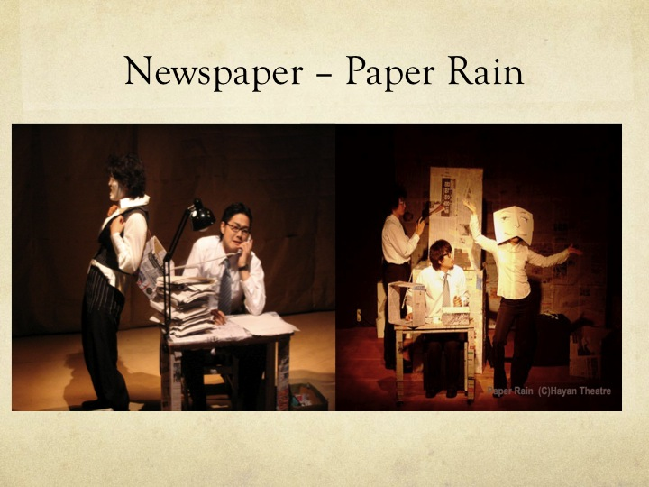With the symbol that is based on common sense, Paper Rain’s dramaturgy is constructed in a traditional dramatic way, following an anecdotal day of the protagonist. However the versatility of paper complements the spatial structure forming the rectangle spaces where the suppressed salary man transport from one place to another. Paper clowns as other egos of the protagonist depict and create the world in a way the salary man perceives. Secondly, the object becomes playful through the poetic undoing as in Kantor’s sense of ‘poor object’, namely, ‘the object of the lowest rank’. Undoing the meaning, the function, and the sign of object engenders the poetic deviation while maximizing the autonomous theatricality of the performance. However, eliminated of function and erased of its sign, the ‘undone object’ still shows traces of original object but is given a new sign and meaning within the setting of the performance. Therefore when an object is seen through two layers of original place and its negated state, it starts to build up poetic quality.
As a third path for an object performance dramaturgy could take, I propose, it is by hiring archetypical characters of the material that is shared within collective subconsciousness. I insist it lies within the gap situated between the body of a performer and the words particularly inherent to the material. My concern about the relationship between words and material started from my deviation against a myth that is often believed by theatre artists who I met. The myth is that puppetry and object theatre is not so much ambivalent with words. Therefore the object theatre is better depicted without words. It is true to a certain degree, however I believe it is actually the processed transformation between words and material that brings new alchemy and metaphor of a performance. Even if it is not uttered, material and object hide their words intrinsic to their quality as a fist gate to encounter with the people. Words may not deliver the materiality itself, but is it not through words that we can actually communicate? Words may not reliable and exact, nevertheless we appreciate words to connect with this world and other people. To bring the otherworldly materiality into this world, we cannot put the words lay aside from the interpretational process. So I suggest the alchemy of dramaturgy lies in this word ‘Nevertheless’ that symbolise the struggle between what is said and what is not said. Paper relay is an object performance focused on toilet paper as material that followed the third path in terms of dramaturgy. 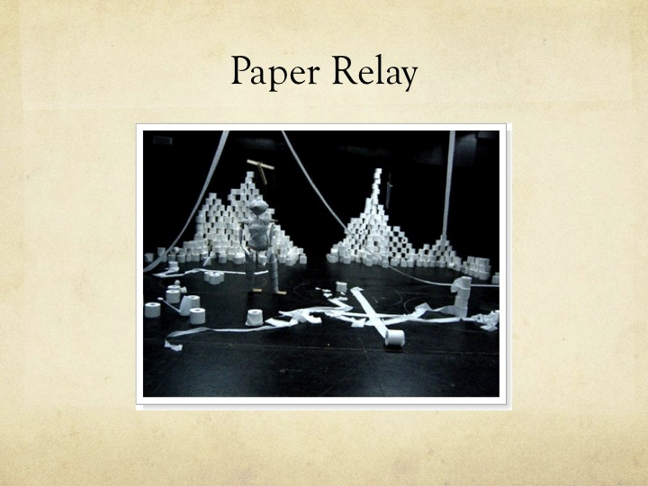

Paper Relay is the prototype of two different collaborative productions; those are Paper Relay: A Mudong Story made for children and The Voice of Things: Toilet Paper as an object performance. Paper Relay that I devised and performed in 2006 in Korea was initially designed to be an omnibus of three solo performances to show varied relations that three performers establish to the paper, using the descriptive words of paper as catalysts. The concept is based on the presumption that a human body inevitably intervenes to deliver the soul of material to other humans as an agency, and the body of a performer forms the cacophony along with the voice of the material during the process of performance. And the product of this marriage throuth the spatio-temporal continuum is metaphor. Paper Relay and The Voice of Things: Toilet Paper led me into PhD research to examine my fundamental questions:
In what way the material can arise memory hidden in the body? Apart from sensorial contact, in what way we share the characteristic and quality of the material in common? What is the role of language in this recognition and communication? The words latent to the material can really arise the memory lay in our body? Can they be aroused from the process? Are the words depicting the materiality fundamental to the dramaturgy of the performance?
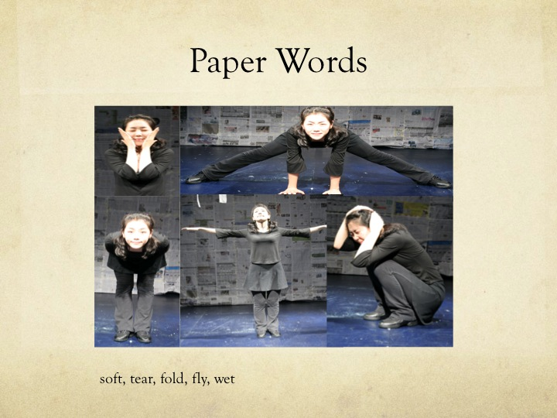
The performance hires 5 paper words in terms of structure: fragile, float, fold, tear, and wet. By abstracting these paper words and use them for the theatrical creation, they functioned as the key for performance in Goffman’s sense.

“Play is often related to an object, a ‘play-thing’, which is not one of the normal objects of serious behavior. These objects may include the body as a whole, or its parts. A plaything while in play provides some sort of ideal evidence of the manner in which a playful definition of the situation can utterly suppress the ordinary meaning of the word. ‘The key’ refers here to the set of conventions by which a given activity, one already meaningful in terms of some primary framework, is transformed into something patterned on this activity but seen by the participants to be something quite else. The process of transcription can be called keying. A rough musical analogy is intended.”

The key that is borrowed from music composition conceptualise the perceptual frame that defines the mood of a strip of movement, action, and experience. The performance is consisted of 4 sequences given each paper word as the key for contextualisation of the mood and the story. Until the scene reaches to the key, it accumulates layers of meaning that portrays the trace of an original object and the sign regenerated within the structure of the performance.
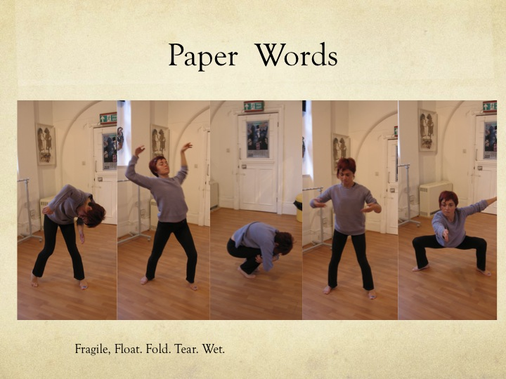
The first sequence starts from body movement that interpret the 5 paper words that are fragile, float, fold, tear, and wet before revealing they are from the paper to the audience. I used these words in Korean with Korean actors, English and Italian with an Italian actor. The words resonate in subtle difference subsumed to each cultural and language differences, as well as the style of the performance that we were dealing with. As you can see in the picture, the Korean paper words movement are straight and facing directly towards the audience, meanwhile European paper words are tilted, curved and subtle. This is also due to the audience we dealt with, the first picture is for children and the second is for adults. Body movement in the first sequence are patterned after the characteristic of the material.
Then fragile, float, fold, tear, and wet, a story serving the theme and attitude of the paper word suggested only at the end of the sequence like a puzzle. For example Tear is used as pun in English performance with tearing off the dog made of toilet paper, but also meaning tears of the dog owner who experience the death for the first time. To frame the sequence with the underlying key, the scene finished with the video clips playing with the key word. By putting the action of tearing off a dog made of toilet paper roll, it is momentarily funny. Then when the emotion of dog owner at the loss of her first dog, it adds a tone of sadness for a moment. This layering structure of words, object emotion and story accumulates to the theme.

Last but not least, there are two paper words that were not uttered but essential to the creation of the performance. What is the exclusive nature of toilet paper that is distinguished from paper in general? One major aspect that is most discerned from the rest of its kind is its shape. A roll. One fundamental aspect is its lineness when it unfolds itself. Therefore the other words, although they are not uttered in the performance, underlies the structure of the performance are fold and unfold. Unfolding is particularly inherent quality to toilet paper.
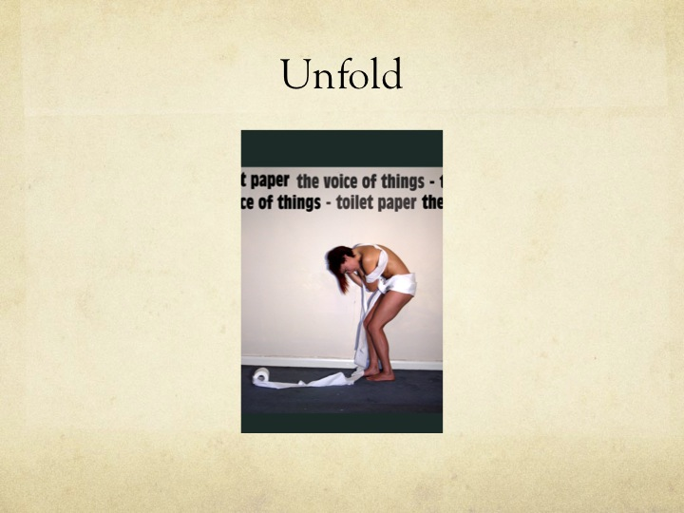I contrived it to use as a spatial drawing tool on stage, determining the landscapes of each sequence such as a house, the sea, the mountain, etc.
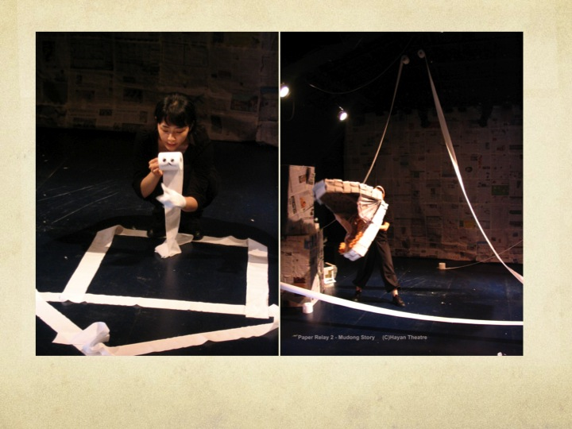
As the layers of the different sequence accumulate, the theme of the performance is aroused in our subconsciousness. Through the layers of the each sequence, the paper words are subsumed to the thematic meaning through the process of the performance. This is related to the very characteristic of metaphor as in its original meaning of ‘metaphorein’ transport or transfer from one layer to another.
If I end this presentation in an anecdotal way than academic way, I would talk about my experience of the actual audience expectation and anticipation about the performance in Edinburgh. With toilet paper most of general public members I encounter in the royal mile where we advertise our show and distribute the flyers expected the performance to be playing with the cultural connotation of an everyday object. It means people expected a joke where somehow it associates and dissociates the function of toilet paper. If the performance took this path, it could have been more comic and humorous. However, as our performance actually approached it as undoing the meaning of ‘toilet paper’ and endow its function as a spatial drawing tool, or particle that forms a fundamental structure of the universe, some people were very disappointed. For the moment exploration of the third path gives a new light for me in terms of the dramaturgical value of object performance for me. However in terms of communicating with the audience, the production should be inclusive of all three aspects of dramaturgical categories as I suggested.

