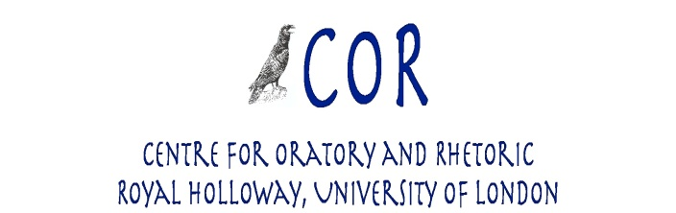

***From Antiphon to Autocue: Speechwriting Ancient and Modern***

**London, 25-26 April 2013**

**Conference fee**

**Full Fee**: £35 (£20 for students)

**Day rate**: £17.50 (£10 for students)

You can pay the conference fee in cash at the conference.

Conference dinners on will be on a self-paying basis in a local restaurant (further details will be announced in due course). Please indicate whether you would like to join us on the booking form.

Please fill in the form below and email it as an attachment to [antiphon2autocue@gmail.com](mailto:antiphon2autocue@gmail.com) by 3 April 2013 at the latest.

### BOOKING FORM

### Title: _______

### First name(s): ____________________

### Surname: _______________________

### Institutional Affiliation: ______________

### Address: ____________________________________________________________________________

### ____________________________________________________________________________ Tel: _____________________

### Email address: _______________________________________________________________

**Please tick as applicable**

|  |  |  |
| --- | --- | --- |
| Full Conference fee, 25-26 April | £35 |  |
| Student fee, 25-26 April | £20 |  |
| Day rate, 25 April 2013 | £17.50 |  |
| Student day rate, 25 April 2013 | £10 |  |
| Day rate, 26 April 2013 | £17.50 |  |
| Student day rate, 26 April 2013 | £10 |  |

**Please let us know if you have any special dietary requirements (for lunch)**:_________________________________

**Please delete as applicable:**

**Would you like to join us for dinner on:**

**25 April 2013: YES/NO**

**26 April 2013: YES/NO**

