

***From Antiphon to Autocue:***

***Speechwriting Ancient and Modern***

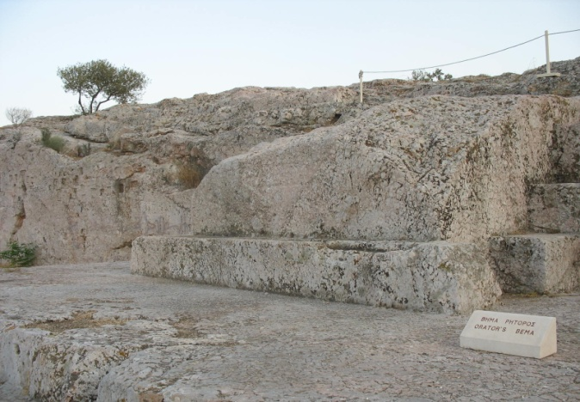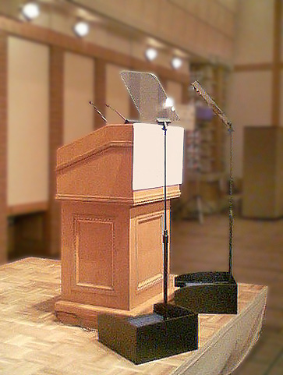

**Hellenic Centre, London, 25-26 April 2013**

