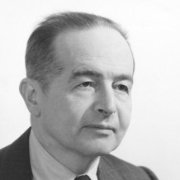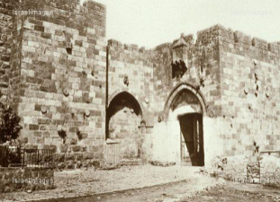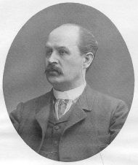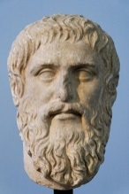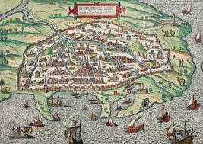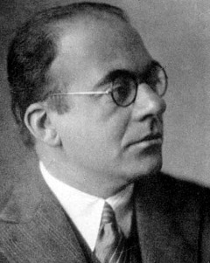
Hellenism and Judaism in Modernity
Nov. 19, 2014, 1pm -6:30pm
UCL, Gordon House, Room 106

Organizers: Ahuvia Kahane (RHUL) and Miriam Leonard (UCL)

1:00 Arrival and Welcome

1:15-3:15

Simon Goldhill (Cambridge): ‘What Has Alexandria to Do with Jerusalem?’
Tim Whitmarsh (Cambridge): ‘Greek Fiction and the Monstrosity of the East: Rohde versus Braun’?

Respondent: David Feldman (Birkbeck)

3:15-3:45 Tea
3:45- 5:45

Jas Elsner (Oxford): ‘Jewish Art: A C20 story’
Jim Porter (University of California, Irvine): ‘Mimesis or Realism? Plato and the Old Testament in Erich Auerbach’

Respondent: Bryan Cheyette (Reading)

6:00-6:30 Closing Discussion

6:30 Reception

There is no registration fee but attendees must register at this link: http://bit.ly/1tZyAcK

Messages to the list are archived at http://listserv.liv.ac.uk/archives/classicists.html

