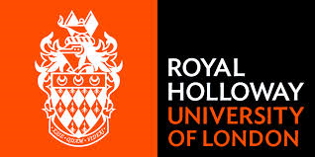 | Institute of Cardiovascular Research Royal Holloway University of London
ICR2UL CARDIOVASCULAR LECTURE SERIES 2016
For GPs and HOSPITAL DOCTORS
Tuesday 28th June 2016
Dr Michael Wood
Consultant Respiratory Physician

Obstructive Sleep apnoea and Cardiovascular Disease

OSA ,who, how many, why. Diagnosis. Treatment
How does OSA affect cardiovascular system
Research project in making

Dr Peter Wilkinson
Consultant Cardiologist

How to minimise your risk of getting Cardiovascular disease

Chaired by Professor Pankaj Sharma
Buffet lunch on arrival at 12.30 – lectures 1pm-3pm
Certificate of attendance and CPD available
Please use the main outpatients car park – exit tickets provided
Location: Oliver Plunkett Post Graduate Education Centre – St Peter’s Hospital, Guildford Road Chertsey, Surrey KT16 OPZ
Booking in advance is helpful email: ICR2UL Manager/Contact: kate.sargeant@rhul.ac.uk
Please note future ICR2UL lecture dates & locations for 2016:
TBC
Supported by Pfizer BMS

